
Topic Web – Early Years Curriculum Spring 2 - 21/22 Reception
Literacy
Writing captions and sentences, spelling out words and using finger spaces.
Looking at the difference between fiction and non-fiction books.
Enjoying reading and talking about books, using our segmenting and blending skills

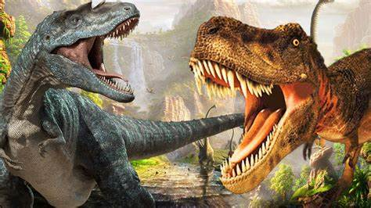
Physical Development

Throwing and catching different sized balls
Practising handwriting on the handwriting sheets using the RWI mantras
Talking about different foods and how to keep healthy and safe.

Gymnastics
Striking and fielding games
Mathematics

Adding and subtracting groups of items together to find the total.

Finding doubles and halves

Playing with patterns
Playing with rulers and measures to discover all about length

Animals Then and Now
Dinosaurs:
Dinosaur Facts
Gigantosaurus
Mary Anning – Dinosaur Lady

Expressive Art and Design

Using different materials to create 3D models
Using watercolours, pastels and chalk to make pictures
To create dances and their own music
Dinosaur Art – textures and patterns
Appreciating music – Carnival of the Animals
Personal Social and Emotional Development

Circle time
PSHE activities
Jigsaw – Healthy Me!
Stories linked to feelings
Talking about what we like doing and what we’re good at.
Turn taking games (dominoes, etc)

Communication and Language

Using improved vocabulary and developing questioning skills.
Answering how and why questions and asking their own questions.

Understanding the World

Dinosaurs
People in history – Mary Anning
Easter
How to log onto a computer

