Occasional Visitor Procedures  - Visitors MUST sign in at the inventory  machine by the office.  - Photo ID issued MUST be worn at all times whilst on school premises.  - Visitors should remain under the supervision of school staff whilst on site, unless arranged otherwise.  - All visitors must sign out at the main office before leaving the site.  Any visitors wishing to speak to a member of the team should telephone school to make an appointment.  Please let school know if you have any access needs.  Regular Volunteers  - Visitors MUST sign in at the InVentry machine by the office.  - Volunteers must wear an ID Badge throughout their visit.  Regular volunteers to school have a valid DBS certificate. |  | SAFEGUARDING STATEMENT  At Manchester Road Primary Academy, we are committed to safeguarding and promoting the welfare of children.  We expect all staff, volunteers and visitors to share this common commitment.  This leaflet contains information about our school, and other safeguarding procedures. If you are unclear about anything in the leaflet please speak to any of the contacts named within.  Please keep this leaflet with you so that you can refer to it if needed.  If you are concerned about the safety of any child in our school, you must report this to one of the designated team.  If you are concerned about the conduct of a member of staff or volunteer in your school, you must contact the Designated Safeguarding Lead.  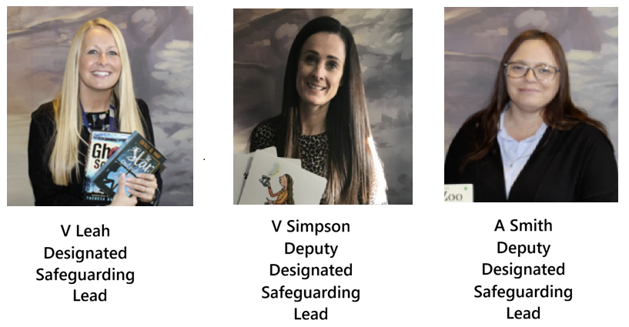   |  |   - Event subtitle  Visitors guide & safeguarding information  We hope you enjoy your visit to our school.  Please read this leaflet carefully before entering the building.  Revised December 2025
If a child discloses that they may be subject to abuse:  - React Calmly  - Listen Carefully to the child, particularly what is said spontaneously.  - Do not promise confidentiality. Explain to the child that you may have to pass on information to make sure they are safe.  - Do not ask any leading questions or make judgements. Ask for clarification using language such as ‘can you explain… Can you tell me anymore, describe…’ but as soon as you think there may be an issue, ask no further questions. This needs to be passed to designated safeguarding officer in school.  - Reassure the child that they are doing the right thing.  - Record carefully what the child has said in their own words, including when and how the account was given. Fill in the school concern sheets (available at the office). Pass this to the safeguarding lead or one of the safeguarding team immediately. |  | If you feel that a child may be at risk of harm, but are not sure, then inform one of the safeguarding team immediately. They will offer advice and take appropriate action.  Child abuse can happen to any child regardless of elements such as gender, culture, religion, social background or disability.  A copy of the school safeguarding policy is available in the staffroom.  Types of Harm:  Physical: when a child is deliberately hurt of injured.  Sexual: when a child is influenced or forced to take part in sexual activity. This can also include being made to look at inappropriate images.  Emotional: when a child is made to feel frightened, worthless or unloved. It can be shouting, using threats or making fun of someone. It can also be if a child witnesses fighting at home.  Neglect: when a child is not being taken care of by their parents / guardians. It can be poor hygiene, poor diet, not keeping appointments for additional support, not coming to school, or being left home alone.   |  | Staff and Visitor Conduct  We expect all visitors to behave in a manner in line with our school principles of PRIDE, POSITIVITY and POLITENESS.  As such, we ask all members of our community to follow the code below:  - Treat everyone with respect  - Set an example that your actions can’t be misinterpreted – so be professional.  - Be respectful to a child’s right to privacy.  - Do not use any mobile device whilst on school property.  - No photos of videos must be made of the children.  - Do not make any attempt to befriend children or their families – either in school or on line.  - Do not permit any unacceptable or unsafe behaviour.  - Do not play any games with physical contact, or have inappropriate ‘banter’ with the children.  - Avoid being alone with a child – keep a door open or have a second adult in the room  BE CONFIDENTIAL – no personal information about staff or children should be shared outside school.

