Foundation Stage
Information Booklet
“Children get off to a strong start to their education in early years…As a result, children learn well during their time in the Nursery and Reception classes.”
Manchester Road rated GOOD by Ofsted: September 2019
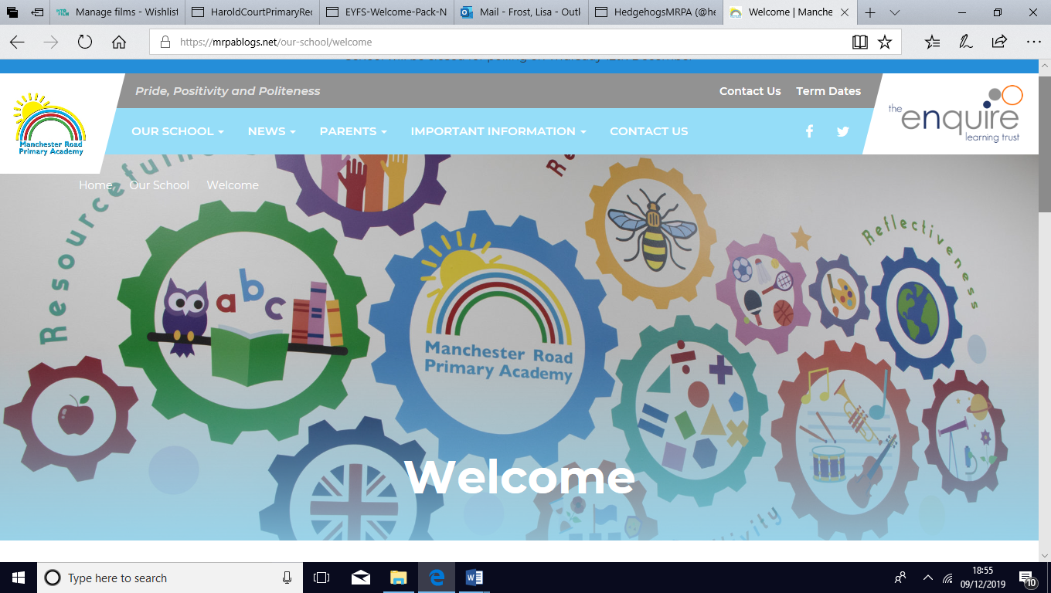
Contents
Admissions, places and fees 3-4
Facilities 5
Daily Routine, curriculum and uniform 6-8
Meet the Team 9
Celebrating Success 10
Supporting your child 11
Summary & Contact details 12
Admissions, Places and Fees
3 and 4 Year old Funded Places
When will my child start?
Your child is eligible for up to 15 hours of free early years provision per week, over 38 weeks per year. Your child will be eligible from the term after their third birthday.
Children Born Between | Spring Born  01 Jan to 31 Mar | Summer Born  01 Apr to 31 Aug | Autumn Born  01 Sep – 31 Dec
Becomes Eligible for a Funded Place | 1st April | 1st September | 1st January
If places are available your child can start as soon as they turn three . However because they are not yet entitled to a funded place you would need to pay for the sessions that they take.
Which sessions are available?
15 hour funded places These can be taken as:
Half Days
5 morning sessions | Monday – Friday 8:45 – 11:45am

30 hour funded places (Eligibility criteria apply)
Families where both parents work more than 16 hours each week (or earn more than £120 per week and not more than £100,000 a year) may be eligible for 30 hours of funded childcare.
Full Time 30 Hour Place

5 full days | Monday – Friday 8:45 – 3:15pm
*Additional cost of £11:25 per week
*Charges: Because of the lunchtime period 5 full days is in fact 32 ½ hours each week. So, a charge of £11:25 is made to cover the additional 2 ½ hours.
Priority for places is always given to funded children. However, when we are not full and places are available it is also possible to access much more flexible provision.
Families who are entitled to 30 hours may also choose to take a
29 Hour Place

4 full days | 8:45am – 3:15pm
1 half day session | 8:45am – 11:45am
*No additional charges as there are no additional hours

Families with a 15 hour entitlement can also purchase additional sessions as can families whose child is not yet eligible for a funded place. Below are our charges.
Additional Paid For Sessions |  | Charge (£4:00 per hour)
full day | 8:45 – 3:15pm | £24.00
half day session | AM 8:45 – 11:45am or  PM 12:15 – 3:15pm | £12.00
Lunchtime  *supervision only, meal not included.  School hot meal £1.50 per day | 11:45 – 12:15pm | Supervision and Lunch:  £2.50 per day  Supervision only:  £1.00 per day

We always aim to accommodate the needs of families whenever we can, including working in partnership with other providers, splitting funded hours between settings when needed. Please come and talk to us and we will try and come up with a mutually convenient plan.
Our experience tells us that children who go on to attend our school benefit from the time they spend in our school nursery and are well equipped to make a confident and happy start to full time school.
Information about eligibility and help with the cost of your childcare is available from:
Tameside Local Authority information:
https://www.tameside.gov.uk/earlyyears/elc
Government tax free childcare : https://childcare-support.tax.service.gov.uk/
Facilities
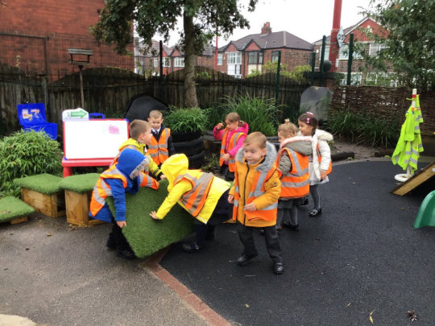
The Early Years department is comprised of two Reception classes (Hedgehogs and Rabbits) and one Nursery class (Little Owls) all centred around a shared café area. The children have access to the outdoor play area including new climbing frame, creative shelters, sand pits and bikes. We work hard to change and reinvent the outdoors throughout the year so keep your eyes peeled for new challenges and experiences.
We also have a brand new sensory room where the children have access to therapeutic sessions involving mindfulness strategies and sensory integration. This facility is very popular with the children from Early Years right up to year 6! At Manchester Road we pride ourselves on our inclusivity and ability to cater for all children, including those with additional learning, physical or emotional needs.
As part of our inclusive approach, children in Early Years have access to a range of skilled professionals and programs of support that enable us to create early interventions for those children who may need extra support.
If you feel your child may have a special educational need or disability (send) then please get in touch with the school office staff or the school SendCo.
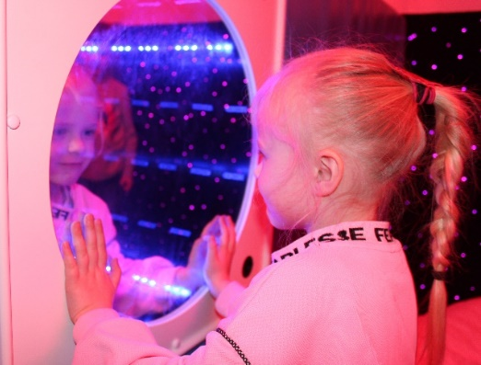
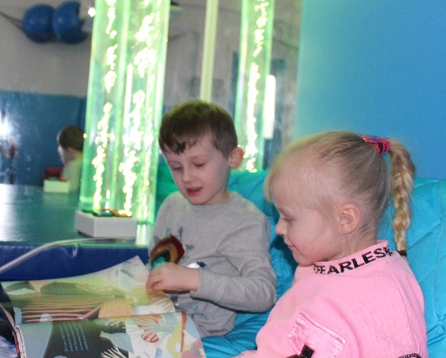
For more information of SEND please visit the Tameside Local Offer at https://www.tameside.gov.uk/localoffer or the school website.
Daily Routine, Curriculum and Staffing
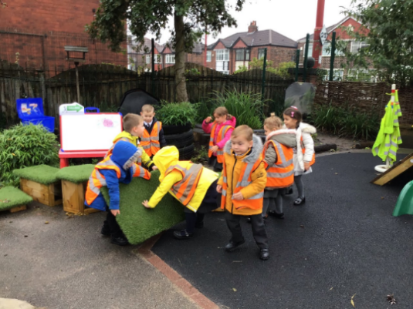
Morning session starts at 8.45am and finishes at 11.45am
Full day sessions start at 8.45am and finish at 3.15pm
Our Day
At 8.45am the children will come together as a group on the carpet for a short time. We hope that you will help them find their name card and even help them have a go at writing it! Once all parents have said their goodbyes, the Nursery teacher and support staff will begin singing the morning song. The children will then have the opportunity to choose from a range of activities across the settings. These activities are important in helping children to develop their skills across the curriculum. During these activities the practitioners will make observations, take photos of key learning and record assessments. You will have access to this at home through the website Tapestry. At different points during the day, the children may split into key worker groups for more focused work. During this time they may be learning Literacy, Numeracy or other areas of the Early Years Foundation Stage Curriculum.
Learning Outdoors: Play and learning are a key part of our provision. The children spend time everyday outside, whatever the weather! We have just made a huge investment in the outdoor equipment and we’ve even bigger ideas for this coming year.
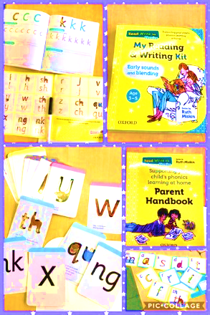
Snacks and Drinks: During the day the children have access to their very own children’s café. The children can choose from a variety of snacks, milk and water. Snack time is wonderful for developing self-care skills, independence and a social time for chats with friends.
Supporting you and your child: We know that parents are often keen to chat and find out about their child’s day and we encourage parents to do this. Your child’s safety is our first priority so we ask that parents wishing to speak to the teacher wait until the end of the day and when all of the children have been seen out safely. Parents can also contact the school office or use the Tapestry app to contact the teacher. During the morning, transition can be difficult for some children at first and we ask that messages are passed on to the adult on the door so that the children can have the undivided attention of the adults within the nursery.
The Curriculum
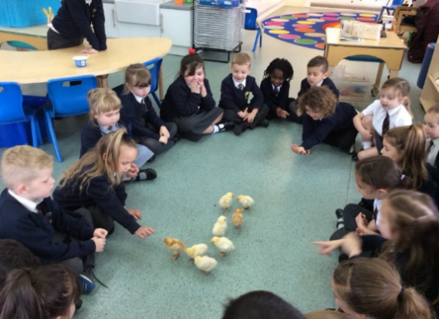
At Manchester Road we believe all learning should be fun and we aim to make our curriculum an exciting, challenging and engaging one. We follow the Early Years Foundation Stage Curriculum. This has seven areas of learning including three prime areas: Communication and Language, Physical Development and Personal, Social and Emotional Development; and four specific areas: Literacy, Mathematics, Understanding of the World and Expressive Arts and Design. These are taught through a wide range of different experiences and through topics which have been carefully planned to engage and interest the children. We will provide you with further information about the curriculum through topic webs sent home half termly and via our blog @Owls_MRPA @SpeechLangMRPA

Uniform
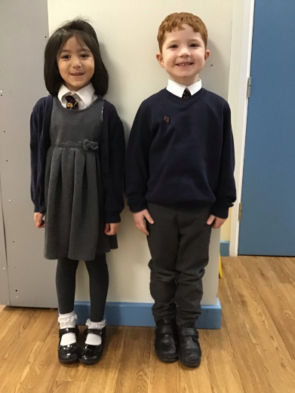
Our uniform is designed to be comfortable, practical, to promote independence and encourage our ‘Pride’ principal.
Children can wear:
- a white shirt or polo shirt
- a school tie
- a navy blue jumper or cardigan
- grey or black skirts/pinafores/dresses.
- Grey or black trousers or shorts
- Comfortable black shoes that promote independence
The children also have access to outdoor play every day, whatever the weather (safety permitting) and so please ensure they have:
- A coat with hood
- Hat (winter or sun hat)
- Wellies or waterproof shoes to play out.

Your child will also need a bag of named spare clothing on their peg every day. This is in case they get wet or do not make it to the toilet on time. If your child is not yet independent with their toileting then please inform the teaching staff. It is important that teaching staff are made aware as soon as possible to that toileting plans can be put into place, to support toilet training at home.
Uniforms are available from Panache Droylsden or visits https://myclothing.com/ueslink/24037.school?t=1587386195343

Meet the Team
We have a great team of experienced and talented staff. Here are some of the familiar faces in Early Years

Mrs Joanne Taylor Mrs Emma Brennan Mrs Lisa Frost,
Principal EYFS Leader & SendCo EYFS Co-ordinator,Teacher
,

Miss Jade Collinson Mrs Kayleigh Sheridan Mrs Sam Wagstaff
Nursery Teacher Owls Reception Teacher Rabbits Teaching Assistant

Mrs Mary Higginbotham Mrs Paula Hobin Mrs Rebecca Radford
HLTA Rabbits HLTA Hedgehogs HLTA Hegehogs

We also have on site:
*A Speech and Language therapist in school * Educational Psychology Services *School Counsellor *Pupil Support Services
Celebrating Success
At Manchester Road we aim to help foster a positive sense of self-esteem in all children and hope to nurture the whole child. We value the 3 principles of Pride, Positivity and Politeness as core values and our school behaviour policy is built on rewarding and promoting these qualities.
We promote positive behaviour learning powers encouraging the children to be resilient and keep trying even when things seems challenging and this starts within our Early Years. In class we have a ‘Rainbow Rules’ system where the children can be placed on the ‘extraordinary Zone’ to celebrate an amazing achievement.
Reward Systems
- Dojos- Online dojo system where you can track your child’s rewards.
- Learning Hero- a weekly award that goes to children who demonstrate positive learning behaviours that week
- Extraordinary Zone- An award to celebrate ‘=something amazing!
- Attendance Awards-For children who meet attendance targets

Assemblies and Performances:
The children in Nursery will take part in a class assembly during the Spring term. Reception and Nursery also perform a Nativity at Christmas.
Supporting your child at home
Helping your child get ready to start nursery.
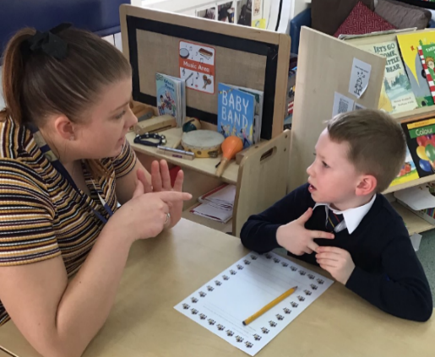
Starting nursery is an opportunity for your child to come to learn and develop in a new environment, making new friends, learning new skills and developing independence. Sometimes this can be an exciting and worrying time. There are things you can do to help prepare your child for a positive transition.
- Help your child to spot their teacher by showing them the photographs.
- Talk positively about Nursery
Attention and Listening: Share stories with your child and slowly build up the time they are able to sit and concentrate on this activity and any other activities you do with them.
Taking Turns: Encourage your child to share and take turns. Playing games are a wonderful and fun way of teaching this skill.
Independence: Encourage your child to start putting their coat and shoes on by themselves and independence with toileting. Encouraging them to ask for help when they need it.
Toileting: Although children do not have to be toilet trained to start at Nursery School it certainly helps them to engage with their learning and environment quicker. Consult with your health visitor for advice about how to start. If your child is still in pull ups when starting Nursery please make sure that the staff are aware. Regular toilet visits are part of the nursery routine.

Summary
Here is a brief summary of key information.
- Funded places start the term after your child’s 3rd birthday.
- Half (mornings) or full day sessions are available. You can usually pay for extra sessions.
- Your child needs a school uniform.
- Please provide a bag of spare (labelled) clothing
- Your child will be learning through play and this will be recorded in their Learning Journeys and online via Tapestry.
- Encourage your child to socialise (where possible) with others and encourage sharing and turn taking games.
- Talk positively to your child about Nursery School and familiarise them with their teachers.
Contacting Us
Please contact us if you have any questions, would like to talk about your child starting nursery or would like to look around the unit. We are always happy to help in any way we can.
It helps if you ring outside of sessions hours, before 8.45am or after 3.15pm and then we can arrange a convenient time to meet. Alternatively, you can ring during the school day and talk to the office staff who will help you in any way they can.
Telephone: 01613703079
Email:admin@mrpa.org.uk
School website: https://mrpablogs.net/

