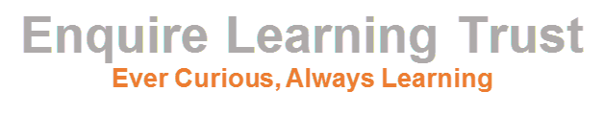
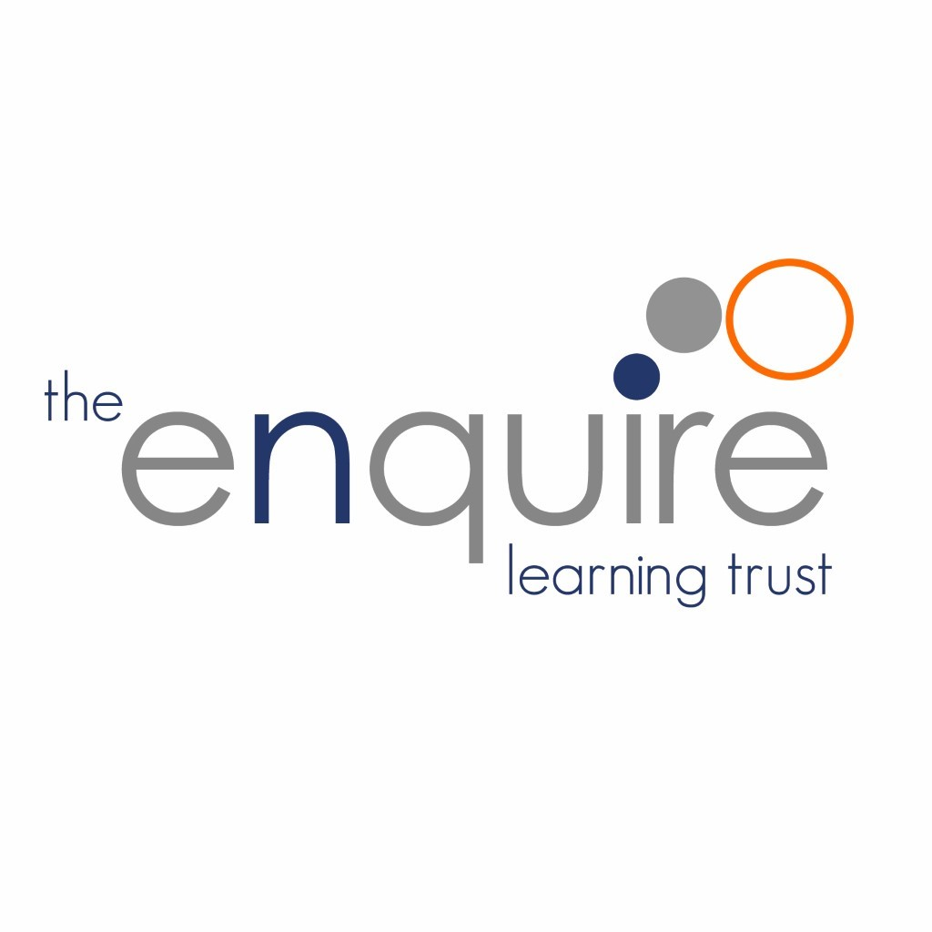
Sex and Relationships Policy 2023

Approved by: | Trustees
Last reviewed: | September 2023
Next review due by: | September 2026

Contents

1. | Aims | 3
2. | Statutory requirements | 3
3 | Policy Development | 4
4. | Definition | 4
5. | Curriculum | 4
6. | Delivery of RSE | 5
7. | Roles and Responsibilities | 6
8. | Parents’ right to withdraw | 6
9. | Training | 6
10. | Monitoring arrangements | 7
11. | Appendix 1: Curriculum map | 8
12. | Appendix 2: By the end of primary school pupils should know | 9
13. | Review of this Policy | 12

Version History

Date | Author | Version | Comment
Sept 2019 | J.Taylor | 1
Sept 2020 | J.Taylor | 2 | Review Sept 2023
Sept 2023 | J.Taylor | 3 | Review Sept 2026

1. Aims

The aims of relationships and sex education (RSE) in our Trust are to:
- Provide a framework in which sensitive discussions can take place
- Prepare pupils for puberty, and give them an understanding of sexual development and the importance of health and hygiene
- Help pupils develop feelings of self-respect, confidence and empathy
- Create a positive culture around issues of sexuality and relationships
- Teach pupils the correct vocabulary to describe themselves and their bodies.
- To ensure that the teaching of RSE correlates with the key principles of ‘Pride, Positivity and Politeness’ which underpin the ethos at Manchester Road.

2. Statutory requirements

As a Trust we must provide relationships education to all pupils as per section 34 of the Children and Social work act 2017.

We do not have to follow the National Curriculum but we are expected to offer all pupils a curriculum that is similar to the National Curriculum including requirements to teach science which would include the elements of sex education contained in the science curriculum.
In teaching RSE, we are required by our funding agreements to have regard to guidance issued by the secretary of state as outlined in section 403 of the Education Act 1996.
At The Enquire Learning Trust we teach RSE as set out in this policy.

This policy complies with our funding agreement and articles of association.

3. Policy development

This policy has been developed in consultation with staff, pupils and parents. The consultation and policy development process involved the following steps:
- Review – a Director pulled together all relevant information including relevant national and local guidance

- Staff consultation – all school staff were given the opportunity to look at the policy and make recommendations

- Parent/stakeholder consultation – parents and any interested parties were invited to attend a meeting about the policy

- Pupil consultation – we investigated what exactly pupils want from their RSE

- Ratification – once amendments were made, the policy was shared with governors and ratified

4. Definition
RSE is about the emotional, social and cultural development of pupils, and involves learning about relationships, sexual health, sexuality, healthy lifestyles, diversity and personal identity.
RSE involves a combination of sharing information, and exploring issues and values.
RSE is not about the promotion of sexual activity.

5. Curriculum
Our curriculum is set out as per Appendix 1 but we may need to adapt it as and when necessary.
We have developed the curriculum in consultation with parents, pupils and staff, taking into account the age, needs and feelings of pupils. If pupils ask questions outside the scope of this policy, teachers will respond in an appropriate manner so they are fully informed and don’t seek answers online.
Primary sex education will focus on:
- Preparing boys and girls for the changes that adolescence brings
- How a baby is conceived and born
For more information about our curriculum, see our curriculum map in Appendix 1.

6. Delivery of RSE.
RSE is taught within the personal, social, health and economic (PSHE) education curriculum. Biological aspects of RSE are taught within the science curriculum, and other aspects are included in religious education (RE).
Pupils also receive stand-alone sex education sessions which may be delivered by a trained health professional.
Relationships education focuses on teaching the fundamental building blocks and characteristics of positive relationships including:
- Families and people who care for me
- Caring friendships
- Respectful relationships
- Online relationships
- Being safe
For more information about our RSE curriculum, see Appendices 1 and 2.

These areas of learning are taught within the context of family life taking care to ensure that there is no stigmatisation of children based on their home circumstances (families can include single parent families, LGBT parents, families headed by grandparents, adoptive parents, foster parents/carers amongst other structures) along with reflecting sensitively that some children may have a different structure of support around them (for example: looked after children or young carers).

7. Roles and responsibilities
7.1 The Board of Trustees
The Trustees will approve the RSE policy, and hold the Principal to account for its implementation.
7.2 The Principal
The Principal is responsible for ensuring that RSE is taught consistently across the academy, and for managing requests to withdraw pupils from the non – statutory/non science components of RSE (see section 8).
7.3 Staff
Staff are responsible for:
- Delivering RSE in a sensitive way
- Modelling positive attitudes to RSE
- Monitoring progress
- Responding to the needs of individual pupils
- Responding appropriately to pupils whose parents wish them to be withdrawn from the [non-statutory/non-science] components of RSE
Staff do not have the right to opt out of teaching RSE. Staff who have concerns about teaching RSE are encouraged to discuss this with the Principal.
All class teachers are responsible for delivering the statutory, non – statutory and science elements of the RSE curriculum. There are named teachers and the inclusion leader who are responsible for delivering bespoke information to those families who need it. Examples of this may be the materials associated with LGBTQ. The Y6 team are trained in delivering the ‘Real Love Rocks’ program which tackles the issue of controlling relationships.

7.4 Pupils
Pupils are expected to engage fully in RSE and, when discussing issues related to RSE, treat others with respect and sensitivity.

8. Parents’ right to withdraw

Parents do not have the right to withdraw their children from relationships education.
Parents have the right to withdraw their children from the [non-statutory/non-science] components of sex education within RSE.
Requests for withdrawal should be put in writing using the form found in Appendix 3 of this policy and addressed to the principal Mrs Joanne Taylor.
Alternative work will be given to pupils who are withdrawn from sex education.

9. Training

Staff are trained on the delivery of RSE as part of their induction and it is included in our continuing professional development calendar.
The Principal will also invite visitors from outside the academy, such as school nurses or sexual health professionals, to provide support and training to staff teaching RSE.

10. Monitoring arrangements

The delivery of RSE is monitored by the Principal through: enquiries and lesson observations.
Pupils’ development in RSE is monitored by class teachers as part of our internal assessment systems.
This policy will be reviewed by the Board of Trustees annually.

11. Appendix 1: Curriculum map
Relationships and sex education curriculum mapping
Year Group
EY | How do we keep healthy? Good Diet, exercise, sleep. | What makes a good healthy diet?  What foods do we enjoy?  What are the food groups and which things from food groups do we like? Dislike? | What exercise do we do? Which do we like? What can we do without equipment? | Why is exercise good? Keeps you fit and healthy and strong. | How do we know how we are feeling? What feelings are there? Happy, sad worried, excited. | What things make us happy/ sad/ worried?  What things make our friends or family happy/ sad.  How do we know? | What can we do if someone is feeling sad or worried?
EY | Who are the people special to us? Family and friends who we see a lot. | Who is in our families? | Which other people are important but are not family/ friends? | How do we show people we care? What do our families do for us that show they care? | How do we make good friends in school?  Talking, smiling, helping. | What do good friends do? What things do we do with friends?  Talking, helping us feel better. | What do we do if we fall out with people? How do we make things better?
EY | What things happen to us sometimes that make us feel sad or hurt? | What does it feel like if someone is unkind?  Where might this happen? | What would you do if someone was unkind lots and lots and you wanted it to stop? | What is a stranger? | What do you do if someone asks you to do something you do not want to do? Playing a game, going somewhere you don’t want to go? | What can you do if someone does something you do not like. | How do we play nicely with everyone?  How do we show we are part of a team?
EY | How do we keep safe in school? What are our rules? Why do we have them? | How do we keep safe at home? What things could happen? How do we stop it? | What to do if you see something you do not like on the computer or device at home or in school. | Which people have jobs that are there to help us?
EY | How do we care for ourselves and keep ourselves safe? | Who/ what else do we care for? animals, younger children, people who may need help. | How can we look after our classroom and school? | How can we help to look after the wider world? | Who are people with responsibilities in our community? | What kinds of jobs do people have who we know? Why do we go to work? To earn money… Why do people need money?
EY | What makes me special? We are all different but amazing! | What makes people around us special? Celebrate the differences in each other. | What do we do when things get hard? | SRE | SRE | SRE
1 | Healthy lifestlyes and mental health  How to keep healthy – diet, exercise, mental health and sleep | Healthy lifestyles and mental health  Different food groups and what nutrients they have. | Healthy lifestyles and mental health  How do we relax? Why is relaxing important? | Healthy lifestyles and mental health  What happens when we feel sad or down? What can we do to feel better? | Healthy lifestyles and mental health  Managing big feelings – what are big feelings and what happens to our bodies when these feelings occur? | Healthy lifestyles and mental health  Managing big feelings – what can we do to help when feelings get big? Who are the people we trust to help us?
1 | Relationships:  Identify family members, people who love and care for us.  Harvest  Anti – Racism Day | Relationships:  Roles of different people – close family, other family members, friends. How do they show up in our lives? | Relationships:  Identify features of common family life – feeling safe and secure, a sense of belonging, loved and cared for, can talk to them | Relationships:  How to share if you are unhappy or worried, who to report to | Relationships:  What makes a good friendship | Relationships:  How to resolve an argument
1 | Relationships  What is bullying? How to identify feelings that hurt including words and actions. | Relationships  How do people feel if they are being bullied? What can bullying look like? | Relationships  How we can report bullying and what do we expect to happen. | Relationships  How do we respond to strangers? How do we know if people we don’t know are safe? | Relationships  What kind of physical contact is safe? How do we know? What to do if any physical contact feels unsafe.
1 | Keeping safe, including drug education  How you can stay safe at home | Keeping safe, including drug education  People who help to keep us safe and what to do in an emergency. | Keeping safe, including drug education  What dangers are there on line? How do you report if you feel uncomfortable about what you see/hear on line? | Keeping safe, including drug education  Road Safety
1 | Healthy me:  Being physically active | Healthy me:  Keeping safe | Healthy me:  Being a good friend. | Healthy me:  Keeping calm and dealing with a situation. | Ourselves, changing and growing:  To talk about what makes us special and unique. | Ourselves, changing and growing:  What I’m good at, what I like and dislike | Ourselves, changing and growing:  How to manage when finding things difficult
1 | Ourselves, changing and growing:  Naming the parts of the body, including external genitalia (penis, vagina) | Ourselves, changing and growing:  Biological differences between male and female babies. | Ourselves, changing and growing:  To know that body parts are private. NSPCC Pants Rules. | Ourselves, changing and growing:  Changes happen when growing from young to old. How people’s needs change. | Ourselves, changing and growing:  Prepare to move to a new class/year group. | SRE  How to keep clean and Hygiene  Difference between girl babies and boy babies  How babies grow to adults. | SRE  Different types of families and asking for help
2 | Healthy Lifestyles and Mental Health:  ZOR language around feelings. Big feelings can be managed in different ways. E.g. loss  Asking for help with feelings and who to ask. | Healthy Lifestyles and Mental Health: How activities affect our mental health.  Ways in which people can relax and feel good  Limiting device time.  . | Healthy Lifestyles and Mental Health:  Spreading germs and how to stop it. Washing hands effectively. | Healthy Lifestyles and Mental Health:  Medicines and vaccines.  Regular medications for everyday needs e.g allergies. Importance of adult supervision. | Healthy Lifestyles and Mental Health:  How to brush teeth and foods that support oral health | Healthy Lifestyles and Mental Health:  Sun safety – SPF, clothing and protective wear, hydration | Harvest  Anti – Racism Day
2 | Relationships:  Who cares for us? Family members and their different roles | Relationships:  Different types of family. What type of family do we have? | Relationships:  What kind of things make us worry? Who do we talk to if we are worried? How does being worried make us feel? | Relationships:  How to get help if a friendship is making you feel unhappy. | Relationships:  People who have different roles around us – family, friends, people in society.
2 | Relationships:  What is bullying? What are the actions that hurt – including words and actions? | Relationships:  How do people feel if they are being bullied? | Relationships:  What can you do if you feel you or someone else is being bullied. | Relationships:  NSPCC Pants rule. Safe touch and contact. | Relationships:  What kind of contact is good? What can feel uncomfortable?  Asking for permission. | Relationships:  Who to talk to if you feel unhappy or uncomfortable about something that is happening to you.
2 | Keeping safe, Including drugs and alcohol  What rules are in place and age restrictions to keep us safe | Keeping safe, Including drugs and alcohol  How to keep safe at home – including medicines and cleaning products. | Keeping safe, Including drugs and alcohol  How do we keep safe when out and about?  Beach, swimming pool, on the street. | Keeping safe, Including drugs and alcohol  How do we keep safe on line? | Keeping safe, Including drugs and alcohol  What things can happen on line that make us unsafe. Who to tell. | Keeping safe, Including drugs and alcohol  How do we get help in an emergency?
2 | Living in the wider world  Where do we find rules, and why do we need them? | Living in the wider world  How do we care for living things? What are our responsibilities in this? | Living in the wider world  How do we look after the environment? | Living in the wider world  What is money and how do we pay for things? | Living in the wider world  What do we do if we want things but don’t have the money?  Saving
2 | Ourselves, Changing and Growing  What makes us unique? How do we celebrate the things that are different? | Ourselves, Changing and Growing  What things are you good at and what to do if things get hard. BLP | Ourselves, Changing and Growing  How do we identify if animals are male of female. Stereotypes and tackling these. | Ourselves, Changing and Growing  Different body parts. How bodies change over time and how people need different things as they get older. | Ourselves, Changing and Growing  How bodies change over time and how people need different things as they get older. | SRE  Male and female stereotypes and how to challenge them. | SRE  Naming body parts and differences between male and female animals.  How a new life is created.
3 | Healthy lifestyles and mental health:  Making choices on keeping healthy. Food and exercise. | Healthy lifestyles and mental health:  Habits. What is a habit? Recognise good and bad habits. | Healthy lifestyles and mental health:  Healthy diets – varied nutrition, beneficial to health. Risks of unhealthy diet (obesity, tooth decay) | Healthy lifestyles and mental health:  Regular exercise – mental and physical health benefits, opportunities to exercise | Healthy lifestyles and mental health:  Everyday hygiene, spread of infection | Healthy lifestyles and mental health:  Medication | Harvest  Anti – Racism Day
3 | Relationships  Different types of relationship – friends, family, romantic, online | Relationships:  Different types of relationships – family and friends, including thise on line. | Relationships:  Features of family life and how we show care for each other. | Relationships:  Different types of family: single parent, adoptive, same sex. | Relationships:  What makes a positive friendship? Why are friendships so important? | Relationships:  What to do if friendships go wrong. Who can help and how ca we sort out problems?
3 | Relationships:  What is bullying?  Types of bullying on and off line. | Relationships:  What kind of behaviour can be hurtful? | Relationships:  What things do we like to keep private?  What are boundaries?  How do we give consent? | Relationships:  How to respond to strangers.  Permission and consent. | Relationships:  What to do if you do not feel comfortable.  Where to get help and support if needed.
3 | Keeping Safe:  What are rules and why do we follow them? | Keeping safe:  Taking medicines correctly. | Keeping safe:  Hazards inside and outside the home. | Keeping safe:  How to keep personal information safe.
3 | Living in the wider world:  Relationship between rights and responsibilities | Living in the wider world:  What groups make up a community?  How do we show compassion and care for others? | Living in the wider world:  How can we help protect the environment? | Living in the wider world:  How do we pay for things?  The difference between wanting and needing things. | Living in the wider world:  What do we do if we want things but do not have the money?
3 | Ourselves, changing and growing:  Identify features of personal identity (ethnicity, gender, faith, family, personality) | Ourselves, changing and growing:  Identify personal strengths, aspirations and interests and how these contribute to self-worth | . Ourselves, changing and growing:  Ways of managing setbacks and perceived failure, how to re-frame unhelpful thinking (BLP) | Ourselves, changing and growing:  Identify external genitalia of males and females and know why these are private. Understand that not everyone identifies with biological sex. | Ourselves, changing and growing:  Changes – physical and emotional approaching puberty. Basic hygiene and importance of keeping clean. | Ourselves, changing and growing:  Touch, personal space and speaking up when feeling uncomfortable | Ourselves, changing and growing:  Changes and transition to a new class
3 | Ourselves, Changing and Growing:  SRE  Naming different body parts of males and females using agreed words. | Ourselves, Changing and Growing:  SRE  Appropriate touch and personal space. Who to ask for help and how to keep safe. | Ourselves, Changing and Growing:  SRE  How to resist pressure and report if things are uncomfortable or do not feel safe. | Ourselves, Changing and Growing:  Different types of relationships in families and different partnerships – marriage, civil.
4 | Healthy Lifestyles:  To make healthy choices: diet, exercise, sleep, | Healthy Lifestyles:  Positive and negative habits we can form which impact health. | Healthy Lifestyles:  Change4 life snack swaps and advice cards.  Children taste some healthy snacks and evaluate. | Healthy Lifestyles:  The importance of sleep and how we can prepare for a good sleep. | Healthy Lifestyles:  What are good hygiene practices: washing hands, preparation of food, containing germs (sneezing etc…) | Healthy Lifestyles:  Protecting from the sun. What harm can sun rays cause and how we can keep safe in the sun. | Harvest  Anti – Racism Day
4 | Relationships  Different types of family: friendships, close family, distant family. What is a romantic relationship. | Relationships  Different types of family? Same – sex families, adoptive families, step – families, single parent families. | Relationships  Features of family life – what do people do as families to show they care for each other? | Anti – Bullying week | Relationships  What makes a positive friendship? What would this look and fee like?  What might it look and feel like is it was not positive? | Relationships  How do we ask for help with friendships? What might we do to resolve problems?
4 | Relationships:  Bullying – what is it?  Focus on what bullying on line may look like. | Relationships:  What is meant by discrimination?  Respectful behaviour. | Relationships:  How do we respond to strangers? Where might we meet strangers? | Relationships:  Consent and respectful behaviours.
4 | Keeping Safe:  Where do we find rules around us? Why do we need rules? | Keeping Safe:  What are the rules for medicines and cigarettes/ alcohol? Why are these in place? | Keeping Safe:  Organisations that can help with substance use. | Keeping Safe:  How do we keep personally safe? Outdoors? Personal information.
4 | Living in the wider world:  Relationships between rights and responsibilities. | Living in the wider world:  Hoe do we show compassion and care?  Protecting the environment. | Living in the wider world:  What groups make up our community? Charitable groups and activist groups. | Living in the wider world:  What can I recognise as my strengths and the positive things about me?  Dealing with setbacks | Living in the wider world:  How people spending money can have an impact on the world: fairtrade, plastics etc..
4 | Ourselves, changing and growing:  What are our personal identities?  Faith, gender, hobbies etc.. | Ourselves, changing and growing:  What is prejudice and how do celebrate differences? | Ourselves, changing and growing:  Recognising diversity in our class community and the wider community. | Ourselves, changing and growing:  SRE  How bodies change through puberty and basic facts about puberty. | Ourselves, changing and growing:  SRE  How emotions can change through puberty and how you can use strategies to help. | Ourselves, changing and growing:  SRE  How puberty is linked to reproduction and life cycles.
5 | Healthy Lifestyles and Mental Health:  Mental health and ill health. Warning signs. | Healthy Lifestyles and Mental Health:  Supporting own mental health – wellbeing (5 steps) | Healthy Lifestyles and Mental Health:  Importance of discussing feelings, identifying people to talk to, vocabulary for a range. | Healthy Lifestyles and Mental Health:  Expressing emotions. Strategies in response to intense and conflicting feelings. | Healthy Lifestyles and Mental Health:  Conflict. Strategies and steps of restorative practice. | Healthy Lifestyles and Mental Health:  Change and loss as a part of life.  Responding to changes and challenges. | Healthy Lifestyles and Mental Health:  Death, grief and bereavement.
5 | Healthy Lifestyles and Mental Health:  To know how and when to seek support for themselves or others. | Relationships:  Different types of relationships – family, friends, romantic, on – line. How are these the same and different? | Relationships:  Different types of romantic relationships – How people can be attracted to others of the same sex (use Proud materials) | Relationships:  What is the difference between on – line and off – line relationships? | Anti – Bullying Week | Relationships  What does a healthy friendship look like? | Relationships  What can you do if you feel a relationship is not positive? Who do you ask for help?
5 | Relationships:  What is bullying and what impact does it have on people? | Relationships:  What is respectful behaviour and how do we show respect? What is discrimination. | Relationships:  Recognise different types of physical contact – what is acceptable and what is not. | Relationships:  Consent and what is appropriate and not appropriate contact. | Relationships:  Recognising pressure and responding to it. | Relationships:  Where people can get advice and support for themselves and for others.
5 | Keeping Safe:  How to keep personal information private. What personal information may they have now? When they are older? | Keeping Safe:  Organisations that can help people with drug and substance use. | Keeping Safe:  Basic First Aid
5 | Living in the wider world:  Recognise the need for rules in society, and how systems are in place to protect us. | Living in the wider world:  What are Human Right?  What are Children’s rights? | Living in the wider world:  How do our choices impact the environment and what can we do to help? | Living in the wider world:  What are stereotypes and prejudices?  Protected characteristics. | Living in the wider world:  How to keep track of money and make choices about what to spend/ how to pay for things | Living in the wider world:  Risks associated with money – how it can be lost/ stolen and the impact of this on emotions and physical well – being.
5 | Ourselves, changing and Growing:  What is personal identity?  Celebrating differences and individual qualities. | Ourselves, changing and Growing:  How do we manage setbacks and perceived failures? | Ourselves, changing and Growing:  SRE  Changes in physical and emotional presentation during puberty. | Ourselves, changing and Growing:  SRE  Understanding the reproductive cycle in girls and how reproduction takes place. | Ourselves, changing and Growing:  SRE  Caring about other people’s feelings. What behaviour and touch is appropriate. How to report concerns about feeling safe.
6 | Healthy Lifestyles and Mental Well Being:  What is a healthy lifestyle? What and who can effect the lifestlyes we choose? | Healthy Lifestyles and Mental Well Being  What good and bad habits can be formed? Why are they good/ Bad | Healthy Lifestyles and Mental Well Being  What makes us ill? Bacteria/ viruses. How do we know when we are becoming physically ill? What do we do about it? | Healthy Lifestyles and Mental Well Being:  How we can prevent the spread of disease and viruses? How do we treat them? Medicines and safety. | Healthy Lifestyles and Mental Well Being:  Sun safety and the damage sunshine can do. | Healthy Lifestyles and Mental Well Being  Mental health is a part of daily life. We can help keep good mental health through the 5 steps (NHS). | Healthy Lifestyles and Mental Well Being:  Expressing feelings in different ways and dealing with conflict.  Process or restorative practice.
6 | Relationships:  Naming different relationships in your life – which of these are really important? Why? | Relationships:  Different types of romantic relationships – including on – line and same – sex. | Relationships:  Gender re – orientation: what is it and what does it mean for people? | Relationships:  Managing peer influence – what might influences look and feel like? Recognising positive influences and negative ones. | Relationships:  What is forced marriage?  How can you get help for yourself or others if you feel this is happening. | Relationships:  FGM – Brief overview and where to get help if you feel this may have happened to you or anyone you know.
6 | Relationships:  Different types of bullying – including discriminationhow to recognise these and how they make people feel. | Relationships:  Acting against bullying – what action can you take? | Relationships:  Privacy and boundaries – different types of physical contact. What is acceptable and what is not. How to respond to this. | Relationships:  What things might we have to give consent to? What type of consent is there? | Relationships:  What to do if you feel physical contact is not appropriate? What help is available?
6 | Keeping safe:  How do we manage risks? What risks may the children face as teens? As adults?  What role does peer pressure play in this? | Keeping safe:  Risks of alcohol and drug abuse – impact on finance, mental health, physical health, social well – being. | Keeping safe:  What are the mixed messaged about drugs and alcohol/ vaping? What do adverts look like? What might peers say? | Keeping safe:  Who are the organisations who can help with drug and substance misuse?
6 | Living in the wider world:  What are the rules and laws that we have to follow? Why are these in place?  Human rights | Living in the wider world:  How everyday decisions can effect the environment and how we can help protect them. | Living in the wider world:  What are stereotypes, discrimination and how do we challenge this? | Living in the wider world:  Planning for spending – what does a budget look like and how do people make choices? | Living in the wider world:  Jobs and careers – what does futher and higher education look like in the UK?
6 | Ourselves, moving and growing  What is people’s personal identity?  Gender and gender identity. | Ourselves, moving and growing:  Recognising strengths in ourselves and other people. | Ourselves, moving and growing  SRE  Knowing how and why bodies change through puberty and the agreed language to describe this. | Ourselves, moving and growing  SRE  Conception and pregnancy. Decisions that need to be considered before having a baby. | Ourselves, moving and growing  SRE  Positive and negative ways of communicating when in a relationship. | Ourselves, moving and growing  SRE  Keeping safe in the community and on line.
6 | Transition Activities – Dealing with change | Transition Activities – Dealing with change | Transition Activities – Dealing with change

12. Appendix 2: By the end of primary school pupils should know
Topic | Pupils should know
Families and people who care about me | - That families are important for children growing up because they can give love, security and stability  - The characteristics of healthy family life, commitment to each other, including in times of difficulty, protection and care for children and other family members, the importance of spending time together and sharing each other’s lives  - That others’ families, either in the academy or in the wider world, sometimes look different from their family, but that they should respect those differences and know that other children’s families are also characterised by love and care  - That stable, caring relationships, which may be of different types, are at the heart of happy families, and are important for children’s security as they grow up  - That marriage represents a formal and legally recognised commitment of two people to each other which is intended to be lifelong  - How to recognise if family relationships are making them feel unhappy or unsafe, and how to seek help or advice from others if needed
Caring friendships | - How important friendships are in making us feel happy and secure, and how people choose and make friends  - The characteristics of friendships, including mutual respect, truthfulness, trustworthiness, loyalty, kindness, generosity, trust, sharing interests and experiences and support with problems and difficulties  - That healthy friendships are positive and welcoming towards others, and do not make others feel lonely or excluded  - That most friendships have ups and downs, and that these can often be worked through so that the friendship is repaired or even strengthened, and that resorting to violence is never right  - How to recognise who to trust and who not to trust, how to judge when a friendship is making them feel unhappy or uncomfortable, managing conflict, how to manage these situations and how to seek help or advice from others, if needed
Respectful relationships | - The importance of respecting others, even when they are very different from them (for example, physically, in character, personality or backgrounds), or make different choices or have different preferences or beliefs  - Practical steps they can take in a range of different contexts to improve or support respectful relationships  - The conventions of courtesy and manners  - The importance of self-respect and how this links to their own happiness  - That in the academy and in wider society they can expect to be treated with respect by others, and that in turn they should show due respect to others, including those in positions of authority  - About different types of bullying (including cyberbullying), the impact of bullying, responsibilities of bystanders (primarily reporting bullying to an adult) and how to get help  - What a stereotype is, and how stereotypes can be unfair, negative or destructive  - The importance of permission-seeking and giving in relationships with friends, peers and adults
Online relationships | - That people sometimes behave differently online, including by pretending to be someone they are not  - That the same principles apply to online relationships as to face-to face relationships, including the importance of respect for others online including when we are anonymous  - The rules and principles for keeping safe online, how to recognise risks, harmful content and contact, and how to report them  - How to critically consider their online friendships and sources of information including awareness of the risks associated with people they have never met  - How information and data is shared and used online
Being safe | - What sorts of boundaries are appropriate in friendships with peers and others (including in a digital context)  - About the concept of privacy and the implications of it for both children and adults; including that it is not always right to keep secrets if they relate to being safe  - That each person’s body belongs to them, and the differences between appropriate and inappropriate or unsafe physical, and other, contact  - How to respond safely and appropriately to adults they may encounter (in all contexts, including online) whom they do not know  - How to recognise and report feelings of being unsafe or feeling bad about any adult  - How to ask for advice or help for themselves or others, and to keep trying until they are heard  - How to report concerns or abuse, and the vocabulary and confidence needed to do so  - Where to get advice e.g. family, academy and/or other sources

13. Appendix 3: Parent form: withdrawal from Sex Education within RSE
Parents can request a pupil is withdrawn from the sex education component up until 3 terms before the young person’s 16th birthday.

To be completed by parents
Name of child |  | Class
Name of parent |  | Date
Reason for withdrawing from the sex education component within Relationships and Sex Education
Any other information you would like the school to consider
Parent signature

To be completed by the school
Agreed actions from discussion with parents

13. Review of this Policy

Trustees to review this policy every 3 years. It may however review this policy earlier than this if the government produces new regulations, or if it receives recommendations on how this policy might be improved

