Maths Calculation Policy
At Manchester Road we ensure children are taught skills at an appropriate level for their ability. Throughout their time at school, children are taught following the concrete pictorial abstract technique, focussing on developing written methods by the time they leave school.
Children are taught new methods appropriate to their year group and curriculum content; however teachers enable children to use methods from previous year groups, when it is appropriate. Children are not moved on to the next stage in the sequence of learning until they are secure in the methods they have previously been taught. Teachers are able to assess this by completing Ready to Progress assessments from the previous year group before planning a new unit of learning.
The tables below outline when a new method or technique is introduced. Children are taught methods from previous year groups and their current year group.

Addition
Early Years
- Have a deep understanding of number to 10, including the composition of each number
- Subitise (recognise quantities without counting) up to 5
- Automatically recall (without reference to rhymes, counting or other aids) number bonds up to 5 and some number bonds to 10, including double facts
- Explore and represent patterns within numbers up to 10, including evens and odds, double facts and how quantities can be distributed equally.
Practical Visuals  Tens frames  Counters  Number Line  Numicon  Counting objects  Part part whole  Hands |   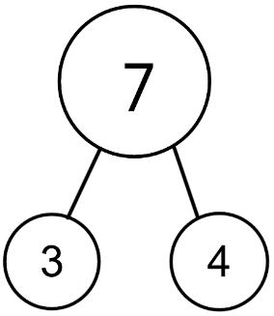    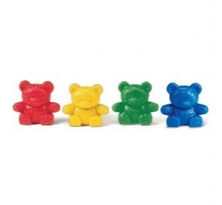  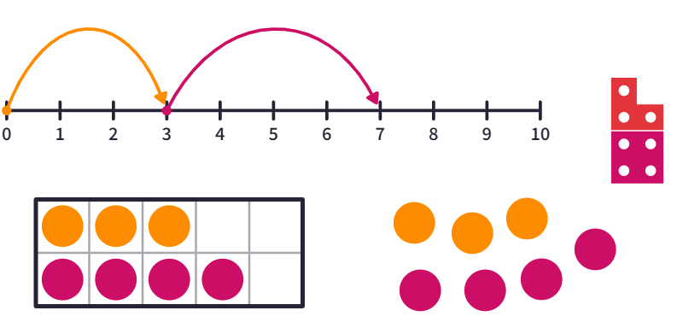
Year 1
- read, write and interpret mathematical statements involving addition (+) and equals (=) signs
- represent and use number bonds within 20
- add one-digit and two-digit numbers to 20, including zero
Addition statements  Rekenreks  Dienes  Counting on | 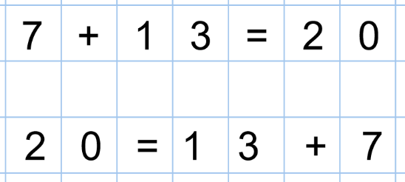  `  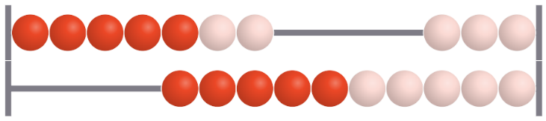  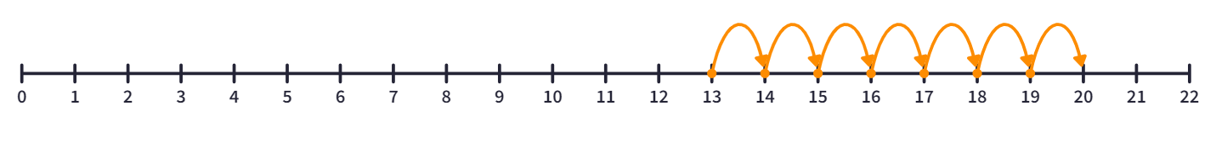  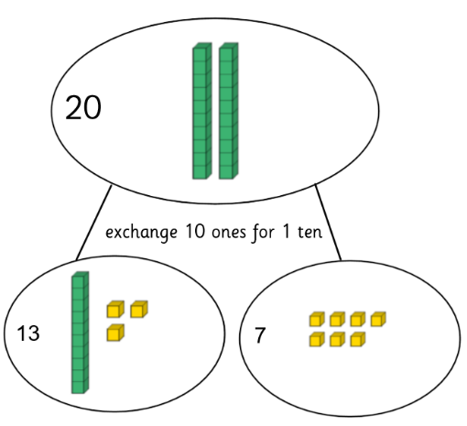
Year 2
- recall and use addition facts to 20 fluently, and derive and use related facts up to 100
- add numbers using concrete objects, pictorial representations, and mentally, including:
-a two-digit number and ones
-a two-digit number and tens
-two two-digit numbers
-adding three one-digit numbers
Part part whole  Tens frame dienes  Column addition  Children will use their knowledge of number bonds to 10 and doubles to support their mental addition strategies. | a two-digit number and ones
 | 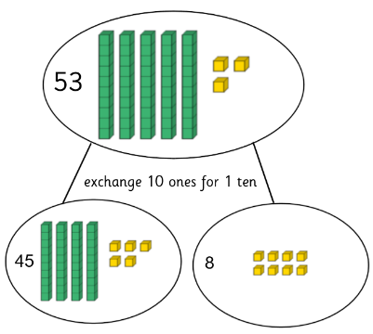  45+8= | 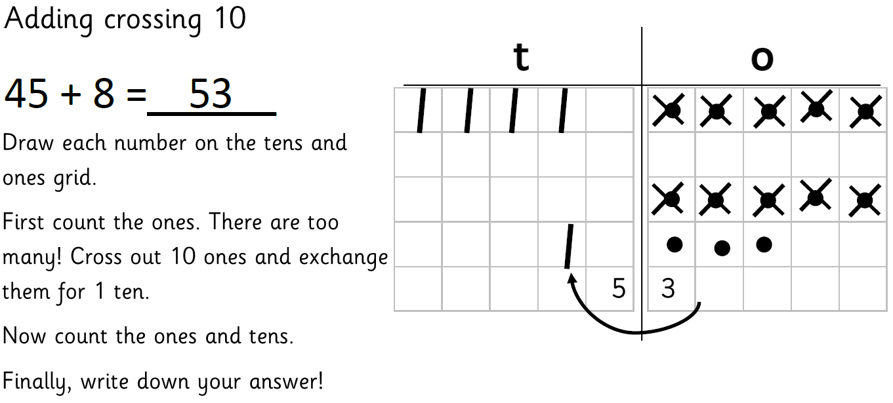 |  | 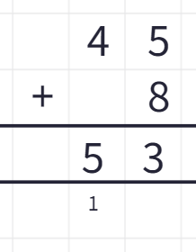
 | a two-digit number and tens
 | 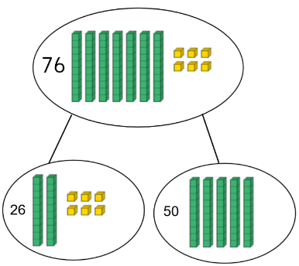  26+50= | 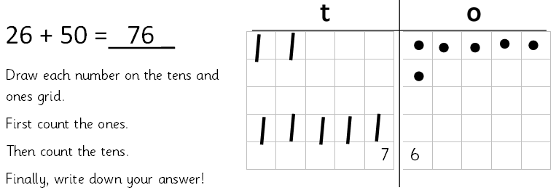 |  | 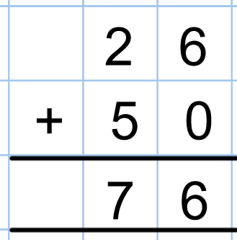
 | two two-digit numbers
 | 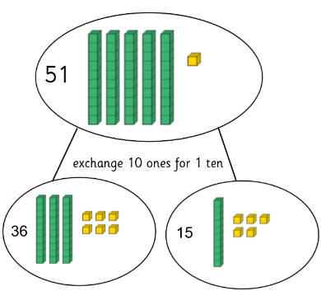  36+15= | 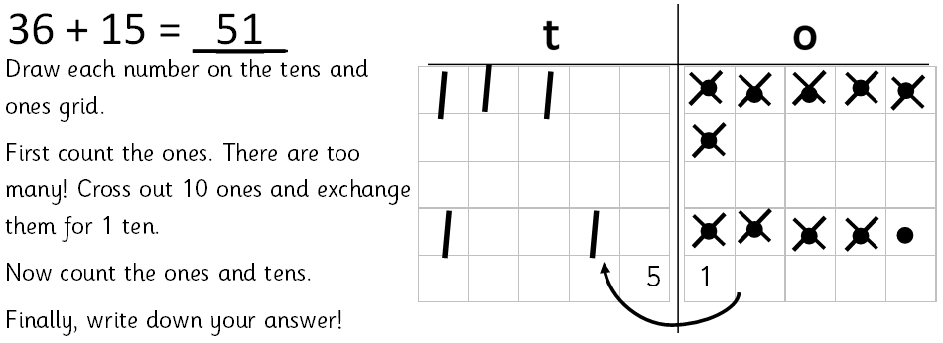 |  | 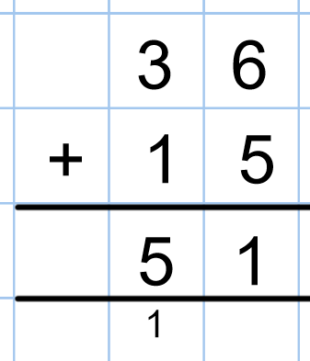
Year 3
- add numbers with up to three digits, using formal written methods of columnar addition
Year 4
- add numbers with up to 4 digits using the formal written methods of columnar addition where appropriate
HTO frame – Place Value counters  Column addition | add numbers with up to three digits
 | 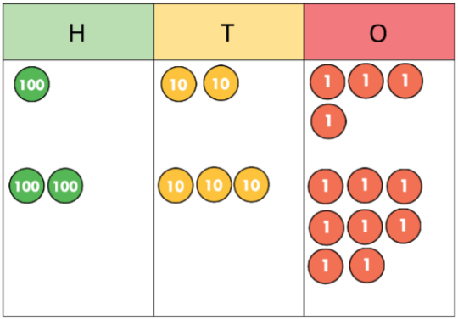  124 + 238 = 362  exchange 10 ones for 1 ten |  | 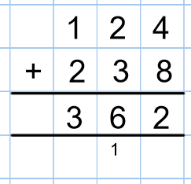
 | add numbers with up to four digits
 | 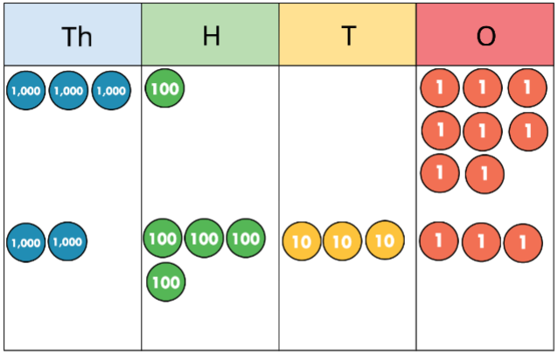  3108 + 2433 = 5541  exchange 10 ones for 1 ten |  | 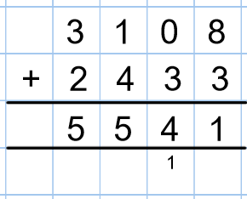
Year 5 and 6
- add whole numbers with more than 4 digits, including using formal written methods (columnar addition)
Column addition | 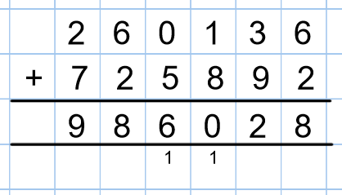  260,136 + 725,892 = 986,028
Subtraction
Early Years
- Have a deep understanding of number to 10, including the composition of each number
- Subitise (recognise quantities without counting) up to 5
- Automatically recall (without reference to rhymes, counting or other aids) number bonds up to 5 (including subtraction facts) and some number bonds to 10, including double facts
- Explore and represent patterns within numbers up to 10, including evens and odds, double facts and how quantities can be distributed equally.
Practical Visuals  Tens frames  Counters  Number Line  Numicon  Counting objects |  | 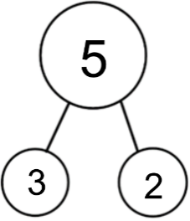  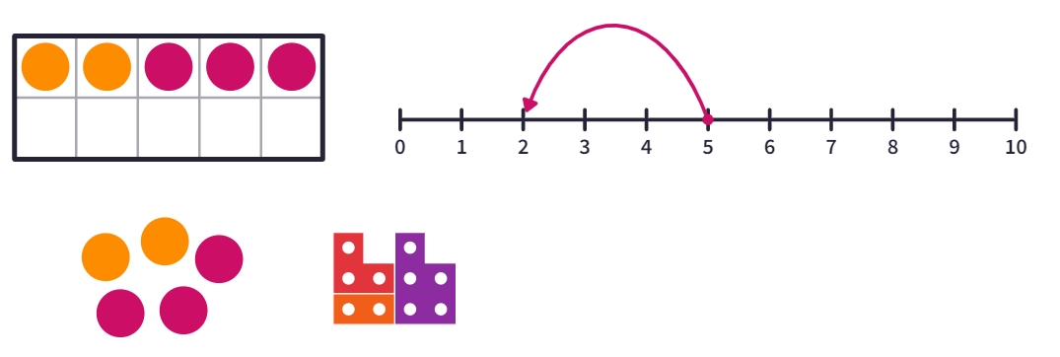  
Year 1
- read, write and interpret mathematical statements involving subtraction (–) and equals (=) signs
- represent and use number bonds and related subtraction facts within 20
- subtract one-digit and two-digit numbers to 20, including zero
Subtraction statements  Rekenreks  Dienes  Counting back | 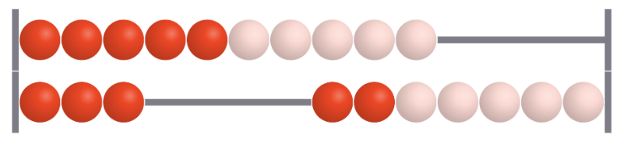  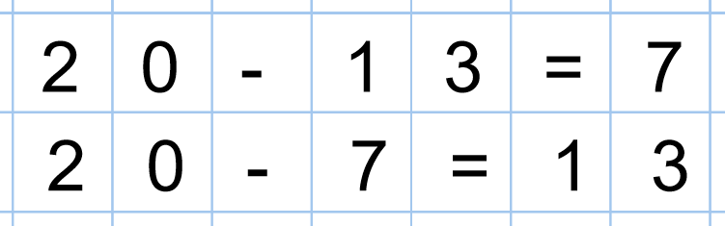  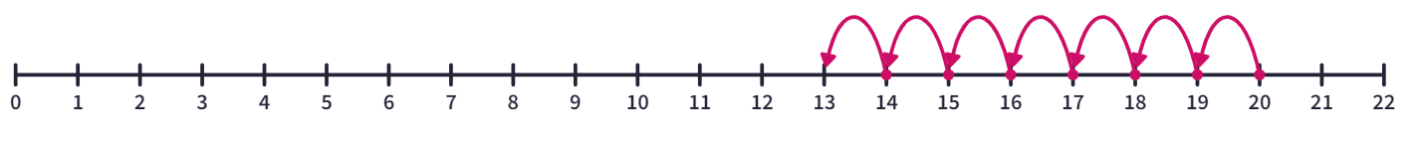  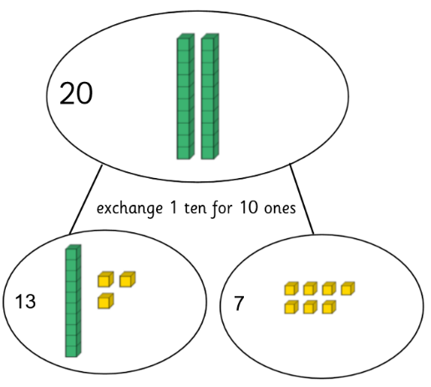
Year 2
- recall and use subtraction facts to 20 fluently, and derive and use related facts up to 100
- subtract numbers using concrete objects, pictorial representations, and mentally, including:
-a two-digit number and ones
-a two-digit number and tens
-two two-digit numbers
Part part whole  Tens frame – dienes  Column subtraction | a two-digit number and ones
 | 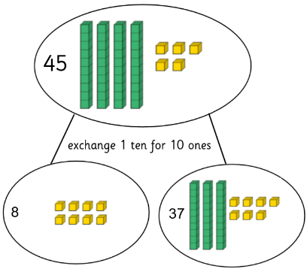  45-8= |  | 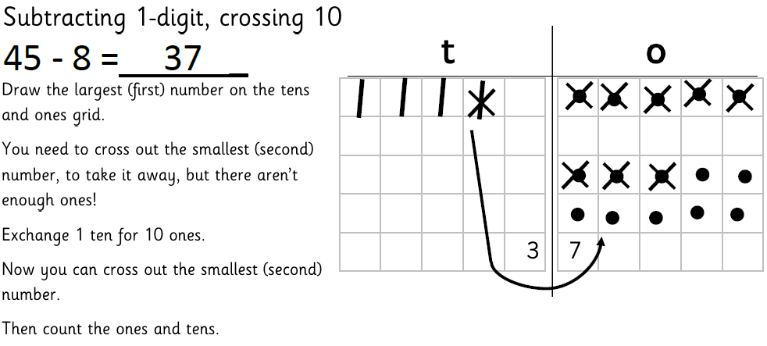 |  | 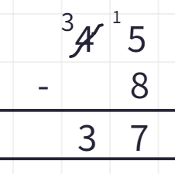
 | a two-digit number and tens
 | 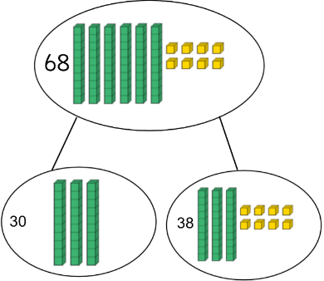  68-30= |  | 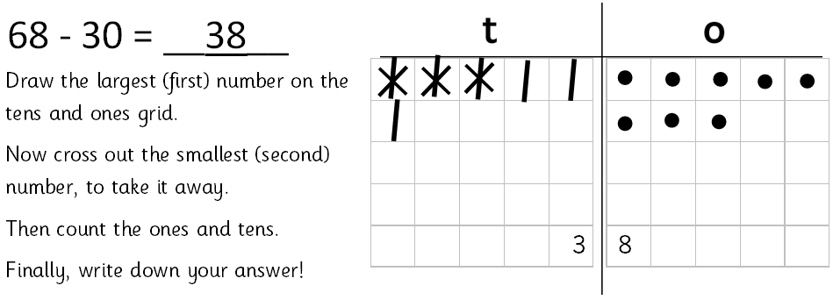 |  | 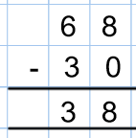
 | two two-digit numbers
 | 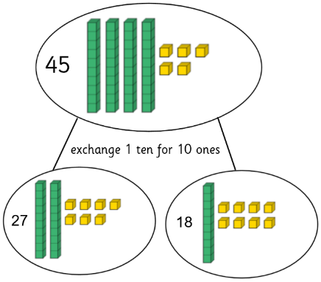  45-27= |  | 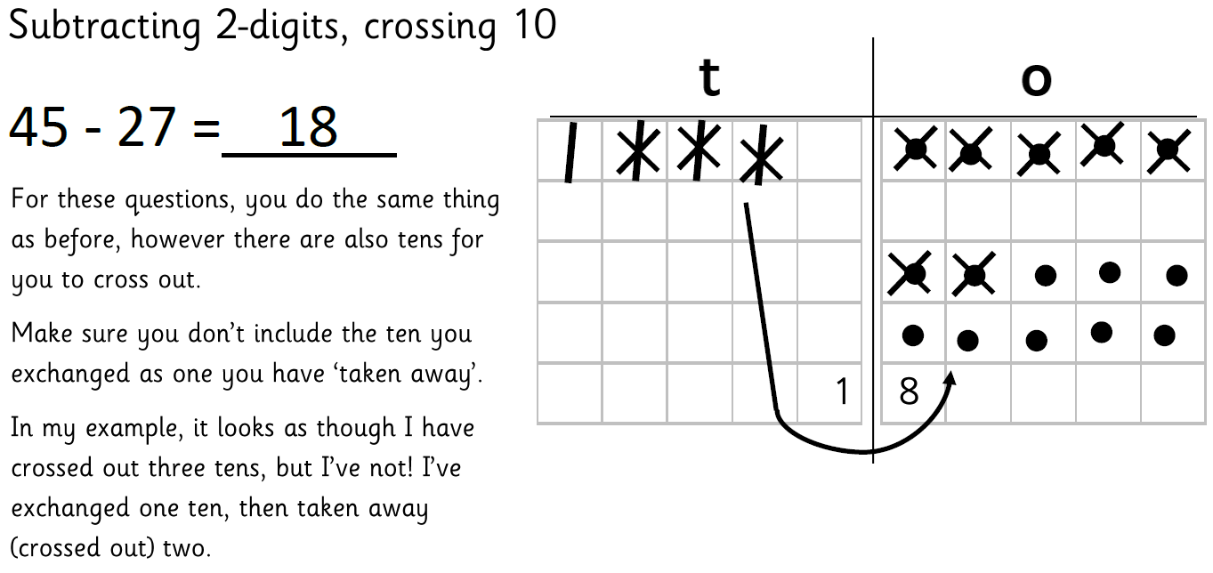 |  | 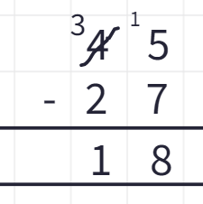
Year 3
- subtract numbers with up to three digits, using formal written methods of columnar subtraction
Year 4
- subtract numbers with up to 4 digits using the formal written methods of columnar subtraction where appropriate
HTO frame – Place Value counters  Column subtraction | subtract numbers with up to three digits
 | 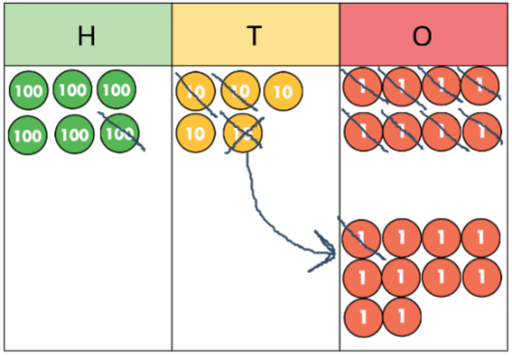  658 – 129 = 529 |  |  | 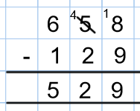
 | subtract numbers with up to four digits
 | 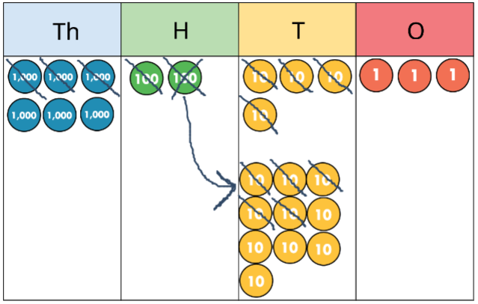  6,243 – 3,190 = 3,053 |  |  | 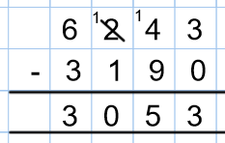
Year 5 and 6
- subtract whole numbers with more than 4 digits, including using formal written methods (columnar subtraction)
Column subtraction | 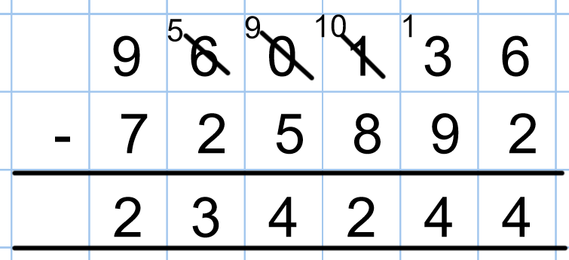  960,136 – 725,892 = 234,224

Multiplication
Early Years
- Compare quantities up to 10 in different contexts, recognising when one quantity is greater than, less than or the same as the other quantity;
- Explore and represent patterns within numbers up to 10, including evens and odds, double facts and how quantities can be distributed equally.
Objects – making equal groups |   
Year 1
- calculate the answer using concrete objects, pictorial representations and arrays with the support of the teacher
Objects – making groups  Repeated addition  Arrays  Counting 2s, 5s, 10s on a number line | 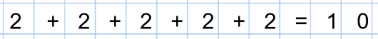        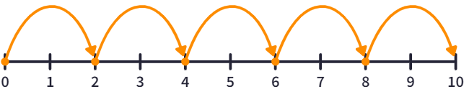  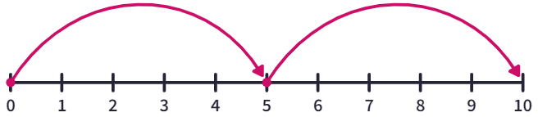
Year 2
- recall and use multiplication facts for the 2, 5 and 10 multiplication tables, including recognising odd and even numbers
- calculate mathematical statements for multiplication within the multiplication tables and write them using the multiplication (×) and equals (=) signs
- use materials, arrays, repeated addition, mental methods, and multiplication facts
2x 5x 10x  Counting in 3s | 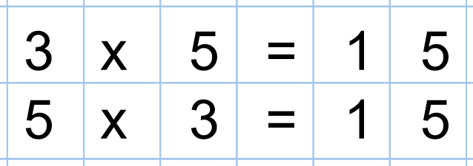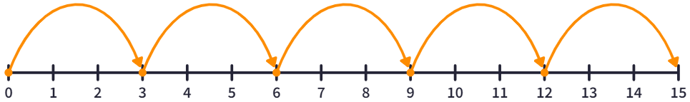
Year 3
- recall and use multiplication facts for the 3, 4 and 8 multiplication tables
- write and calculate mathematical statements for multiplication using the multiplication tables that they know, including for two-digit numbers times one-digit numbers, using mental and progressing to formal written methods
1x 3x 4x 8x 11x  Multiplication Grid | 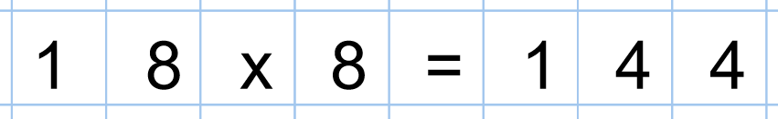  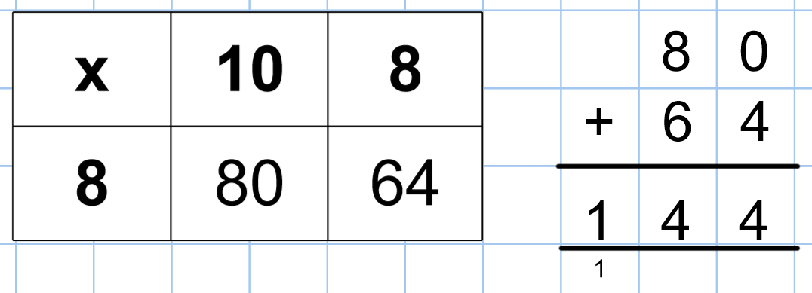
Year 4
- recall multiplication facts for multiplication tables up to 12 × 12
- multiply two-digit and three-digit numbers by a one-digit number using formal written layout
6x 7x 9x 12x  Multiplication Grid Column multiplication for 2-digit and 3-digit x  1-digit numbers | 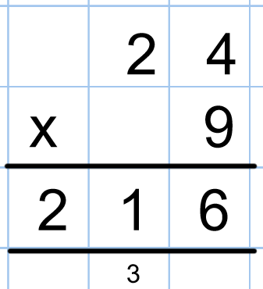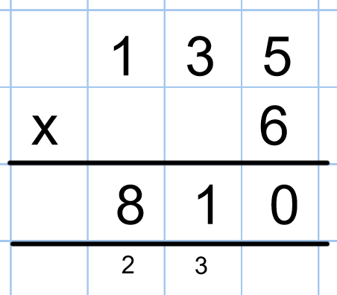
Year 5
- multiply numbers up to 4 digits by a one- or two-digit number using a formal written method, including long multiplication for two-digit numbers
- multiply whole numbers and those involving decimals by 10, 100 and 1000
Year 6
- multiply multi-digit numbers up to 4 digits by a two-digit whole number using the formal written method of long multiplication
Column  Short method: 2-digit,  3-digit and 4-digit x  1-digit numbers  Compact method: 2-digit, 3-digit and 4-digit x  2-digit numbers | 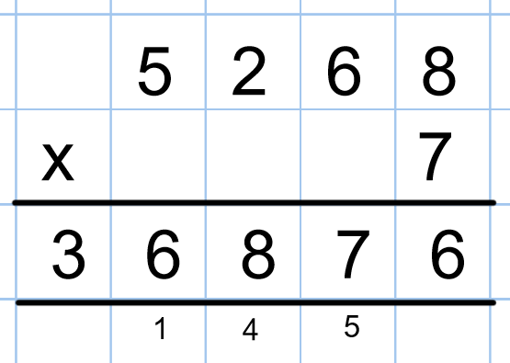
 | 2-digit x 2-digit numbers | 3-digit x 2-digit numbers | 4-digit x 2-digit numbers
 | 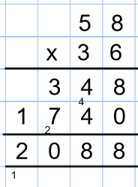 | 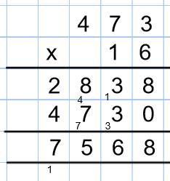 | 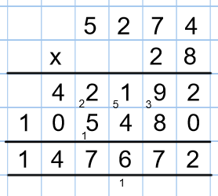

Division
Early Years
- Compare quantities up to 10 in different contexts, recognising when one quantity is greater than, less than or the same as the other quantity;
- Explore and represent patterns within numbers up to 10, including evens and odds, double facts and how quantities can be distributed equally.
Objects – sharing | 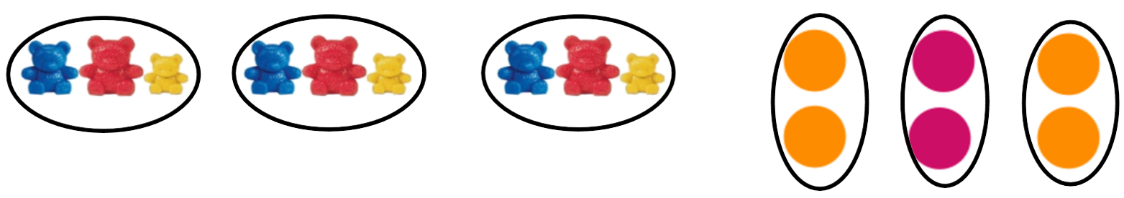
Year 1
- calculate the answer using concrete objects, pictorial representations and arrays with the support of the teacher
Objects – sharing into groups, grouping objects  Arrays  Counting 2s, 5s, 10s on a number line | 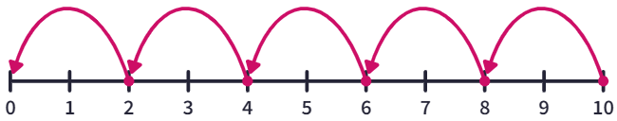  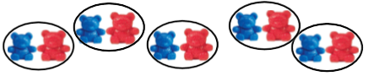  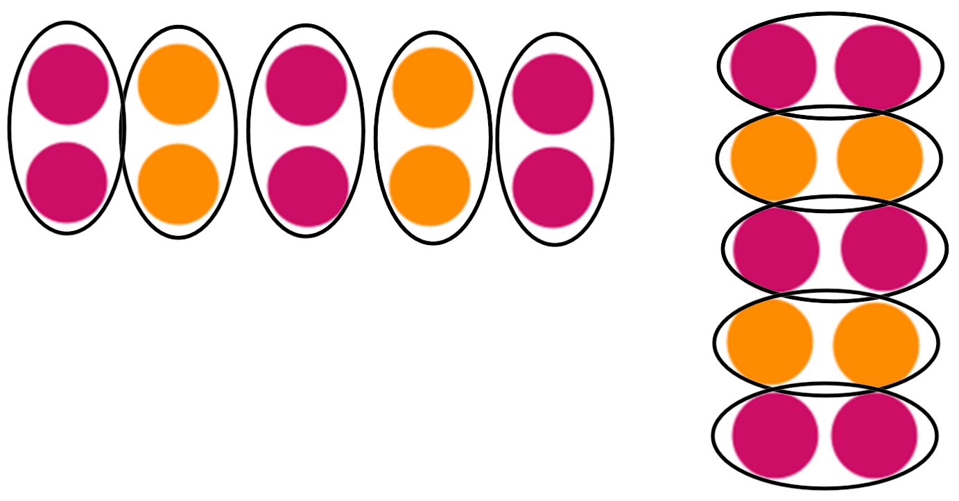
Year 2
- recall and use division facts for the 2, 5 and 10 multiplication tables, including recognising odd and even numbers
- calculate mathematical statements for division within the multiplication tables and write them using the division (÷) and equals (=) signs
- use materials, arrays, repeated addition, mental methods, and division facts
÷2 ÷5 ÷10  Counting in 3s on a number line | 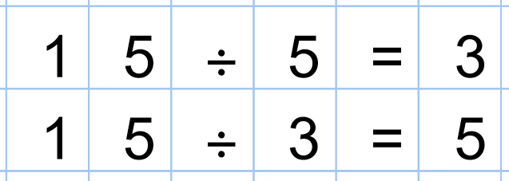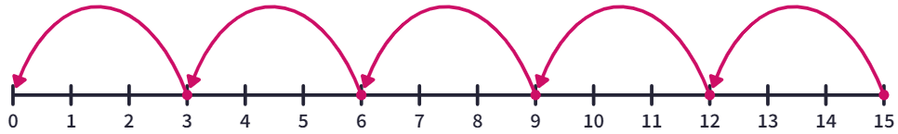
Year 3
- recall and use division facts for the 3, 4 and 8 multiplication tables
- write and calculate mathematical statements for division using the multiplication tables that they know, using mental and progressing to formal written methods
÷1 ÷3 ÷4 ÷8 ÷11  Mixture of equipment and images groups, arrays, number line | 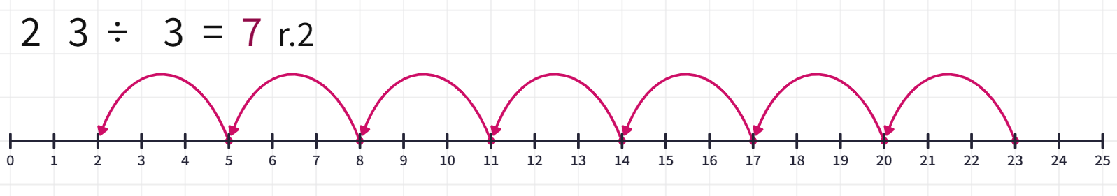
Year 4
- recall division facts for multiplication tables up to 12 × 12
÷6 ÷7 ÷9 ÷12  Short division  2-digit ÷ 1-digit | 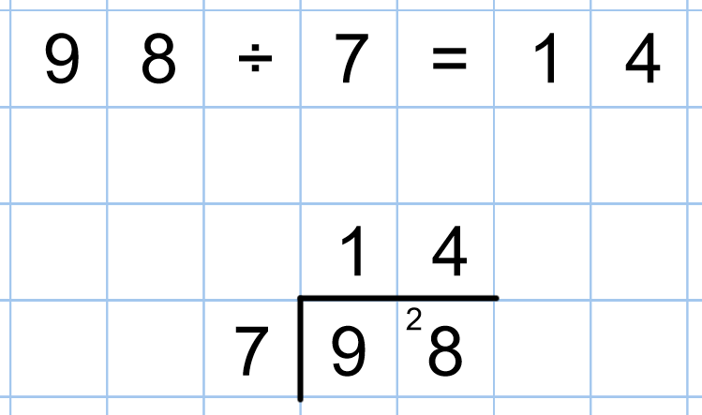

Year 5
- divide numbers up to 4 digits by a one-digit number using the formal written method of short division and interpret remainders appropriately for the context
- divide whole numbers and those involving decimals by 10, 100 and 1000
Short division  Place Value Chart | 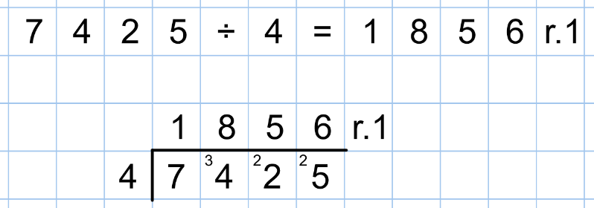  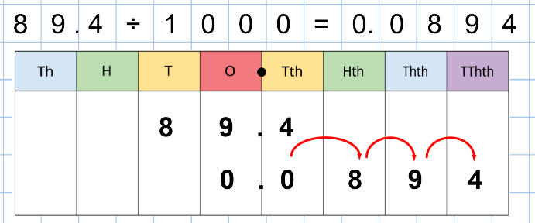
Year 6
- divide numbers up to 4 digits by a two-digit whole number using the formal written method of long division, and interpret remainders as whole number remainders, fractions, or by rounding, as appropriate for the context
- divide numbers up to 4 digits by a two-digit number using the formal written method of short division where appropriate, interpreting remainders according to the context
Chunking  Adding a decimal point to carry in order to divide | 