Newsletter 29th September

Attendance 25/09/23 – 29/09/23

Announcements

Upcoming events

* Wednesday 18th October – Friday 20th October: Robin Wood
* Tuesday 31st October: Individual and Sibling Photographs
* Tuesday 31st October: High School Application Deadline
* Wednesday 29th November: Flu Immunisations
* Thursday 7th December: Year 5 going to Droylsden Academy for Christmas Dinner

|  |  |  |
| --- | --- | --- |
| Class | School Attendance | Lates |
| Bumble Bee | 98.1% | 0 😊 |
| Clover Bee | 95.1% | 2 |
| Honey Bee | 91.7% | 4 |
| 1A | 98.8% | 2 |
| 1B | 94% | 1 |
| 2A | 96.5% | 2 |
| 2B | 100% 😊 | 0 😊 |
| 3A | 89.4% | 2 |
| 3B | 94.1% | 7 |
| 4A | 84.1% | 5 |
| 4B | 96% | 1 |
| 5A | 97.3% | 2 |
| 5B | 97.7% | 3 |
| 6A | 99.3% | 4 |
| 6B | 91.9% | 9 |

)

After school clubs

These clubs can be booked via MCAS, If the places are full, your child will be added to the waiting list.

|  |  |  |  |
| --- | --- | --- | --- |
| Mon | Tue | Wed | Thur |
| Yoga KS1  (FULL) | Art & Craft EY & KS1  (FULL) | Dance Years 5&6  (12 places left) | Sign Language  Years 2-5  (FULL) |
| Board Games KS2  (FULL) | STEM Years 3&4  (FULL) | Sport Years 1-6  £10 | Sport Years 1-6  £10 |
| French Years 4&5  (5 places left) | Lego KS2  (1 place left) |  |  |
|  | Choir KS2  (Full) |  |  |
|  | Sport Years 4-6 £10 |  |  |

Lateness has a massive impact on children’s learning. Not only on the children that are late, but also on the children in the classes being disrupted. Please ensure your child arrives at school on time each day.

|  |
| --- |
| 97% and above  Excellent |
| 95% to 96%  Attendance is slipping and will be closely monitored |
| 95% or below  Poor (high numbers of children are persistently absent) |

Class assemblies

Parents are welcome to come and watch their child’s assembly at 9am on the following dates.

|  |  |
| --- | --- |
| **Class** | **Date** |
| 5B Mrs Williams-Moore | 6th October |
| 4A Miss Lawton | 13th October |
| 3A Miss McDougall | 20th October |
| 2A Ms Lanigan | 3rd November |

**Please note: these dates could potentially change. If they do, we will inform you.**

Star of the week

|  |  |
| --- | --- |
| Bumblebee | Joe for being so kind and helpful to others. |
| 1A | Jerusha for continuously showing a positive attitude to her learning and for being a great role model to her peers. |
| 1B | Blake for working his socks off when he returned to school. Particularly in maths. |
| 2A | Sienna for being an excellent role model displaying all our learning powers. |
| 3A | Lewis for a fantastic positive attitude to learning, working well with others and challenging himself during independent work. |
| 3B | Favour for fantastic reasoning in Math and making links between subjects. |
| 4A | Olivia for perseverance and absorption in lessons and in spelling. |
| 4B | Esther for collaborating well in maths and supporting her peers. |
| 5A | Madeleine for being a kind peer and always being ready to learn in all lessons. |
| 6A | Amelia for always displaying our 3P’s and showing great dedication to her writing. |
| 6B | Karar for being an absolute pleasure and always polite. |
| The Hive | Amber for fantastic writing skills. |

High School Applications are now open. The deadline is Tuesday 31st October. Any applications after this date will be late applications which means you will unlikely get your first choice.

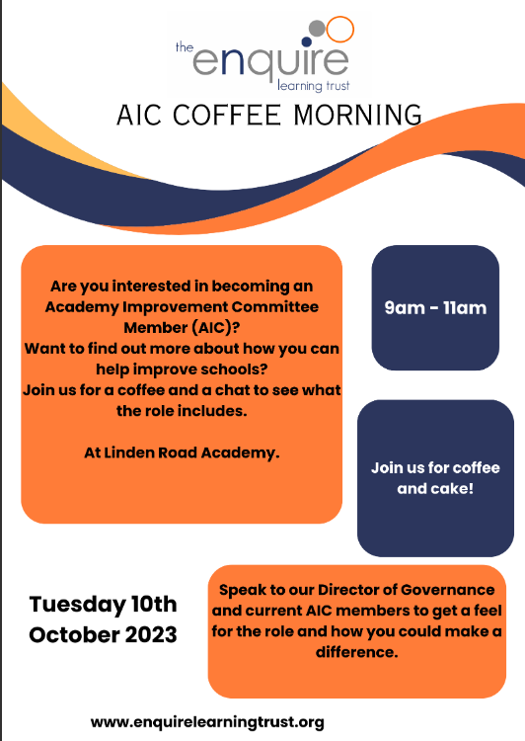

If you are interested in becoming an Academy Improvement Committee Member but feel a little daunted by the responsibility you may be taking on, remember that:

§ full training will be available;

§ you will always be part of a team;

§ no particular experience or qualifications are required;

Your Commitment

If you become an AIC Member you will be taking on the following commitments;

§ Attend and participate in meetings on a regular basis – three meetings per year. Meetings normally last no longer than two hours § Share the responsibilities of the Academy Improvement Committee as outlined in the Cycle of Activity.

§ Take part in Enquiries for each academy § Undergo appropriate training

§ You may also be invited to sit on appointment or other panels

What do you need to do next?

Please visit our website www.enquirelearningtrust.org or contact info@enquirelearningtrust.org with the subject AIC membership.

Message from Tameside admissions

Have your say on the new Local Offer website for families and carers and of children with special educational needs and disabilities. Please click the link below to access the website and tell us what you think!

[https://xd.adobe.com/.../040d7fee-2553-45f9-81ac.../](https://linkprotect.cudasvc.com/url?a=https%3a%2f%2fxd.adobe.com%2f...%2f040d7fee-2553-45f9-81ac...%2f&c=E,1,oh6Il-hugAU3iz3Eix9esfj8f50vQRDOeMr2wN4KQEMT5d34BBdwllZhdvCtPJitygm_26E4okyymA-Gsr-e6x26vzEPS7Zxo5M162EkA__Q&typo=1)

We have created an online question form which can be completed here [https://forms.office.com/Pages/ResponsePage.aspx](https://linkprotect.cudasvc.com/url?a=https%3a%2f%2fforms.office.com%2fPages%2fResponsePage.aspx&c=E,1,00ACcjbbN1TRqMd2ZJDeoyyRohXr1K1xPLeBPSVE28GK1guEC1oz6uormVwcCy2vMgb3FkFbROZOUl8GvfBJ2udIQubEHcC7aCa7vPlyxco1w68,&typo=1)...

The deadline is Monday 2nd October.

