 Topic Web – Early Years Curriculum Spring 2 - 21/22 Reception

Literacy

Writing captions and sentences, spelling out words and using finger spaces.

Looking at the difference between fiction and non-fiction books.

Enjoying reading and talking about books, using our segmenting and blending skills

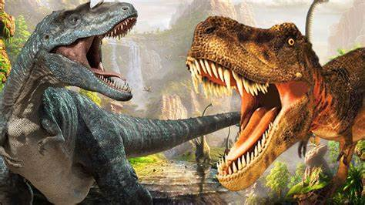

Physical Development

Throwing and catching different sized balls

Practising handwriting on the handwriting sheets using the RWI mantras

Talking about different foods and how to keep healthy and safe.

Gymnastics

Striking and fielding games

Mathematics

Adding and subtracting groups of items together to find the total.

Finding doubles and halves

Playing with patterns

Playing with rulers and measures to discover all about length

Animals Then and Now

Dinosaurs:

Dinosaur Facts

Gigantosaurus

Mary Anning – Dinosaur Lady

Expressive Art and Design

Using different materials to create 3D models

Using watercolours, pastels and chalk to make pictures

To create dances and their own music

Dinosaur Art – textures and patterns

Appreciating music – Carnival of the Animals

Personal Social and Emotional Development

Circle time

PSHE activities

Jigsaw – Healthy Me!

Stories linked to feelings

Talking about what we like doing and what we’re good at.

Turn taking games (dominoes, etc)

Communication and Language

Using improved vocabulary and developing questioning skills.

Answering how and why questions and asking their own questions.

Understanding the World

Dinosaurs

People in history – Mary Anning

Easter

How to log onto a computer