

**Community Learning Policy**

**A policy for Relationships, Response, Reflection and Resolution.**

1. ***Aims***

One of the central principles of this policy is that we know if children are feeling happy and safe that they will then be in the best possible place to learn effectively. Learning effectively ensures that all children are able to reach their full potential – both academically and socially. Central to this principal is adults in school building positive relationships with the children, parents and wider community and developing an authentic sense of community which embraces everyone regardless of race, colour, gender, disability, special educational needs, sexual orientation or socio – economic backgrounds. This policy aims to give children and adults common language to describe their emotions and set of vocabulary to reflect on situations and behaviours. We want to empower children to build an awareness of strategies to enable them to support self-regulation and positively adapt behaviour for the benefit of themselves, their class community and wider community.

1. ***Values-*** *Pride Positivity and Politeness*



This policy sets out the framework for the values and behaviours we expect from everyone working and learning in our community. The relationships we form, the language we use and the restorative methods we implement are vital in ensuring that everyone is able to learn and develop social awareness effectively.

1. ***Key Principles linked to theory***

At Manchester Road we:

* Conduct research into best practice and ensure that the principles of these underpin the policy and practice in school.
* Understand child development, and that children develop in different ways as they move through the school. We understand and respect differences.
* Believe that it is vital to separate the behaviours from the child, and to consider why a child may be displaying the behaviours seen.
* Know that the choices and decisions made around the curriculum, pedagogy and classroom environment can create a sense of routine and security for our children so they have a safe emotional place in which to learn.
* Have high expectations of adult and child behaviour, and use role models across the school to set the example.
* Consider children as a whole person, and give opportunities for them to make contributions to our learning community.
* Believe passionately that restorative practice is the key in children developing their emotional literacy and understanding.
* Do not use punitive punishments or language that implies punishment. Where there are occasions for natural consequences to support reflection, regulation and restoration, these are done with consideration of the context and the individual child.
* Ensure that any natural consequences are used consistently and quickly so there is a safe and healthy conclusion to an incident and all members of the community are ready to learn effectively.

1. ***How does RSE/PSHE and the wider curriculum relate to our behaviour policy?***

The curriculum at Manchester Road is designed to ensure our children develop into independent, confident and successful learners with high aspirations. The children have opportunities to develop resilience and can identify how they can make a positive contribution to the community and wider society. The PHSE and SRE curriculum follows the DfE guidance, and goes beyond. There are 5 key themes which the children cover: Relationships, living in the wider world, Keeping safe, Keeping healthy and changing and growing. In addition to the PHSE and SRE curriculum, Manchester Road also has a Character Development curriculum, which acknowledges the contributions children make outside of the lessons in school.

1. ***How does the environment support our behaviour policy?***

From the moment children join Manchester Road they are welcomed into the community with warmth and respect. We have the expectation that all members of our school community will strive to do their best and will uphold our key values of ‘**Pride Positivity and Politeness’.** Every child at Manchester Road is treated as an individual, and we pride ourselves on how well we know the children and their different needs.

It is the responsibility of everyone within the school to maintain these high expectations, and to ensure that the children have regular opportunities to discuss and talk about them during lessons and school social time. Lessons across the whole curriculum carefully consider how children’s personal development can be enhanced. Examples of these units of work include learning about democracy, keeping safe, the safe use of the internet, respecting art, music and faiths and how to resolve conflicts.

Our curriculum starts the moment the children enter the building each morning. Classrooms are welcoming and purposeful, and the outdoor spaces make the most of environment in which we are set. Throughout the school, the principles of relationships, reflection and resolution are supported through low arousal environments, regulations stations, a regulation room and a sensory room. All these areas support children with the shared language agreed across the school, and in understanding how they can start to regulate their own emotions using different strategies.

1. **The Zones of Regulation**

The zones of regulation is a conceptual framework which teaches children self – regulation. Materials are used to help children to categorise feelings and emotions and improve their ability to recognise and talk about them in a safe, non – judgemental way. Children develop a ‘toolbox’ of strategies which help them move between the zones.

The zones are grouped into colours to show the state of alertness and emotion:

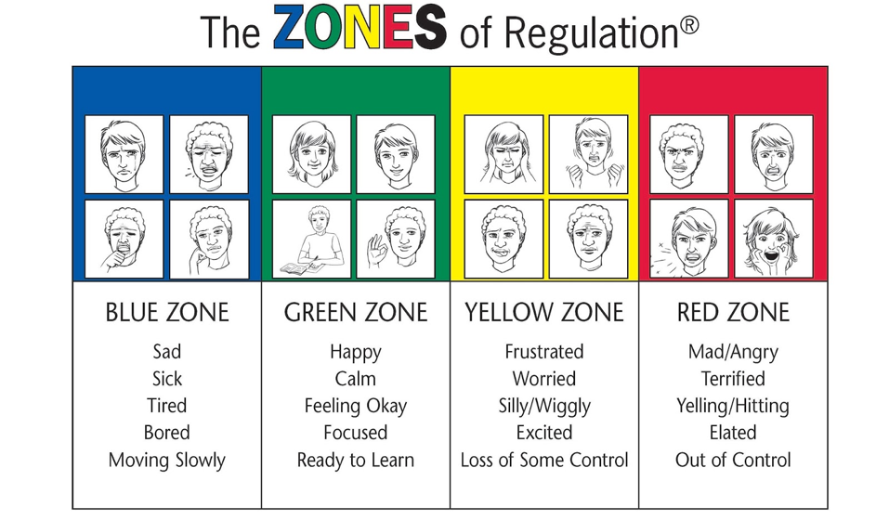

When teaching the children about zones, there is a focus on why all zones are important and how to recognise when you are in each one. Each zone is treated as neutral – one is not better than another. Children consider what behaviours are expected in different circumstances, and whether or not they need to change their behaviours because of this.

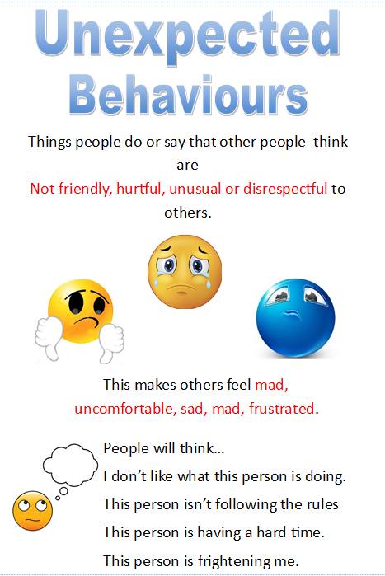 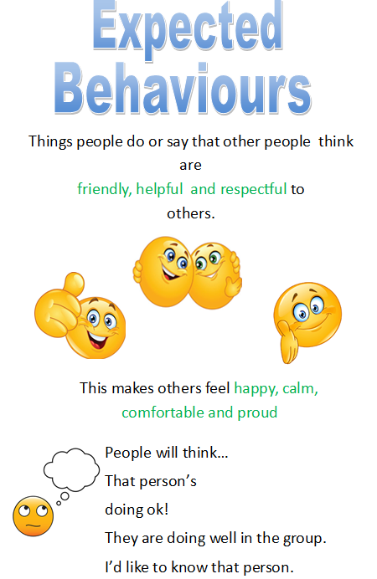 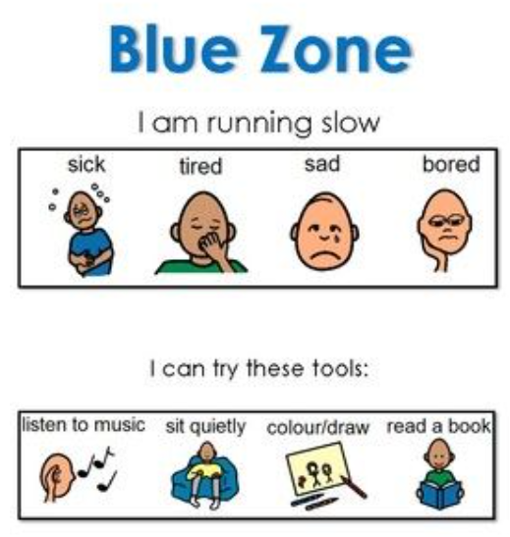

Children are taught a range of strategies that can help them move between zones, and they may have ideas of their won about what helps them personally.

1. **Emotional Coaching**

***“I’ve learned that people will forget what you said, people will forget what you did, but people will never forget how you made them feel.”***

**Maya Angelou**

At MRPA emotional coaching works on the principles that every moment and every interaction with a child can be an intervention and that **safe, consistent, reliable** relationships enable co – regulation.

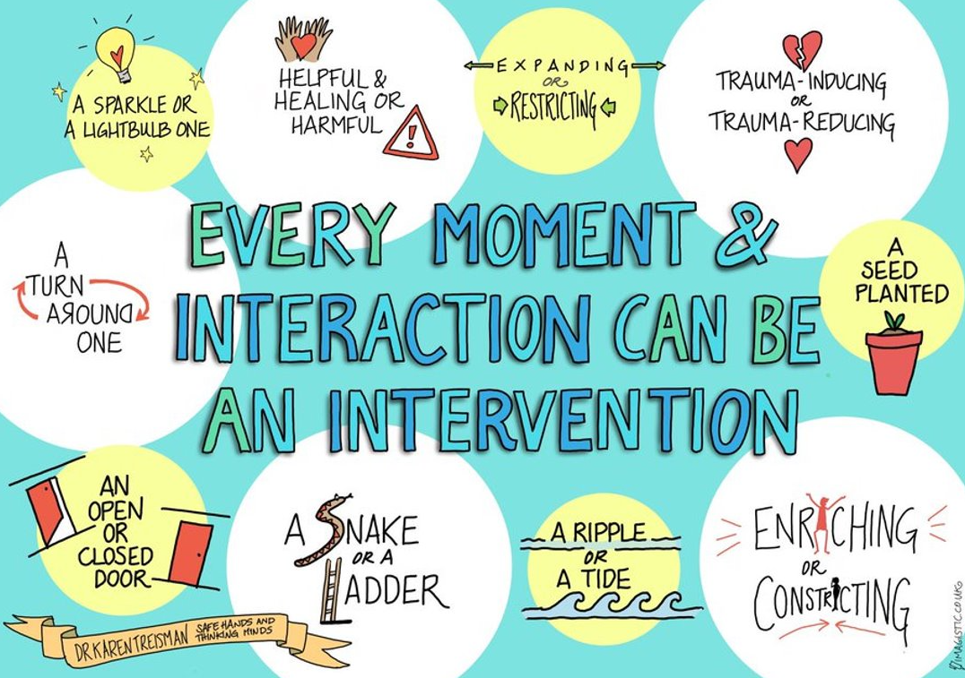

These are the key principles of emotional coaching:

1. Notice the child’s feelings and your own: Connect with the child and empathise
2. Listen and validate feelings
3. Help child to label the emotions
4. Set limits on behaviour and problem - solve with the child.

**The Window of Tolerance** –

Every child has a unique window of tolerance. When they are in their window of tolerance, they are happy, playful and able to be themselves.

When pushed outside their window of tolerance children can become hyper- aroused or hypo - aroused. Triggers for moving children out of their window of tolerance can be a whole range of things: hometime, playtime, tests, noise.

Children who are hyper – aroused are in fight or flight mode. They will have a sense of panic, they may be loud and aggressive. These are behaviours seen on the outside, but inside they are frightened, anxious and in need of support and help.

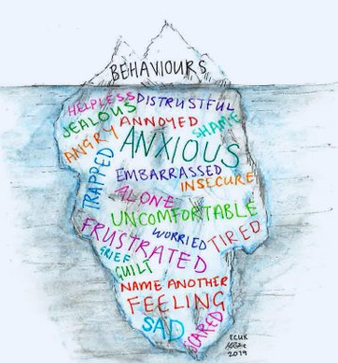

I can see that...

It is expected that you feel like that...

I might feel like that if....

I’ve noticed that...

I wonder if...

Have I got that right?...

The children arriving at school need to feel that school is a safe place, and adults are the key to ensuring that children have safety cues.

SHOW DIAGRAM AND WRITE NOTES

**Non – Verbal Communication**

80% of communication is non – verbal:

* The use of voice
* Body Language
* Facial Expressions

? Principals of emotional coaching…. Wondering, noticing, imagining, judging the size of the problem. Recognising, acknowledging, accepting.

STOP – OPT – GO

STOP. Emotional coaching, make and option to choose a tool, go.

1. **Restorative Practice**

**Promoting guilt and avoiding shame**

Ensuring children know that they will be valued and cared for unconditionally and that it is the behaviours that need to be corrected.

How has the incident/behaviour impacted on others in the community?

Authoritarian V Restorative DIAGRAM

Intrisic V extrinsic motivation: punishment doesn’t work as it relies on extrinsic motivation. Restorative promotes intrinsic motivation which leads to longer term change.

Knowing importance of relationships.

Learning to take responsibility for our own actions

Learning that relationships can be repaired

We are not defined by our actions

What happened? Who did it effect? How did it impact the learning community?

How can we make things better? What do we need to do to reach a resolution so that relationships are intact.

How are natural consequences part of the restorative approach? How do we differentiate according to age, needs, individuals etc…

Restorative language/ questioning: possible language… I feel pleased that… I am upset by… I feel that the action was disrespectful…

Benefits of Restorative Practice:

Social, moral and emotional development

Sense of belonging and connection

Improve self esteem and academic progress

Adults:

Improved staff – pupil relationships

Enhanced staff well being and reduces stress

VICTIMS NNEDS AND DESIRES – OFFENDERS NEEDS AND DESIRES CHART

1. **Incidents that are deemed to have a serious impact on children’s learning**

If a child shows persistent disruptive behaviour which disrupts the learning of others. If they hurt, threaten or bully any members of the school community. If they have actions in the community which cause harm or upset to members of the community (including on line) – these will all be deemed to be serious incident.

Any behaviours which are deemed serious will be recorded on the school CPOMS system and a member of the school leadership team will be informed.

The inclusion and leadership team will act immediately to stop any further disruptions to the learning community. The actions taken will take into consideration the individual child, the statements of the victims, the specific circumstances and the effectiveness of the restorative practice.

Choices which can be taken by teachers or, if called, the leadership team include the following:

* A longer restorative process with clearly set targets for resolution.
* A period of time in the reflection room to complete restorative activities.
* Reflection during playtime or dinnertime.
* Time in class at the reflection station.
* Time in another class at the reflection station
* Parental contact

If needed, a monitoring and response period may be set up to establish whether there needs to be any further input from the SEN team, or any individualised programs put in place.

**Fixed – Term and Permanent Suspensions**

On very rare occasions a decision is made to suspend a pupil from school. This decision can only be made by the principal and must be lawful, rational, reasonable, fair and proportionate. The principal may suspend pupil for one or more fixed periods, for up to 45 days in one school year. The principal may also exclude a pupil permanently. It is also possible for the principal to convert a fixed – term suspension into a permanent suspension if the circumstances warrant this and evidence supports a fresh decision.

A suspension may be given for behaviour within the school day, behaviour on the way to and from school, and any behaviour that impacts on other pupils in the school.

A permanent exclusion is only ever used as a last resort, in response to a serious breach of this policy; and where allowing a pupil to stay in school would seriously harm the education or welfare of the pupil or others in the school.

If the principal excludes a pupil, they inform the parents/ carers immediately, giving reasons for the exclusion. At the same time, the principal makes it clear to the parents/ carers that they can , if they wish, appeal against the decision to the trust. The principal informs the parent/ carer how this can be done.

(See also the Enquire Learning Trust Suspension Policy)

1. **Celebrations as individuals, classes and as a community**

At Manchester Road we celebrate our children’s achievements in many ways:

* Teachers give specific positive praise for making positive contributions in class or around school.
* All school staff are able to give Dojo’s (EY&KS1) or Championship Points (KS2) to any children as a form of praise in the classrooms.
* Teachers award stickers, post – it home cards and certificates whenever they feel children have done something which makes a positive contribution.
* Gold cards are awarded for positive behaviours and showing the school values (pride, positivity, politeness) outside of the classrooms.
* Gold cards are collected and 3 winners chosen as Gold Card Champions at the end of each half term. A class award is also given to the class with the most gold cards.
* Learning Hero assembly each week celebrates children who have gone ‘over and above’ – each class has ‘extraordinary zone’ achievers and one Super Learning Hero who has displayed a specific behaviour linked to BLP.
* Awards are given for good attendance.
* Championship points are used in KS2 to fed into a house system. The winning house has a bouncy castle at the end of each term.
* Character development points are awarded to children for their achievements both in and out of school. It recognises positive contributions they make as individuals and as part of a team.
* Specific awards are given when children move through the reading scheme, and also when they achieve their handwriting pen licence.

1. **Monitoring and review**

This policy will be reviewed on a regular basis by the relationship development team, liaising closely with teachers, parents and the children.

The school keeps a variety of records upon which to base the impact of this policy. These are discussed weekly at the leadership team meeting and termly at the relationship team meetings.

The principal keeps a record of any suspensions from school and these are recorded termly to the AIC.

This policy will be reviewed termly during 2023 – 2024 and annually afterwards.

**Principal**: J Taylor

**Date**: September 2023

Please see in school and on the website the following supporting documents:

* Anti – bullying policy
* Equality and inclusion policy
* ELT – suspension policy
* PHSE/SRE policy
* E – safety policy

**References:**

**Next steps:**

**The actions below are preparations to be made ready for the new systems to be trialled during the Summer 2 half term. A review will then take place to make any adjustments ready for September.**

* Draft policy to be produced for consultation with consideration to the last meetings straight after Easter break (Jo & Vicky)
* Inset May – Jenny C(EP) to lead training on emotional coaching and restorative practice. Afternoon sessions with smaller groups of staff for half an hour.
* Refresher Sept for all staff, so that systems are in place and ready to go. (Joanne)
* Emotion coaching training (Jenny C EP)
* Parent video-training following a parent day. Child interviews. (Jo/Vicky)
* Teaching walk through-behaviours for learning.
* Parents on board the behaviour team? (Jo to send a letter for meeting on 2.5.23)
* Restorative practise (Jenny C EP)
* Regulation stations class toolboxes split into different areas eg activities for yellow/blue. (Children to make a contribution to design and language – Jo and Vicky to prepare class session)
* Assemblies for transitional periods eg xmas / July transition
* PPP ambassadors training (Chloe and Rebecca E)
* Regulation station to be set up in the reflection room/ faceclub (Jennie M) – needs to be done after class sessions and agreement on visuals/language.
* PSHE links (Chloe)
* High/low arousal activity prompts (Emma)
* Take to phase the key language in BLP to be brought forward. How will this relate to EYFS?
* BLP classroom displays – Standardisation of materials once powers have been decided)
* Writing the Policy -(Jo taking to Smart council and then into class council)
* Emotion coaching scripts -Emma

To do this, we use

including differentiation and individual needs , Zones of Regulation, BLP. What specific language do we use? Consequences, meetings with parents.

Unconditional positive regard. We value our relationships with the pupils and

Emotional Literacy

Emotion coaching through the use of Zones

* Reflection target slips to be shared with home restorative following a period of disruption/dysregulation and aimed at future prevention.
* Preventative reflection sheets and individual tool boxes.
* Whole class regulation toolbox and individual toolboxes (where app & UKS2)