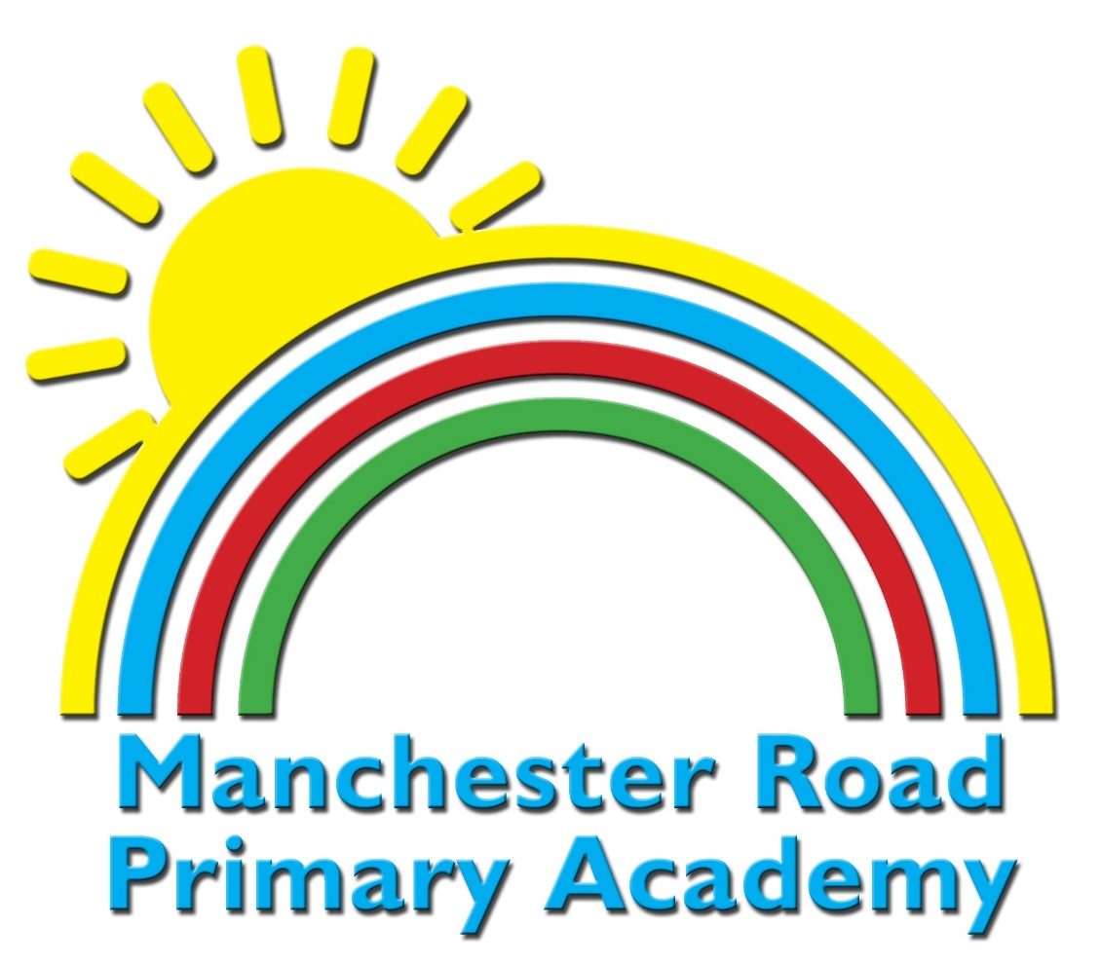
Early Years
Statement of Intent

The Statutory framework for the Early Years Foundation Stage sets the standards for learning, development and care for children from birth to 5 years.
Statement of Intent
Our curriculum is designed to recognise children’s prior learning, both from previous settings and their experiences at home. We work in partnership with parents, carers and other settings to provide the best possible start at Manchester Road Primary Academy, ensuring each individual reaches their full potential from their various starting points. Our curriculum has been designed to enable children to succeed through cooperative and collaborative learning principles. As such, there is a strong emphasis on the Prime Areas of learning: Personal, Social and Emotional Development and Communication and Language.
At Manchester Road Primary Academy, we recognise that Communication and Language not only improves academic outcomes, but is a life skill to ensure success beyond school, in life and future employment. Our enabling environments and warm, skillful adult interactions support the children as they begin to link learning to their play and exploration right from the start.
We believe that high level engagement ensures high level attainment. We therefore provide an engaging curriculum that maximises opportunities for meaningful cross-curricular links and learning experiences, as well as promoting the unique child by offering extended periods of play and sustained thinking. We following children’s interests and ideas to foster a lifelong love of learning both in and outside of school.
By the end of the Reception year, our intent is to ensure that all children are nurtured to build positive relationships, have effective characteristics of learning, make at least good progress from their starting points are equipped with the skills and knowledge to have a smooth transition into Year 1.
Implementation
Each half term, EYFS staff introduce a new theme to provide inspiration for learning, whilst providing the flexibility for children to follow their own interests and ideas. Children learn through a balance of child-initiated and adult-directed activities.
The timetable is carefully structured so that children have opportunities for directed teaching during the day (carpet sessions), small group and one to one targeted learning opportunities and enhanced play opportunities. This mix of teaching approaches means the teaching staff can systematically check for understanding, identify and respond to misconceptions quickly and provide real-time verbal feedback which results in a strong impact on the acquisition of new learning.
The timetable changes throughout the year to take into consideration the changing needs of the children.
Children are provided with plenty of time to engage in ‘exploration’ throughout the variety of experiences carefully planned to engage and challenge them in the provision. The curriculum is planned for the inside and outside classrooms and equal importance is given to learning in both areas.
The Curriculum
English / Literacy
Reading is at the heart of our curriculum and our aim is to encourage a love of reading right from the start. In EYFS the children follow the ‘Read Write Inc’ phonics program where they read daily, a weekly guided reading group and ‘The Write Stuff’ literacy program where Children’s learning opportunities will centre around a key text or theme. In turn focusing and building on their communication and language throughout. We aim to install a ‘love for learning’ as ‘evidence suggests, there is a positive relationship between reading, reading enjoyment and attainment’ (Clark, 2011).
Mathematics
In Reception, we follow the White Rose Maths Scheme of work which is divided into 3 weekly units. High quality learning environments and meaningful interactions with adults, support children in developing mathematical thinking and discussion. Pupils learn through games and tasks using concrete manipulatives and pictorial structures and representations which are then rehearsed applied and recorded within their own child-led exploration.
In Nursery, children develop a love of maths through games, songs, rhymes, and play using concrete manipulatives. There is a focus on the following counting principles; one to one correspondence, stable order and cardinal principle. Children’s fine manipulative skills are a focus to develop 1-1 correspondence so children count each object only once.
Wider Curriculum
Our wider curriculum is taught through the learning areas; ‘Understanding of the World’ and ‘Expressive Arts and Design.’ EYFS staff have a good understanding of how ELG’s feed into the National Curriculum through our robust planning and CPD opportunities. In reverse, colleagues throughout the school are also aware of the key ELG’s that link to each foundation subject and the progression of the subject.
Exciting, purposeful and contextual activities are planned to build on children’s natural curiosity. For example, building a boat for their favourite toy enables them to think like a ‘Scientist’ and ‘Engineer’ as they explore a range of materials and test out their own ideas.
Building further on our oracy focus, children will be encouraged to employ subject specific language and terminology in foundation subjects, and such vocabulary will be modelled, both verbally and orally, by supporting practitioners.
Our inclusive approach means that all children learn together, but we have a range of additional interventions and support for children who may not be at the expected level of development or are showing a greater depth of understanding and need further challenge. This includes, for example, targeted sessions
for developing speech and language, social skills, fine motor skills, phonics, and mathematics.

In addition, we have a higher than average number of children on EHCPs, where bespoke support plans have identified that learning may need to take place away from the classroom to deliver more individualised opportunities for learning. We have highly skilled staff trained in specific programs for children with identified area of need this includes (but is not limited to) Wellcomm- speech and language intervention, Zones of Regulation - emotional literacy program and sensory integration programs. The children also benefit from on-site professional support in the form of Speech and Language Therapist, Educational Psychologist and school Counsellor.
Regular monitoring of teaching and learning by SLT and the EYFS leader ensure staff develop good subject knowledge. The EYFS leader ensures staff receive CPD specific to Early Years to develop their practice. For example, we offer CPD on effective observations, in order to understand where pupils are, and their ‘next steps,’ for learning.
