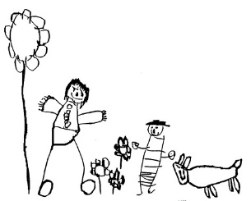

Parental agreement for school/setting to administer medicine
The school will not give your child medicine unless you complete and sign this form, and the school has a policy that staff can administer medicine.
Name of School/Setting
Date
Child’s Name
Class
Name and strength of medicine
Expiry date
How much to give ( i.e. dose to be given)
When to be given
Any other instructions
Number of tablets/quantities to be given to school/setting
Note: Medicines must be the original container as dispensed by the pharmacy
Daytime phone no. of parent or adult contact
Name and phone no. of GP
Agreed by Senior Leader

The above information is, to the best of my knowledge, accurate at the time of writing and I give consent to school staff administering medicine in accordance with the school policy. I will inform the school/setting immediately, if there is any change in dosage or frequency of the medication or if the medicine is stopped.

Parent’s signature: |  | Print Name:
If more than one medicine is to be given a separate form should be completed for each one

Record of medicine administered to an individual child

Date
Time Given
Dose Given
Name of member of staff
Staff initials

Date
Time Given
Dose Given
Name of member of staff
Staff initials

Date
Time Given
Dose Given
Name of member of staff
Staff initials

Date
Time Given
Dose Given
Name of member of staff
Staff initials

