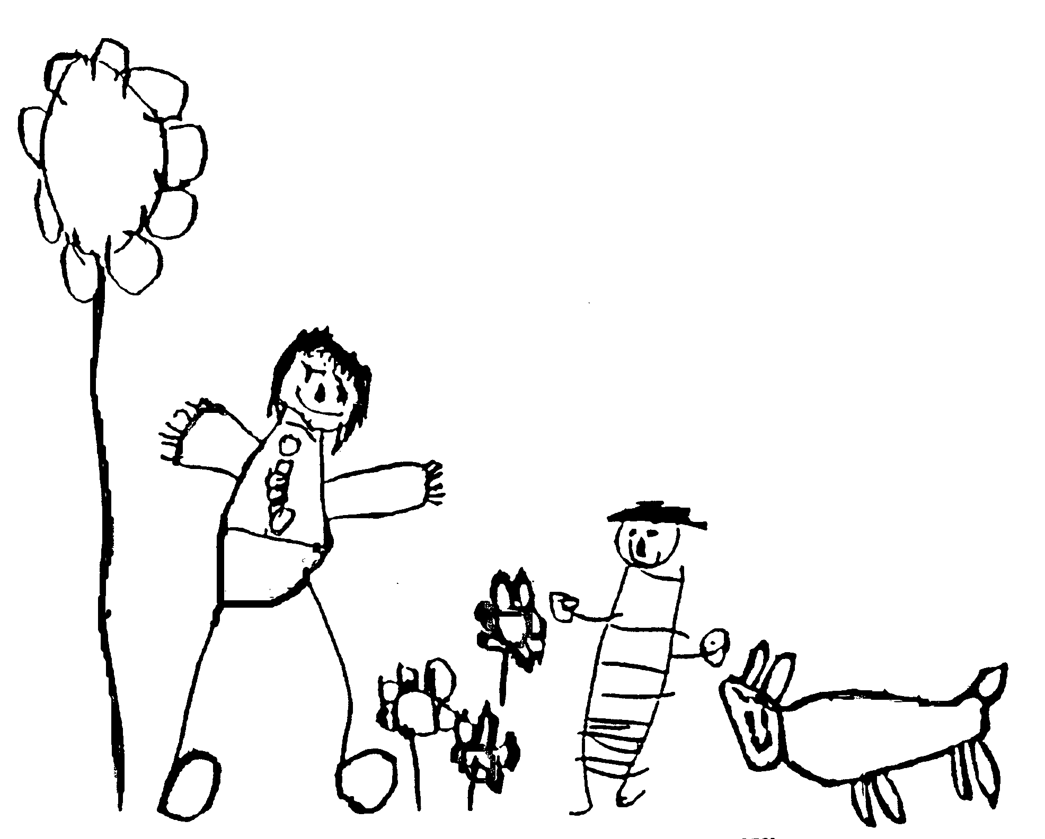
Margaret McMillan Nursery School
and Children's Centre
Hornsey Rise
Islington
N19 3SF
020 7281 2745
www.margaretmcmillan.islington.sch.uk

Asset Management Policy and Practice

INTRODUCTION:

The Governing Body of Margaret McMillan Nursery School is responsible for the proper management and security of the school premises and the custody and physical control of all other assets including machinery, furniture, equipment, stock and other assets

The Asset Register

Margaret McMillan Nursery School maintains an Asset Register of items held by the school that the Governing Body deems to be valuable and/or subject to an insurance claim. Moveable assets valued at £500.00 or more must be recorded. Note that all Information Technology (IT) equipment is recorded, regardless of their value.

The Asset Register should include the following information:
- Date of acquisition of asset
- Description of asset, including unique identification mark such as serial number where appropriate
- For ICT/electrical equipment, a record of the model or other unique reference/security number
- Cost of the asset purchased
- Source of funding
- Location of the asset
- Details of the disposal of any assets, whether scrapped, sold or donated
- Details of the revaluation of an asset where relevant
- Items used by the school but owned by others (eg leased items) supported by a note of ownership

A copy of the Asset Register must be kept in a safe, fireproof place, and be available for inspection.

Acquisitions and disposals should be recorded on the register at the time of acquisition or disposal and reported to the Governing Body.

The Governing Body must ensure that the asset register is kept-up-to-date and is reviewed at least once a year.

Disposing of Assets

Items can be available for disposal because they are:-
- Not capable of running required operational software systems or being upgraded to do so;
- No longer required, due to changed procedures, functions or usage patterns;
- Beyond repair
Any item which is deemed obsolete or damaged beyond repair and is not appropriate for sale may be written off by the Headteacher

For every disposal, the Governing Body or the person who is maintaining the Asset Register must:

- Record the reasons for the disposal
- Be able to demonstrate that the assets are either obsolete or surplus to requirements

Options for the disposal of assets
- Acceptable methods of disposal are:-
- Transfer of assets to a new school site
- Sale of assets
- Donation of assets to a school or community service organization
- Destroy assets
- Recycle assets

Choice of the most appropriate disposal option will normally be influenced by the age and functionality of the equipment for disposal and by market value.

Disposal of IT Equipment

Margaret McMillan Nursery School must ensure that they adhere to the latest WEEE (Waste Electrical and Electronic Equipment) Legislation. The legislation states that such assets cannot just be thrown away, must be disposed of properly, either by:
- Donation to a charity (for refurbishment and re-use) – e.g. Tools for Schools
- Disposal by a specialist organisation, who will take such items away and recycle them.
It is essential to ensure that any computer and laptop hard drive / memory / data store is professionally cleared of such data prior to disposal. This is to ensure that the school adheres to data protection legislation and minimizes the risk that sensitive information is exposed to unauthorised individuals. A certificate of destruction should be required.

Date reviewed | September 2024
Date of next review | September 2026
Ratified by Governing Body | November 2024

