Welcome to all parents and carers!

The first half of the Autumn term has begun and we welcome all our families, new and old! We hope you had a lovely summer and are excited for the new term.

Saplings staff:. Senior Nursery Education Workers Tracie & Danielle
Other staff members: Donna, Sherise, Michelle, Iwona, Fatou

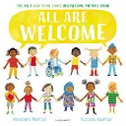
Seedlings staff : Dez & Harley

Curriculum
We will start the year learning about ‘routines and rituals’ to help the new children settle and get everyone back into the familiar structure of the day, so that the children feel secure and confident and ready to play and learn.
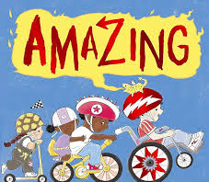
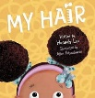
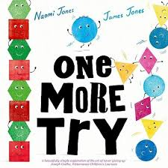

This term our topic will be All About Me. We will be learning all about our families, our communities, our cultures, our bodies and celebrating all that is the same and different about ourselves.

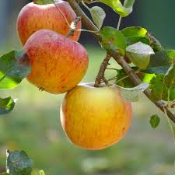
As the weather starts to change, we will be learning about the different seasons and how Summer is changing into Autumn. The children have really enjoyed picking the apples from our trees! We will be making full use of our lovely outdoor area and collecting conkers and autumn leaves to develop our understanding of the world, as well as watching how our beautiful trees change throughout the year.
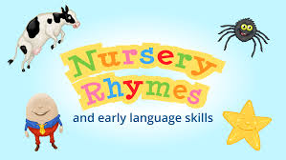

We will be carrying on with our very successful ’Rhyme of the Week’ where the children learn a different rhyme each week. We will send home these rhymes so you can include the whole family in singing and enjoying them at home.
The children will also be having regular music and movement sessions and will cook some delicious food during this half term.

Dates for your diary
Half Term - Monday 27th October to Friday 31st October inclusive
School will be closed for term time only children and will reopen again on Monday 3rd November.
Please see all important dates for this term attached.


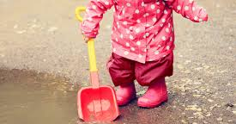
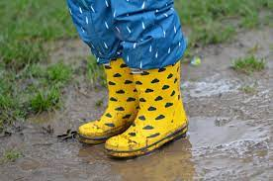
General information

Changing Clothes
We love messy play! Please provide a change of clothes for your child in case they have a toileting accident or become messy/ wet whilst playing. Every child has a blue box for their clothes. Please ensure these boxes are updated with clothes when used and label them with your child’s name. Please also check the weather each day and provide your child with suitable clothing… there is no bad weather just inappropriate clothing!
We love to go outside whatever the weather so they will need a coat to wear, preferably with a hood please. If you have any wellies that don’t fit your children anymore, please do bring them in. We can keep them with our spare wellies as they are sure to fit someone! We don’t use umbrellas at Nursery.
Contact Numbers
Please ensure we have your updated contact details, such as your address, phone numbers and details for more than 2 emergency contacts. It is important for us to be able to contact you in an emergency. The emergency contacts don’t have to be someone living nearby, just someone who can help us reach you if needed.

Allergy Advice

We have children in school who have severe allergies. We ask parents to help us keep all the children safe by not allowing their child to bring food into school. For birthdays, children can bring in some fruit or raisins to share with the class or a cake, providing they contain no nuts. We greatly appreciate your support with this. Please ensure the cake’s ingredients are clearly labelled
Fruit time
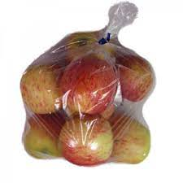


We would like to continue offering the children fresh fruit and vegetables each day at snack time. If you would like to and you are able, you can donate some money (any amount) to enable us to buy the fresh fruit and veg weekly. Alternatively you could donate the food directly to us. Perhaps you could pick up an extra bag of fruit that could be shared with the children when you shop?
Please note that all this is entirely optional and we would only want you to donate if you are able.

Parent workshops
We will be running parent workshops and meetings throughout the term. Please see attached information with all dates and what’s on offer.
We will be having a Welcome Coffee Morning on Wednesday 24th September for all new parents and would love to see as many of you as possible. There will be biscuits!
Attendance and punctuality

We know that good habits from an early age have a very positive impact on achievement. Regular attendance helps children to: make friends and learn social skills; enjoy their learning; feel settled and happy and get ready for school. If your child is absent from school we ask that you please call in and let us know why they are absent and when they will be returning.
Even when you’re very small good attendance makes a big difference!
Important dates for your diary!
date | time | activity
Friday 26th September | All day | Doodle day  A day of fun mark making of all shapes and sizes.
Wednesday 24th September | 9.30-10.30am | Welcome coffee morning  An opportunity to meet each other, as well as Karen (HT) & Bonnie (DHT) & Michal (Clinical Psychologist)
Wednesday 1st October | Seedlings & saplings:  10.30-11.30am or 2.30-3.30pm | Older Peron’s day  Grandparents are invited in to read stories/ play with the children.
Monday 27th October – Friday 31st October | Term time only children | HALF-TERM

Parents/ carers pick-up
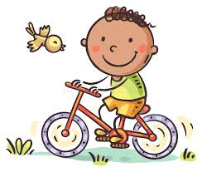

Please ensure you are on time for picking up your child as children can become distressed when they see other parents/carers coming in but not their own. Please also do NOT ring the door buzzer before 11.55am as that can disrupt the children’s story time. Many thanks for your understanding with this.
Buggies and Bikes
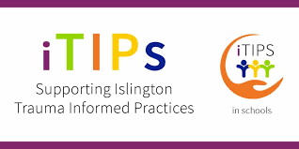
As the weather gets colder, more people begin to use buggies to bring their children into nursery. Please can you fold your buggy up to make room for all the buggies. Please also can you lock any bikes up around the front of the school in the bike area. Buggies and bikes may be left at your own risk and we cannot be responsible for them. We love that the children are riding their bikes and scooters to nursery!
iTips

For the past year we have been focusing on becoming an ITIPS (Islington Trauma Informed Practice School). We have written a new Positive Behaviour Policy and invite you to a Parent Workshop on Friday 7th November to find out more.
Book bags
We have lovely Margaret McMillan Nursery School book bags for your child to bring in each day. This means they can regularly choose a book to take home and read. Please bring in the book bag daily as they will not be able to take a book home without the bag (to keep it safe). It’s also useful for the children to put their lovely work inside!
Many thanks for your continued support.
We look forward to a wonderful, exciting term ahead!

