Welcome to all parents and carers!

The first half of the Autumn term has begun and we welcome all our families, new and old! We hope you had a lovely summer and are excited for the new term.
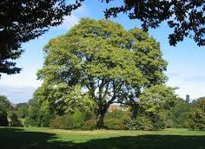
We have also welcomed our lovely new teacher – another Rosie! She will be known as Rosie H. You will see her friendly face around so please say hello!
Sycamore 1. Class teacher Rosie M

Sycamore 2. Class teacher Rosie H
Saplings. Senior Nursery Education Workers Tracie & Danielle (Breakfast & tea)
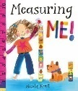


Curriculum

We will start the year learning about ‘routines and rituals’ to help the new children settle and get everyone back into the familiar structure of the day, so that the children feel secure and confident and ready to learn.
This term our topic will be All About Me. We will be learning all about our families, our cultures, our bodies and celebrating all that is the same and different about ourselves.
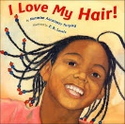
We would love for any parents to come in and help us with this. If you have any skills such as music, cooking, drawing or coming in to read a story with the children, please do let us know. We would particularly love to learn songs and read stories from other languages.
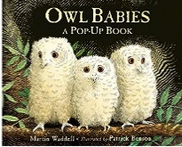
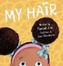
We will be reading books such as Hair, My Skin and I Love My Hair. We thought this would be a great opportunity to create a mini-hairdressers at school as well as other familiar role-play areas!
This week we will be reading the popular story
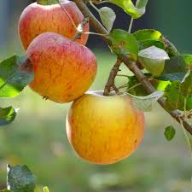
Owl Babies by Martin Waddell. This is a beautiful story set in the forest where the owl siblings huddle together to wait for their mummy to return home to them. This story is a lovely, engaging way to reassure children that their parents will come back to them! We will also use this opportunity to learn about owls, what they look like, what they eat, where they go at night and so-on.
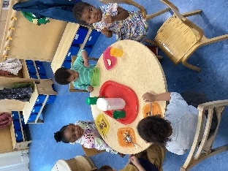
As the weather starts to change, we will be learning about the different seasons and how Summer is changing into Autumn. The children have really enjoyed picking the apples and pears from our trees and sharing them! We will be making full use of our lovely outdoor area and collecting conkers and autumn leaves to develop our understanding of the world, as well as watching how our sycamore trees change throughout the year.
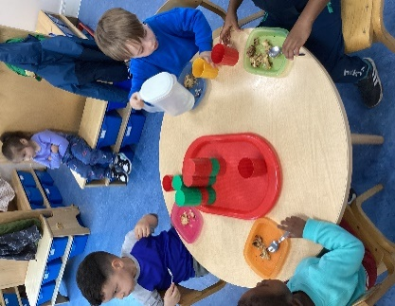
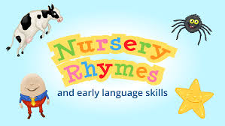

We will be carrying on with our very successful ’Rhyme of the Week’ where the children learn a different rhyme each week. We will send home these rhymes so you can include the whole family in singing and enjoying them at home.

Dates for your diary

Half Term - Monday 27th October to Friday 31st October inclusive
Sycamore Classes will be closed for half term.
Nursery will be open again for children with term time places on Monday 3rd November.
Please see all important dates for this term attached.


General information
Changing Clothes
We love messy play! Please provide a change of clothes for your child in case they have a toileting accident or become messy/ wet whilst playing. Every child has a blue box for their clothes. Please ensure these boxes are updated with clothes when used and label them with your child’s name.
Please also check the weather daily and ensure your child is dressed accordingly. We love to go outside whatever the weather so they will need a coat to wear, preferably with a hood please. If you have any wellies that don’t fit your children anymore, please do bring them in. We can keep them with our spare wellies as they are sure to fit someone! We don’t use umbrellas at Nursery.
Contact Numbers
Please ensure we have your updated contact details, such as your address, phone numbers and details for more than 2 emergency contacts. It is important for us to be able to contact you in an emergency. The emergency contacts don’t have to be someone living nearby, just someone who can help us reach you if needed.

Allergy Advice

We have children in school who have severe allergies. We ask parents to help us keep all the children safe by not allowing their child to bring food into school. For birthdays, children can bring in some fruit or raisins to share with the class or a cake, providing they contain no nuts. We greatly appreciate your support with this. Please ensure the cake’s ingredients are clearly labelled
Fruit time
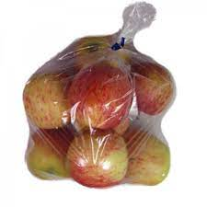


We would like to continue offering the children fresh fruit and vegetables each day at snack time. If you would like to and you are able, you can donate some money (any amount) to enable us to buy the fresh fruit and veg weekly. Alternatively you could donate the food directly to us. Perhaps you could pick up an extra bag of fruit that could be shared with the children when you shop?
Please note that all this is entirely optional and we would only want you to donate if you are able.

Parent workshops
We will be running parent workshops and meetings throughout the term. Please see attached information with all dates and what’s on offer.

We will be having a Welcome Coffee Morning on Wednesday 24th September for all new parents and would love to see as many of you as possible. There will be biscuits!
Attendance and punctuality
We know that good habits from an early age have a very positive impact on achievement. Regular attendance helps children to make friends and learn social skills; enjoy their learning; feel settled, happy and ready for school. If your child is absent from school we ask that you please call in and let us know why they are off and when they will be returning. Please be punctual for pickup!
Even when you’re very small good attendance makes a big difference!
Important dates for your diary!
date | time | activity
Wednesday 24th September | 9.30-10.30am | Welcome coffee morning  An opportunity to meet each other, as well as Karen (HT) & Bonnie (DHT) & Michal (Clinical Psychologist)
Friday 26th September | All day! | Doodle day  A day of fun mark making of all shapes and sizes.
Wednesday 1st October | Sycamore:  2.15-3.15pm | Older Peron’s day  Grandparents are invited in to read stories/ play with the children.
Monday 27th October – Friday 31st October | Term time only children | HALF-TERM
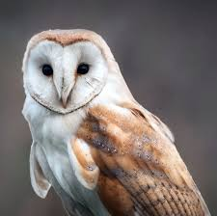
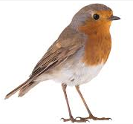
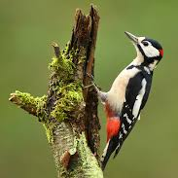
Parents pick -up

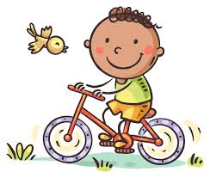
If your child is full-time or does afternoons at Nursery, pick up will be from their story group rooms. These may change throughout the term and year. Please ask staff if you are unsure which story group your child is in – Owls, Robins, Woodpeckers. There will be a red box outside the rooms with children’s work to be collected. Please do go through the box and find your child’s lovely work!
Bikes

We love that the children are riding their bikes and scooters to nursery! These may be left outside the entrance to Sycamore class but we are unable to take responsibility for them. If you would like to lock them up, we have a bike lock area downstairs outside the main reception area.
Book bags
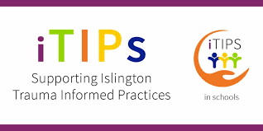
We have lovely Margaret McMillan Nursery School book bags for your child to bring in each day. This means they can regularly choose a book to take home and read. Please bring in the book bag daily as they will not be able to take a book home without the bag (to keep it safe). It’s also useful for the children to put their lovely work inside!
iTips
For the past year we have been focusing on becoming an ITIPS (Islington Trauma Informed Practice School). We have written a new Positive Behaviour Policy and invite you to a Parent Workshop on Friday 7th November to find out more.
Many thanks for your continued support.
We look forward to a wonderful, exciting term ahead!

