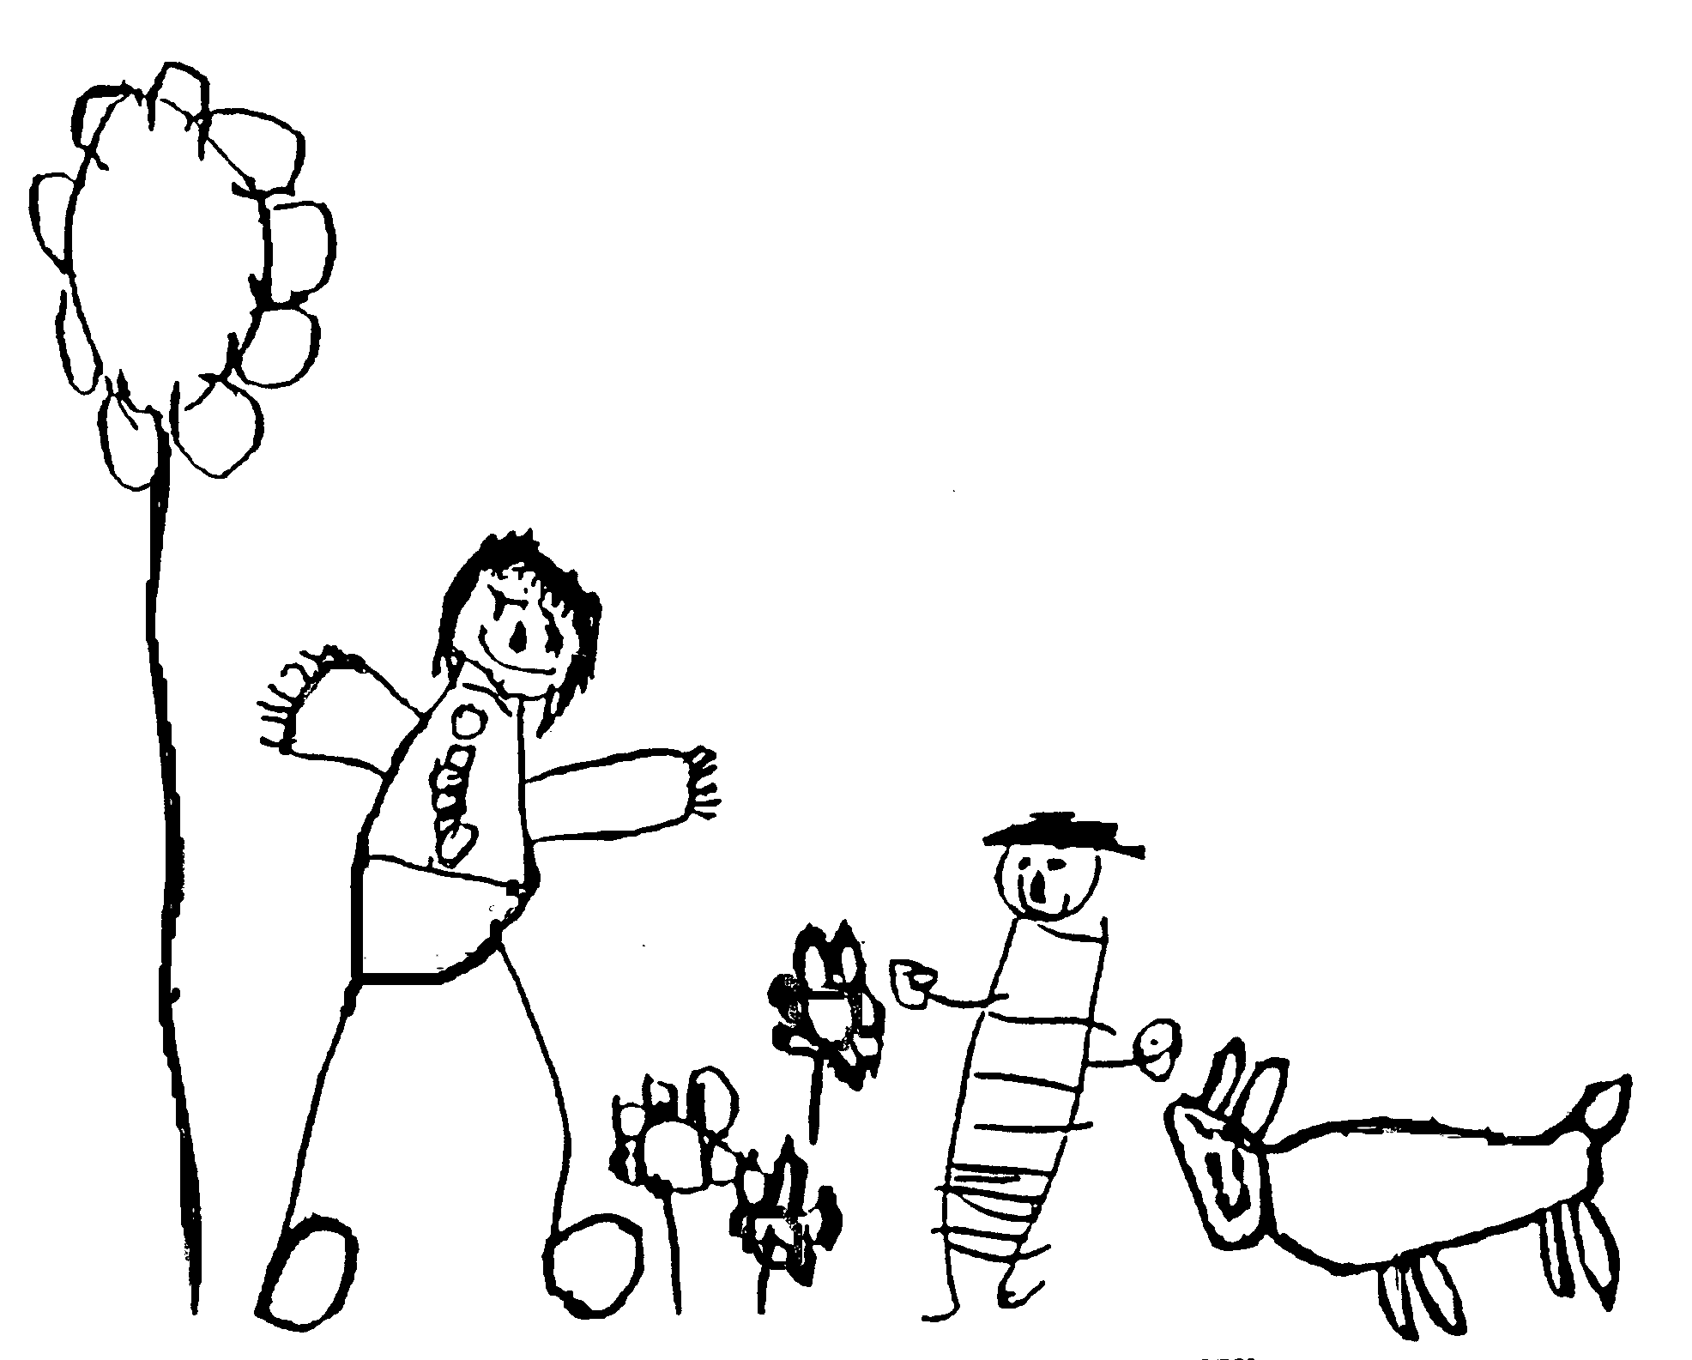
Margaret McMillan Nursery School
and Children's Centre
Hornsey Rise
Islington
N19 3SF
020 7281 2745
www.margaretmcmillan.islington.sch.uk

Collecting Children from Nursery Policy

For the purpose of this policy parents refers to those named on the child’s full birth certificate or those people who can provide legal documents giving full parental rights and responsibilities for the child.

Collection Procedures
Children can only be collected from school by their parents or by a responsible person nominated by their parents. Only the parents identified on the child’s full birth certificate can nominate an alternative collector.

Parents complete and sign an initial contact form at registration and the collection process is explained. The procedures are also covered in the parent handbook.

For occasional changes in collection arrangements parents should:
- Speak to staff to nominate an alternative collector this will be recorded in the diary for each team
- Contact school by telephone if circumstances change unexpectedly during the day and share a password (created on the day) which will be used by the person collecting, for additional security.

Where parents have regular alternative collectors they must complete and sign a collector’s card naming the collector, their address and telephone numbers, relationship to the child and the circumstances in which the parent is authorising the collection. These cards can be obtained from the child’s key worker or from the main school office. The details from these cards are uploaded onto Arbor and the child’s registration card attached to the child’s registration form, kept in the school office.

If there is any doubt about the collection arrangements staff will contact the parent for clarification before entrusting the child to an alternative collector.

Late collection
All children have an agreed collection time. This is an important time for the children so it is important that parents are punctual.
Occasionally delays may occur and parents must telephone the school office to let them know what is happening.
We must treat late collection seriously in the best interests of all the children. Any late collection can make it difficult to maintain staff ratios. Persistent late collection can be distressing and harmful for the child. The key worker will follow up late collection with parents.

Late collection payment for Day-care
Currently under review
Parents have a payment contract for the additional wrap around care. LBI reserve the right to impose a late collection charge where parents are frequently late or remove the place in the case of persistent lateness.

When a child is not collected
If a child is not collected at their usual collection time and no message has been received the school will try to contact the parent using the day time contact numbers provided at registration. We can only contact the nominated emergency contact if we cannot locate the parents.

When it is not possible to contact the parents
If it is not possible to contact the parents and make arrangements to collect the child before the school closes Children’s Social Care will be contacted to arrange a place of safety for the child.

When a child has been removed from the premises
If a child is moved from the premises a notice will be left on the main gate to the school (opposite the Health Centre) stating who should be contacted to find out what has happened.

Recording the incident
If a child is “not collected” and is removed from the premises a detailed record of the incident must be kept and Ofsted must be notified as this is a significant event.

Contacts: Children Social Care: 020 7527 7400 Option 1
The phone line connects to emergency duty team when out of hours service

Date reviewed | October 2024
Date of next review | November 2026
Ratified by Governing Body | November 2024

