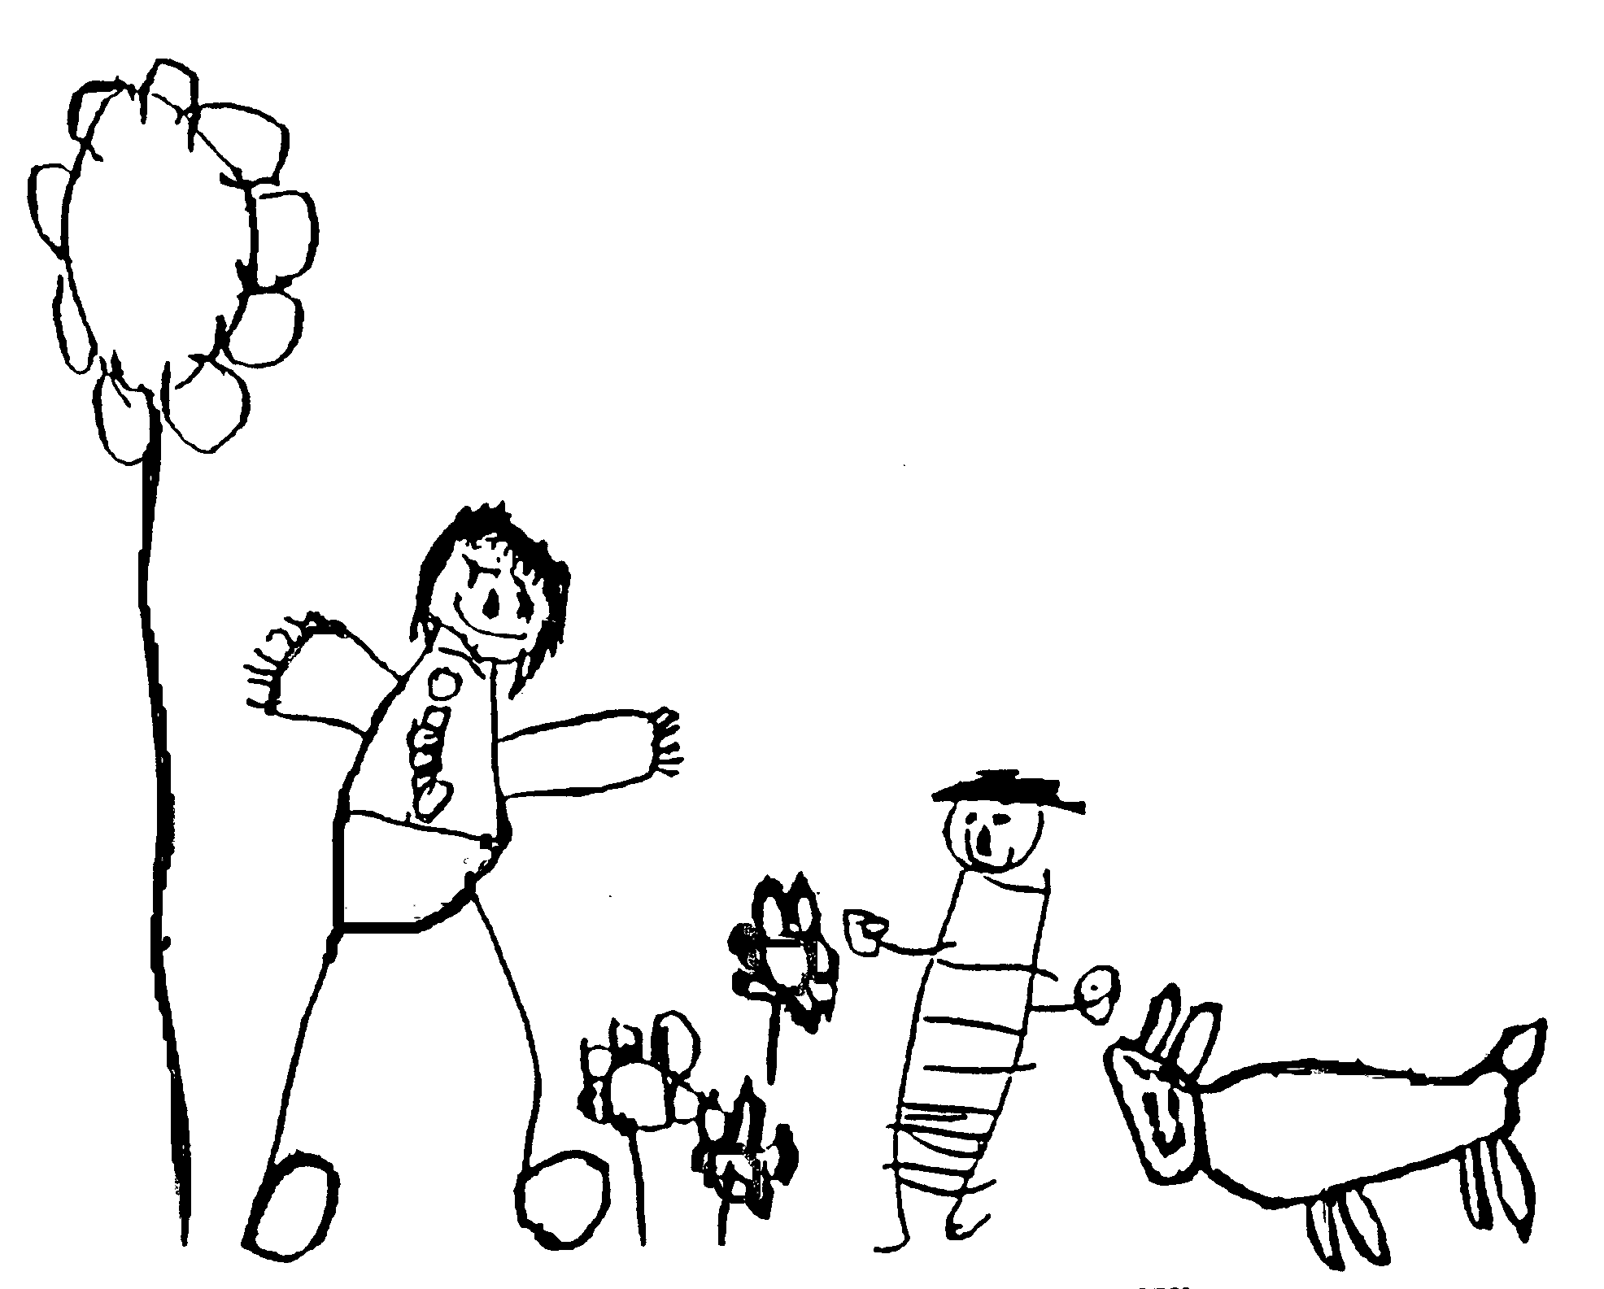
Margaret McMillan Nursery School
and Children's Centre
Hornsey Rise
Islington
N19 3SF
020 7281 2745
www.margaretmcmillan.islington.sch.uk

Famly Policy
Safeguarding and Welfare Requirement: The safeguarding policy and procedures must include an explanation of the action to be taken in the event of an allegation being made against a member of staff, and cover the use of mobile phones and cameras in the setting.

Policy statement
▪ We promote children's safety and wellbeing through the use of an online system called Famly.
▪ We will promote parental / carer engagement with their child’s day at Peekaboo through the facilities offered by this system.
▪ We support our policies and procedures through the tools offered by this system. Some of these are: Security, Safeguarding and Child Protection, Parents as Partners, maintaining legal ratio, admissions and Risk assessment
▪ We support staff to operate the system through, coaching, training and 121 support.
▪ We seek parental / carer permission for staff to access the system away from the setting subject to adherence to the conditions detailed in this policy.
What is Famly?
● Famly is the electronic on/line system we use for registering children and families at nursery, invoicing parents for their child’s nursery sessions and extra purchases, storing children’s information such as emergency phone numbers and contact details, monitoring attendance, securely signing children into nursery and monitoring safe collection of children, logging staff hours and when they are in the nursery building, logging and storing accident and incidents, communicating with parents and staff about events through calendar tool, communicating with staff and parents about nursery news on the news feed, communicating privately with staff and parents in the message tool and providing parents with an up to date log of their child’s day at nursery.
● The system operates by storing the information we input and parents input. We enter our information electronically using iPads, laptops and iphones. They can sometimes include a photo, a video and text.
How will we promote parental engagement?
▪ Parents have full control and access to what information the nursery has on their child and on them.
▪ Parents can contact nursery throughout the day and get up to date information on how their child is.
▪ Parents can have full access to all invoicing history and have a clear idea of what sessions their child will be attending
▪ We allow external access to the system to enable parents/ carers to add their input and view entries for their children online.
Staff Support
● Through,
- Staff Meetings
- Planning Meetings
- Supervision
- Training
we support staff to develop their understanding, skills and confidence in utilising the system
Parental / Carer Consent
● As an online system it can be accessed, from both within the setting and remotely. This may involve staff using their own IT facilities at home.
● Before accessing the system at home staff must,
- Confirm they have appropriate Security Software to protect their equipment
- Follow the Online Safety Policy
- Only use IT equipment that belongs to them personally and never use a shared device
- Confirm we have parental / carer consent to access the system away from the setting for the children whose records they are planning to work on.
- They must not download any material from the system to their own IT equipment.
- Never leave the system open if they are not present at their IT Equipment
Line Managers will,
- Monitor access to the system
- Maintain appropriate insurance cover
- Complete and review a risk assessment to cover remote access to the system
- Where possible provide opportunities for staff to obtain additional access time within the setting
- Ensure parents / carers consent is sought as part of the induction process and keep a record of responses
- Regularly review our IT protocols / security procedures
- As part of the Staff Supervision / Performance Management process, include a check to confirm Security Software arrangements on home IT Equipment.
- Follow the settings Safeguarding Policies and Procedures relating to suitable staff,
▪ Recruitment
▪ References
▪ DBS
Other Related Policies
● Online Safety
● Safeguarding
● Staff Recruitment
● Data Protection

Date written | October 2024
Date reviewed
Date of next review | October 2025
Ratified by Governing Body | November 2024

