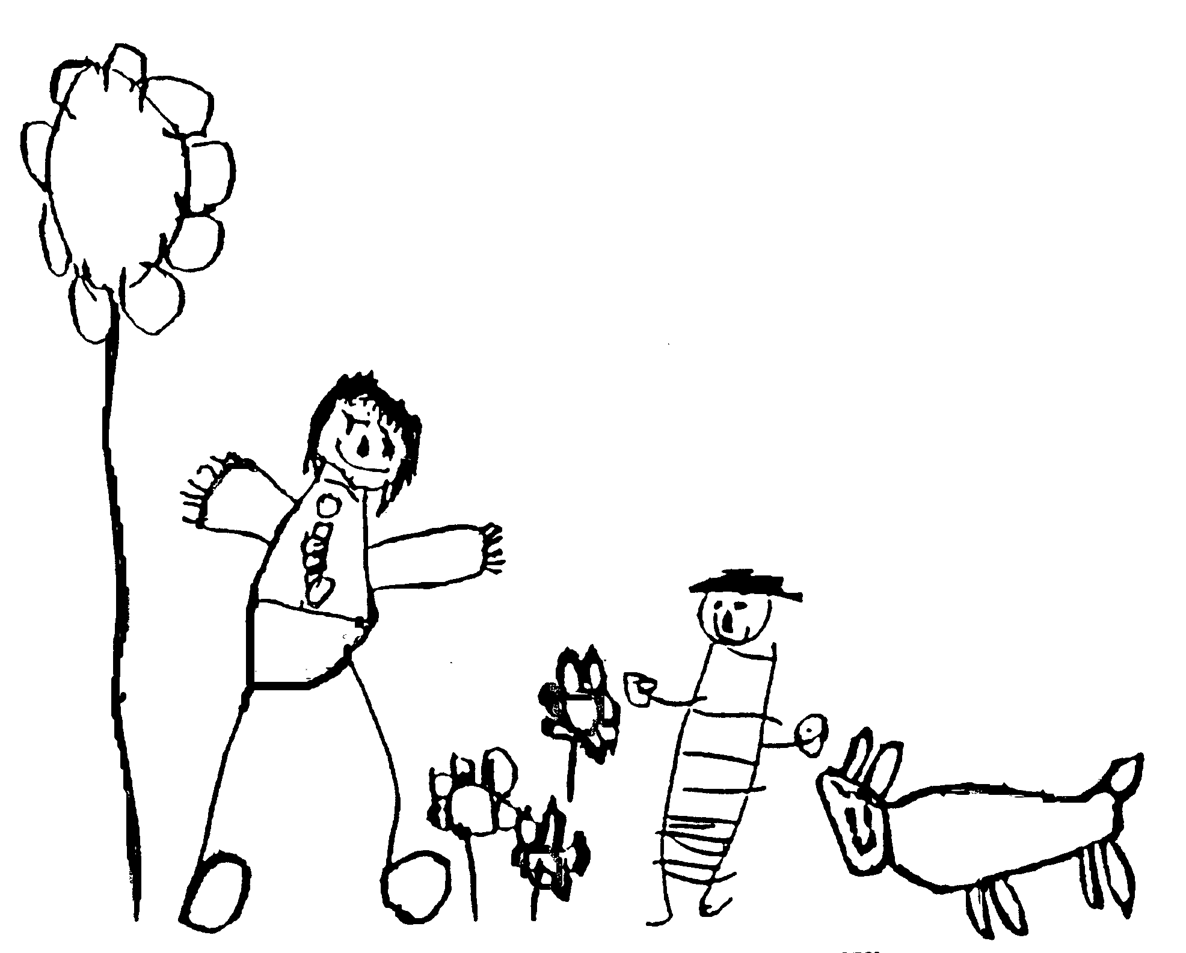
Margaret McMillan Nursery School
and Children's Centre
Hornsey Rise
Islington
N19 3SF
020 7281 2745
www.margaretmcmillan.islington.sch.uk

First Aid Policy

1.0 Introduction
1.1 The purpose of this First Aid Policy is to enable the school to effectively meet the requirements of the Health and Safety (First Aid) Regulations 1981 and in doing so to:
- Provide for the immediate needs and requirements of staff and students who have sustained either a serious or a minor injury
- Ensure that adequate resources and arrangements are in place to deal with injuries/accidents as they arise
- Ensure lines of communication with parents/guardians are in place if required
- Activate a known plan of action with which all staff are familiar

1.2 The School shall inform employees of the first-aid provisions made for staff, including the position of equipment, facilities and names of designated first aiders.

1.3 The treatment of minor illness by the administration of medicines falls outside of the definition of first aid in the Regulations and the School will not permit the presence of any such medication in designated first-aid boxes. Please refer to the Managing Medicines Policy for more information.

2.0 Definitions
2.1 ‘First aid’ means medical treatment for an injured person for the purpose of preserving and stabilising life and minimising the consequences of injury or illness until further medical treatment can be administered.

2.2 ‘First aider’ means: a person who holds a valid First Aid at Work Certificate or equivalent qualification.

3.0 Roles and responsibilities
- The overall responsibility for the day-to-day management of the school rests with the Head teacher.
- The class teacher or Senior Nursery Education Workers are responsible for room and garden supervision.
- The school's Health and Safety Officer is the Head teacher, in her absence the Deputy Head and in both their absences the School Business Manager or Senior Nursery Education Workers or Class Teachers.
- The Head teacher is responsible for ensuring training is up to date.

4.0 ASSESSMENT OF FIRST-AID NEEDS
4.1 The Head Teacher shall make an assessment of first-aid needs appropriate to the circumstances of the school. The Head Teacher will need to assess what facilities and personnel are appropriate, and to justify the level of first aid provision. Where necessary and relevant, all staff will be trained on how to administer aspects of first aid e.g. epi-pens.

4.2 Where the first-aid assessment identifies a need for employees to be trained as first aiders, the Head teacher shall ensure they are provided in sufficient numbers at appropriate locations to enable first aid to be administered without delay should the occasion arise. All designated first aiders must re-qualify every 3 years. This means re-qualifying before the end of the third year when the certificate is no longer valid. It is the responsibility of the head teacher to ensure they are booked onto the course before cancellation of the certificate.

4.3 All staff will ensure that they have read the school’s First Aid Policy, and sign the training record to say they have done this.

5.0 MANAGEMENT OF FIRST-AID EQUIPMENT
5.1 It shall be the responsibility of the designated First Aider to ensure the provision of materials, equipment and facilities needed for the level of cover required. This will include ensuring that first-aid equipment, suitably marked and easily accessible, is available in the agreed designated areas listed in item 6.2 below. Where additional or replacement material or equipment is required, staff should speak to the First Aider about ordering more items. The First Aider will also ensure that all out of date items are discarded and replaced. These need to be checked on a regular basis i.e. termly.

5.2 Although the First Aiders are responsible for maintaining and checking the first aid equipment, it is also expected that before going on duty/ on a school visit etc, first aid boxes will be checked daily by either a team leader or designated staff member.

6.0 FIRST-AID BOXES
6.1 All School first-aid boxes have a green coloured lid and are identified by a white cross on a green background. This conforms to the Safety Signs and Safety Signals Regulations.

6.2 Each first aid box should be placed where it can be clearly identified and readily accessible.
First Aid Boxes are located:
- in the main school office
- in the Saplings/Homebase bathroom
- in the Seedlings/Babyroom bathroom
- in the Sycamore/Class craftroom bathroom

- Portable First Aid kits are taken on educational visits and are available from the School Office.

6.3 The boxes should contain a sufficient quantity of suitable first-aid materials.
According to DFE guidance, as a minimum, First Aid Boxes should contain:
- a leaflet giving general advice on first aid,
- plasters,
- eye pads,
- triangular bandages,
- wound dressings,
- fabric scissors,
- disposable gloves.

A separate box, kept with First Aid Box should contain:
- tweezers

Kept in the office in a separate box next to the First Aid Box for emergency use there is:
- spare reliever inhaler
- spare autoinjector/Epi-pen.

No medicinal substance or materials are permitted within a first-aid box. This includes items such as antiseptic sprays, lotions, suntan oil, etc.

Ice packs are located in the freezer compartments of all fridges with ice boxes.

6.4 Individually wrapped sterile moist wipes, not impregnated with alcohol or antiseptic, may be used.

6.5 Blunt ended stainless steel scissors should be kept in the boxes in case there is the possibility that clothing may have to be cut away prior to first aid treatment.

6.7 Where medicines have to be held they are kept in relevant school area on a high shelf for easy access by staff in emergency
Any person may dispense medicines if they have permission from their line manager to do so.

7.0 First Aid training
7.1 The Head teacher will arrange training for the qualification and re-qualification of first aiders.

7.2 Before being nominated the designated first aider by their manager, a first aider must hold a valid First Aid at Work Certificate of competence or an equivalent qualification. In the event of an unqualified person being nominated to be responsible for first-aid duties, they will be required to undergo a suitable course of training.

8.0 Provision of First Aiders
8.1 There shall normally be a minimum of 3 designated first aiders or appointed persons within the school during Term time. In addition there will be a minimum of 6 paediatric first aiders

8.2 Consideration must also be made to ensure first-aid cover during absences, such as annual leave and sickness. This is the responsibility of the Head teacher.

9.0 CATEGORIES OF INCIDENTS AND PROCEDURES
9.1 Minor Accidents and Injuries
The adult in charge initially looks after the injured party. If deemed necessary, the staff member will contact a paediatric First Aider. No medicines are administered but cuts are cleaned with running water and bandages or plasters are applied if deemed appropriate. The use of disposable plastic gloves is mandatory at all times. All accidents are recorded in the Accident Book by the person administering first aid; parents are always informed on collection.

Treatment of bumps (including head bumps), cuts and grazes:
- A cold wet compress (cold wet blue paper towel) can used for minor bumps, cuts and grazes and cleaning the wound.
- An ice pack can be used for more serious bumps that have instant swelling and bruising.
Important: If an ice pack is used for head bumps, it must be put in a bag and wrapped in fabric (triangular bandage) and should only be used for no more than 5 minutes to avoid inducing hypothermia.
Minor Cuts and Bruises Method:
In all cases of injury it is understood that there is at least one adult present:
- Any member of staff may clean the wound and contact a First Aider if necessary
- Staff observation is maintained
- Children are advised to show/tell parents

Grazes Method:
- Clean the area thoroughly with large volumes of drinkable water until there is no foreign matter in the wound
- Pat dry with a sterile swab
- Cover with a sterile plaster or low adherent dressing

Splinters Method:
- Clean the area with warm soapy water and pat the area dry – do not disturb the splinter
- Remove splinter using tweezers – pull it out at the same angle that it entered
- Gently squeeze around the wound to encourage a little bleeding
- Wash the wound again then pat dry
- Cover with a dressing/plaster
- Phone parents to seek advice to ensure the child’s tetanus immunisation is up to date (in case of Sepsis)
- Tweezers are not kept in the First Aid Box, but in another box near the First Aid Box and must be kept clean.

Sprains/Bruises
- A first aider should administer first aid if appropriate. If the first aider is not available, any member of staff may implement the process of rest, ice, compress and elevate
- If in doubt, parent/s are contacted
- Staff observation is maintained

9.2 More Serious Accidents and Injuries
- Parents are immediately informed, particularly if there is a suspicion of broken bones/head or eye injuries.
- The child is kept under close observation until parents arrive, with the emphasis on making the child as comfortable and as settled as possible.

Burns/scalds
- Hold under running water for 20 minutes

Stings/Bites
- If case is serious parent/s are contacted – no stings should be removed.

Faints and Shocks
A first aider should administer first aid if appropriate. If the first aider is not available, any member of staff may implement the process of:
- Lie the casualty down
- Raise the legs above the level of the heart
- Loosen any tight clothing
- Ensure there is fresh air
- Keep crowds away
- Reassure casualty when they recover
- Contact parents – the pupil should go home

Anaphylactic shocks or Asthma Attack (first time)
- Use the emergency adrenaline autoinjector/Epi-pen or reliever inhaler (as appropriate) and follow the usual procedure
- Ring 999 for the ambulance service if no prescription is in place and permission for life-saving treatment to be used after administering medication and make a record
- Emergency autoinjector/Epi-pen or reliever inhaler is kept in a separate box next to the First Aid box
- Contact parents

Unconscious Child/Adult Recovery position
- Leave the child/adult as they were found if they are unconscious but breathing (in case of broken neck or spinal injuries)
- Monitor breathing continuously
- If breathing becomes compromised, put the child/adult in the recovery position or start CPR.

9.3 Very Serious Injuries
In the event of a very serious injury, parents/guardians are immediately contacted. If the considered opinion of the staff is that immediate professional help is required, an ambulance is called. On very rare occasions the staff may agree that taking the child to Accident & Emergency in a private car is a more prudent option particularly in the case of rapid blood loss. This should be on a voluntary basis. In such cases staff should ensure they have specific cover from their insurance company.
Parents are kept informed of developing situations. Very serious injuries are considered to be: Severe Bleeding, Burns/Scalds, Unconsciousness, Anaphylactic shock, Asthma attack.

The event is subsequently recorded in the Accident Report Book.

The First Aid Policy is based on collective staff input. All staff automatically support each other and the first-aider in the case of a serious injury.

10.0 First Aid record keeping
10.1 It shall be the responsibility of the Head teacher, or other nominated officer, to ensure that procedures are in place for the immediate recording of any injury as required by the Social Security Act 1975 and the Reporting of Injuries, Diseases and Dangerous Occurrences Regulations 1995. Details on the forms to be completed, time scales for completion and distribution and who is to be notified, are shown on the health & safety policy.

10.2 After administering treatment, all staff will ensure they adhere to the School’s arrangements for record keeping and accident reporting, as detailed below. Each first aider must receive appropriate instruction to enable them to carry out this responsibility during first-aid training.

10.3 All incidents, injuries, head injuries, ailments and treatment are reported in the accident book, kept in each school area.
The information recorded will include
- date, time and place of incident;
- name of the injured or ill person;
- details of the injury/illness and what first aid was given;
- what happened to the person immediately afterwards e.g. went home, went back to lessons, went to hospital, etc; and
- name and signature of the first aider or person dealing with the incident.

10.4 Parents are informed of all injuries on collection. The First Aider will decide if parents need to be contacted prior to collection. For head injuries we will inform parents by phone, observe the child until the end of the session for signs of concussion and pass on information to parents via a head bump letter at handover.

10.5 Admin team contact parents by phone if they have concerns about the injury.

10.6 Staff should complete a paper version of the IRIS form if they sustain an injury at work. This should then be passed to the workplace first aider for evaluation then entered on IRIS (LBI electronic system) if medical treatment was required.

10.7 An injured member of staff or other supervising adult should not continue to work if there is any possibility that further medical treatment is needed. The member of staff or other supervising adult concerned should seek medical advice without delay.

Reporting of Injuries, Diseases and Dangerous Occurrences Regulations 2013 (RIDDOR) apply to schools. Most incidents that happen in schools or on school trips do not need to be reported. The duty to notify and report rests with the ‘responsible person’. For incidents involving pupils and school staff, this is the head teacher. For incidents on school premises involving members of staff, pupils or visitors, HSE is the enforcing authority reports should be submitted to them. Details of specific injuries and illness can be found the HSE website and LBI website.

11.0 DUTY TO INFORM STAFF OF FIRST-AID ARRANGEMENTS
11.1 All staff must be informed of the location of first aiders, appointed persons, equipment and facilities.

11.2 The Designated First Aiders must ensure that a notice giving the names of first aiders, their location and telephone number and the location of first-aid boxes, is posted in each of the following locations:
- Staffroom
- School Office
- Saplings/ Homebase
- Sycamore/Class room

Notices will be inspected and kept up-to-date by the Designated Workplace First Aider as part of the regular health and safety inspections.

APPENDIX 1

Margaret McMillan First Aid Training Record October 2025
Margaret McMillan Nursery School

Workplace First Aiders
 | Name | Renewal date
 | Tracie Nugent | Sept 2027
 | Anne Moore | May 2028
Paediatric First Aiders
 | Name | Renewal date
 | Anne Moore | Nov 2025
 | Danielle Lee | Nov 2025
 | Bonnie Mendoza | Nov 2025
 | Clare Kelly | June 2027
 | Livia Kelly | June 2027
 | Donna Simmons | April 2027
 | Dez Demetriou | Sept 2027
 | Maria Liz De-Freitas | Sept 2027
 | Tracie Nugent | Sept 2027
 | Harley Foster | Nov 2027
 | Sherise Edwards | Nov 2027
 | Michelle Walker | March 2026
 | Rosie Schikwambi-Hunt | March 2026
 | Hayley O’Toole | June 2028
 | Iwona Szczypta | June 2028

Date reviewed | October 2025
Date of next review | October 2026
Ratified by Governing Body | November 2024

