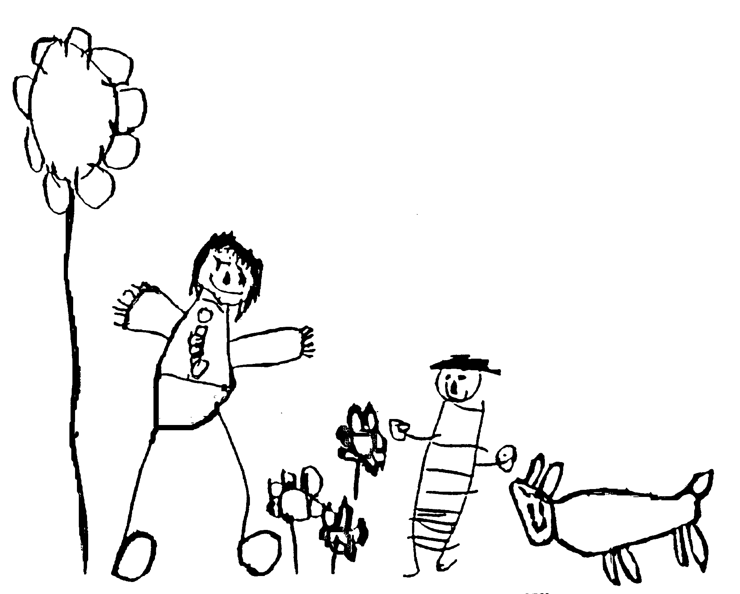
Margaret McMillan Nursery School
and Children's Centre
Hornsey Rise
Islington
N19 3SF
020 7281 2745
www.margaretmcmillan.islington.sch.uk

Healthy Eating Policy

Aims:
- To provide children under 5 with a wide and nutritionally balanced diet to develop their health, growth and well being.
- To show children that meal times are a good time to socialise with each other and to share food together.

What we do
We believe that children should eat a varied diet because this is associated with better health as it is more likely to contain all the vitamins and minerals the body needs.
They should eat foods from each of the four main food groups every day. The four main food groups are:
- Bread, other cereals and potatoes
- Fruit and vegetables
- Full fat milk and dairy foods
- Meat, fish or alternatives such as pulses (peas, beans, lentils and soya).

Dental health is an important issue. The Nursery aims to prevent dental problems related to diet by adopting this healthy eating policy. Sugary foods and drinks are avoided as they:
- Can lead to tooth decay if consumed frequently
- Tend to be high in calories and low in vitamins and minerals
- They can encourage a liking for sweet foods in young children

The healthy diet provided in nursery is the best possible diet for healthy teeth. Foods that contain sugar are eaten as part of a meal. For babies snacks such as fruit, vegetables, rice cakes and bread sticks are nutritious and free of added sugar. Water and milk, which are the safest drinks for teeth, are provided between meals for all children.

All children and their parents/carers should be respected as individuals and their food preferences and religious requirements should be accommodated where possible. This is done by celebrating different festivals and encouraging families to share how they celebrate the festival and the food, which is associated with it. It is important to value the contributions which different cultures and nationalities make to the variety of foods eaten.

Partnership with Parents
In all aspects of our work, we seek to enter into a partnership with parents. We do this by:
- Making sure parents/carers are aware that we are committed to promoting healthy, varied and enjoyable food
- Displaying menus
- Giving clear information on what children eat each day
- Accommodating special diets on medical grounds as needed, e.g. allergies
- Working with parents to celebrate festivals

Adult Role
Adults have a key role in influencing children’s attitudes and choices. We aim to:
- Be positive role models, providing opportunities for children to learn about food, food sources, nutrition, health, seasons and growing cycles and other people's ways of life.
- Use meal times as an opportunity to talk about healthy eating
- Talk about holidays and festivals as food plays an important part in most people’s celebrations
- Develop children’s social skills, sitting in small groups at meal times
- Encourage a pleasant and social atmosphere and environment
- Encourage children to listen and take turns
- Support children with special needs when eating
- Support developing independence and confidence when children are table setting and clearing
- Teach table manners, e.g. to be seated, to encourage children not to talk with food in their mouths, to give children enough time to eat, to encourage children to use please and thank you.
- Encourage health and safety when eating e.g. using utensils
- Promote the concept that mealtime is for eating but it is also a time for learning and socialising

Children are encouraged to become independent and take an active role:
- to take turns, setting tables, and clearing tables
- to learn to use knife, fork and spoon appropriately
- to develop skills and increase knowledge of healthy eating through trying new foods, cooking and discussion
- to share experiences with peers and adults
- to behave appropriately at the dinner table
- to develop social skills with reference to their age and stage of development

Meals provided
Breakfast 8.30- 9.00 (children must be in Homebase by 8.45)
Lunch 12 noon
Tea Babies and Homebase 4.00p.m.
Milk and fresh water are available all day

Snacks
We do provide snacks (fruit) for all children. Milk is available for children throughout the day. We encourage children to develop eating habits which include an active lifestyle with well balanced meals at clearly defined mealtimes.

Menus, special diets
Our menus are designed by Caterlink and are nutritionally balanced. Menus operate on a three week cycle, they are displayed on the main notice boards in each school area.

Bottle or Breast-fed babies:
Babies up to 4 –6 months of age receive all their nutritional requirements from breast or formula milk. When a baby starts at the Nursery the staff will continue to use whatever type of milk has been used at home.

Weaning
We work in partnership with parents when weaning babies. We aim to follow any routines established by parents at home. We can offer support and advice based on guidelines from the health visitor.

Vegetarians
Vegetarian meals are provided each day as part of the main menu.

Birthday and Leaving Parties
Birthdays are a very important event for many children. Parents are welcome to bring in a small treat to share in key groups. Most children are allowed to eat fruit so this is a good option for sharing.

Festivals and celebration
Festivals provide a valuable opportunity to include special occasion foods and to extend knowledge and awareness of other cultures. Parents are welcome to bring specialised foods to share but please discuss this with the keyworker prior to the celebration because of our children’s special diets.

* The Nursery makes every effort not to use nuts in any form or products known to have nut traces as these can induce severe or even fatal reactions in adults or children.

Date reviewed | October 2024
Date of next review | November 2026
Ratified by Governing Body | November 2024

