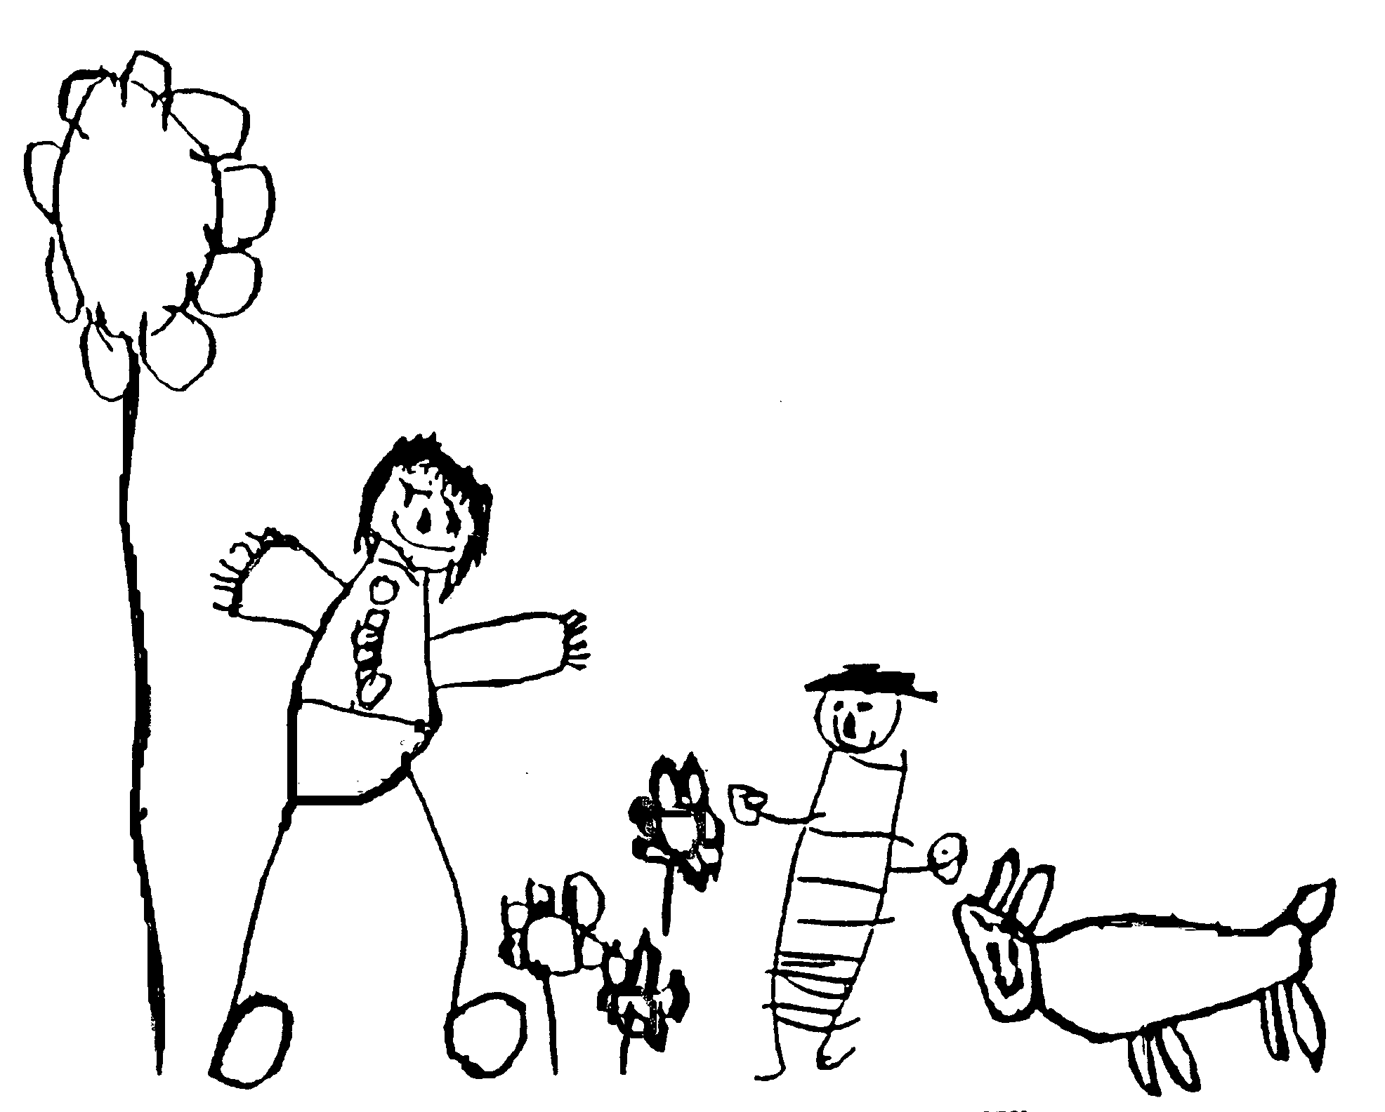
Margaret McMillan Nursery School
and Children's Centre
Hornsey Rise
Islington
N19 3SF
020 7281 2745
www.margaretmcmillan.islington.sch.uk

Intimate Care Policy

Margaret McMillan Nursery School is committed to ensuring that all staff responsible for the intimate care of children will undertake their duties in a professional manner at all times. We recognise that there is a need to treat all children with respect and dignity when intimate care is given. No child should be attended to in a way that causes distress or pain.

Staff that provide intimate care to children have a high awareness of child protection issues. Staff will work in partnership with parents/carers to provide continuity of care.

Definition:
Intimate care is any care which involves washing, touching or carrying out an invasive procedure (such as cleaning up a pupil after they have soiled themselves) to intimate personal areas. In most cases such care will involve cleaning for hygiene purposes as part of staff member’s duty of care. In the case of a specific procedure only a person suitably trained and assessed as competent should undertake the procedure.

Our Approach to Best Practice
The management of all children with intimate care needs will be carefully planned. The child who requires intimate care is treated with respect at all times; the child’s welfare and dignity is of paramount importance. We wish to ensure the safety and welfare of the children involved in intimate care routines and safeguard against any potential harm as well as ensuring the staff member involved is fully supported and able to perform their duties safely and confidently. Staff that will provide intimate care are trained to do so (including Child Protection and Moving and Handling) and are fully aware of the best practice. Areas where intimate care takes place by staff are easily visible to other staff members but offer privacy for the child, e.g. high level vision panels in bathrooms.

Our nursery will provide suitable equipment and facilities to assist children who need special arrangements following assessments from outside professionals.

Ways of Working
- Every child is treated with dignity and respect. Privacy is ensured appropriate to the child’s age and situation, regardless of whether it is staff or a parent or carer attending to the child’s needs. Staff will be supported to adapt their best practice in relation to the needs of individual children.
- All staff undertaking intimate care routines have enhanced DBS checks carried out on them.
- All staff are trained in the appropriate methods for intimate care routines and access specialist training where required i.e. first aid training, specialist medical support.
- All new staff have training to ensure they are fully aware of all nursery procedures relating to intimate care routines.
- The child is involved as much as possible in his or her own intimate care. Staff should avoid doing things for a child and allow the child to be as independent as possible. This is important for tasks such as removing underclothes as it is for washing the private parts of a child’s body.
- Staff should support children in doing all that they can for themselves. Where a child is fully dependent staff should talk with him / her about what they are doing and give choices where possible.
- Staff should be responsive to a child’s reactions. It is appropriate to ‘check’ practices by asking the child (particularly a child you have not previously cared for) – “is it ok to do it this way?”, “Can you wash there?” If a child expresses dislike of a certain person carrying out his / her intimate care, try and find out why. Conversely, if a child appears distressed or dislikes you, ensure your manager is aware of this.
- Staff should encourage the child to have a positive image of his / her own body. Confident, assertive children who feel their body belongs to them are less vulnerable to abuse. As well as the basics like privacy, the approach you take to a child’s intimate care can convey lots of messages about what his / her body is worth.
- Staff attitude to a child’s intimate care is important. As far as appropriate and keeping in mind the child’s age, routine care of a child should be enjoyable, relaxed and fun.
- Staff should make sure the practice of intimate care is as consistent as possible. The team leaders have a responsibility for ensuring the staff have a consistent approach. This does not mean that everyone has to do things in an identical fashion, but it is important that approaches to intimate care are not markedly different between individuals.

Date reviewed | September 2024
Date of next review | September 2026
Ratified by Governing Body | November 2024

