Margaret McMillan Nursery Calendar
September 2026
Mon | Tue | Wed | Thu | Fri | Sat | Sun
 | 1 | 2 | 3 | 4 | 5 | 6
7 | 8 | 9 | 10 | 11 | 12 | 13
14 | 15 | 16 | 17 | 18 | 19 | 20
21 | 22 | 23 | 24 | 25 | 26 | 27
28 | 29 | 30
October 2026
Mon | Tue | Wed | Thu | Fri | Sat | Sun
 |  |  | 1 | 2 | 3 | 4
5 | 6 | 7 | 8 | 9 | 10 | 11
12 | 13 | 14 | 15 | 16 | 17 | 18
19 | 20 | 21 | 22 | 23 | 24 | 25
26 | 27 | 28 | 29 | 30 | 31
November 2026
Mon | Tue | Wed | Thu | Fri | Sat | Sun
 |  |  |  |  |  | 1
2 | 3 | 4 | 5 | 6 | 7 | 8
9 | 10 | 11 | 12 | 13 | 14 | 15
16 | 17 | 18 | 19 | 20 | 21 | 22
23 | 24 | 25 | 26 | 27 | 28 | 29
30
December 2026
Mon | Tue | Wed | Thu | Fri | Sat | Sun
 | 1 | 2 | 3 | 4 | 5 | 6
7 | 8 | 9 | 10 | 11 | 12 | 13
14 | 15 | 16 | 17 | 18 | 19 | 20
21 | 22 | 23 | 24 | 25 | 26 | 27
28 | 29 | 30 | 31
January 2027
Mon | Tue | Wed | Thu | Fri | Sat | Sun
 |  |  |  | 1 | 2 | 3
4 | 5 | 6 | 7 | 8 | 9 | 10
11 | 12 | 13 | 14 | 15 | 16 | 17
18 | 19 | 20 | 21 | 22 | 23 | 24
25 | 26 | 27 | 28 | 29 | 30 | 31
February 2027
Mon | Tue | Wed | Thu | Fri | Sat | Sun
1 | 2 | 3 | 4 | 5 | 6 | 7
8 | 9 | 10 | 11 | 12 | 13 | 14
15 | 16 | 17 | 18 | 19 | 20 | 21
22 | 23 | 24 | 25 | 26 | 27 | 28
23 | 24 | 25 | 26 | 27 | 28

Key: Inset Day – Closed to all children
Staff Development Day – Early Closure
Half Term/Holidays – Closed to term time children only
Bank Holiday – Closed to all
Nursery Closed to all
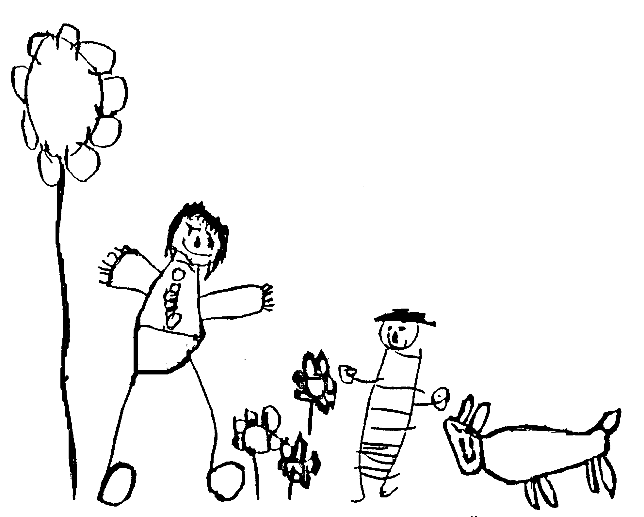
Academic Year 2026-2027
March 2027
Mon | Tue | Wed | Thu | Fri | Sat | Sun
1 | 2 | 3 | 4 | 5 | 6 | 7
8 | 9 | 10 | 11 | 12 | 13 | 14
15 | 16 | 17 | 18 | 19 | 20 | 21
22 | 23 | 24 | 25 | 26 | 27 | 28
29 | 30 | 31
April 2027
Mon | Tue | Wed | Thu | Fri | Sat | Sun
 |  |  | 1 | 2 | 3 | 4
5 | 6 | 7 | 8 | 9 | 10 | 11
12 | 13 | 14 | 15 | 16 | 17 | 18
19 | 20 | 21 | 22 | 23 | 24 | 25
26 | 27 | 28 | 29 | 30
May 2027
Mon | Tue | Wed | Thu | Fri | Sat | Sun
 |  |  |  |  | 1 | 2
3 | 4 | 5 | 6 | 7 | 8 | 9
10 | 11 | 12 | 13 | 14 | 15 | 16
17 | 18 | 19 | 20 | 21 | 22 | 23
24 | 25 | 26 | 27 | 28 | 29 | 30
31
June 2027
Mon | Tue | Wed | Thu | Fri | Sat | Sun
 | 1 | 2 | 3 | 4 | 5 | 6
7 | 8 | 9 | 10 | 11 | 12 | 13
14 | 15 | 16 | 17 | 18 | 19 | 20
21 | 22 | 23 | 24 | 25 | 26 | 27
28 | 29 | 30
July 2027
Mon | Tue | Wed | Thu | Fri | Sat | Sun
 |  |  | 1 | 2 | 3 | 4
5 | 6 | 7 | 8 | 9 | 10 | 11
12 | 13 | 14 | 15 | 16 | 17 | 18
19 | 20 | 21 | 22 | 23 | 24 | 25
26 | 27 | 28 | 29 | 30 | 31
August 2027
Mon | Tue | Wed | Thu | Fri | Sat | Sun
 |  |  |  |  |  | 1
2 | 3 | 4 | 5 | 6 | 7 | 8
9 | 10 | 11 | 12 | 13 | 14 | 15
16 | 17 | 18 | 19 | 20 | 21 | 22
23 | 24 | 25 | 26 | 27 | 28 | 29
30 | 31

