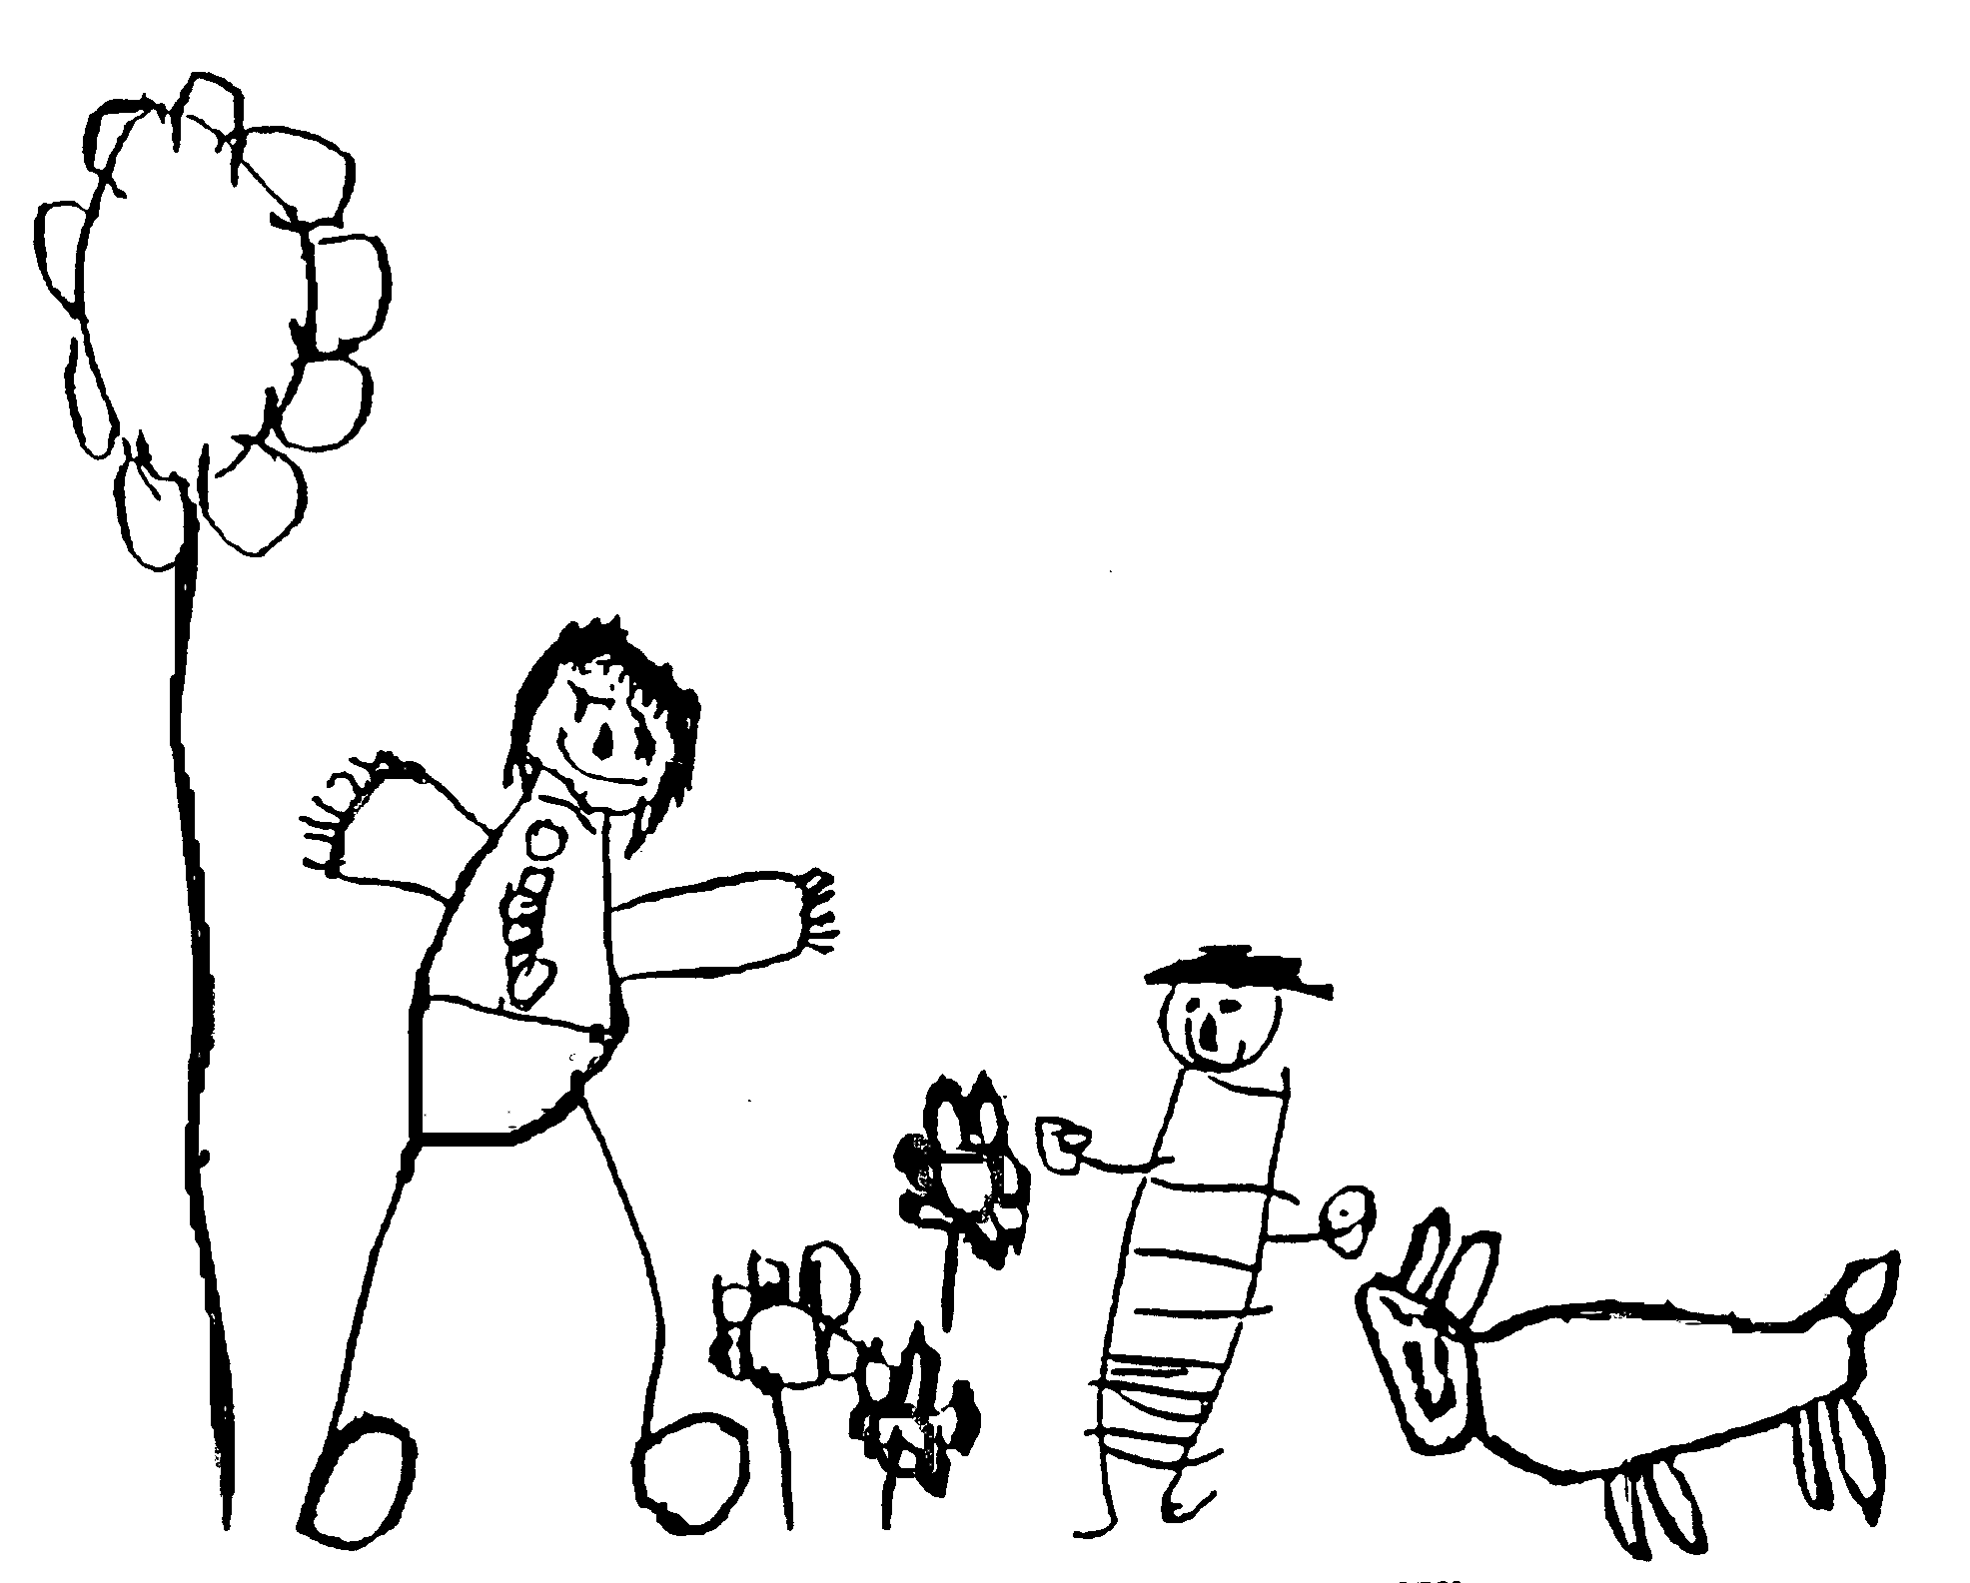
Margaret McMillan Nursery School
and Children's Centre
Hornsey Rise
Islington
N19 3SF
020 7281 2745
www.margaretmcmillan.islington.sch.uk

Managing Medicines in School Policy

Aims
- To promote the inclusion and participation of all children
- To help all children to achieve and to make progress, whatever their medical need
- To safeguard children’s health and safety by ensuring that prescribed medicines are handled responsibly and safely

Non-prescribed medicines should never be administered in schools or settings by school or setting staff.

Overview:
Almost all pupils have a medical condition at some time that affects their attendance or ability to take part in school activities. A medical need may be:
- short term (such a finishing a course of medication)
- acute (such as an allergic reaction),
- recurrent (such as recurrent asthma or epilepsy)
- long term and persistent (such as conditions experienced by children with complex medical needs)
Any of these instances must be managed so that each child’s access to education is safeguarded, no child is discriminated against on the basis of disability caused by a medical condition, and medicines are managed and administered safely.

Most pupils with long term medical needs can, with support, attend school regularly and take part in many normal activities.

Rights and responsibilities
Children
- Children with medical needs have the same right of admission to school as other children.
- Children with medical needs have the same right as other children to join in the activities and life of the school, the school will make reasonable adjustments that allow them to do so.
- Children’s medical details will be kept confidential and information shared only on a need to know basis.

Parents/Carers
- Parents/carers have prime responsibility for their children’s health and for providing information about any medical condition.
- Children should usually be kept at home if they are unwell.
- Parents or carers should administer medicines wherever possible, e.g. by arranging medicines or dosages that can be given out of school hours.
- Where information about a medical condition is shared it will be with the recorded consent of the parents/carers.
- The school will administer medication for a short term illness, e.g. antibiotics for a chest infection. If your child has been prescribed Antibiotics by your GP, we ask that you keep them at home for at least 48 hours or longer if recommended by the health practitioner, whichever if the greater, for the antibiotics to start to do their work before returning to Nursery and agreeing for staff to administer the rest of the course.
- Parental consent to the administration of prescribed medicines in schools must be given in writing (see Appendix 1).
- Parents or carers must deliver prescribed medicines personally in the original container with clear written dosage instructions.
- Parents/carers are responsible for restocking and disposing of medicines.
- Parents or carers should not expect the school or setting to administer non-prescribed medicines.
- We do not administer ‘Calpol’ to children (unless it is prescribed as part of a care plan by a GP).

Childcare providers, Early Years Settings and Schools
- This school has a clear policy on managing medicines together with clear procedures understood and accepted by staff, and drawn to the attention of parents.
- Policy and procedures cover all aspect of school life, including trips and visits.
- Managing and administering prescribed medicines is seen as part of, and included in accessibility planning.
- The law does not specifically require school or setting staff to administer medicines but anyone caring for children including teachers, other school staff and day care staff in charge of children have a common law duty of care to act like any reasonable parent which in exceptional circumstances could extend to administering medicine and or taking emergency action, within the context of the school’s written policy.
- Any member of staff administering medicine must be trained to administer that medicine and is supported by health professionals where needed.
- The school will seek advice and training from health professionals where they deem it necessary.
- A plan, to which parents, health professionals and school/setting staff contribute, should be drawn up by the school/setting for each child with medical needs.

Managing Risk
- All staff should follow universal precautions to protect themselves and others when administering medicines.
- Risk assessment and management procedures must be clearly understood by all.
- The headteacher is responsible for decisions on arranging the administration of medicines within the school and for assessing and managing risk.
- Staff must be appropriately trained and must follow the direction of health practitioners.
- All medicines must be stored in the containers in which they were dispensed.
- Staff must never force children to take medicines. If children refuse to take medicines this should be recorded and parents informed on the same day.
- Medication must only be administered in accordance with school’s clear written policies and procedures.
- The headteacher or designated person should make sure all members of staff are aware of the policy for managing medicines.
- If liability (loss, claims, proceedings) arise as a result of the administration of medicines by a member of staff the Council as employer will indemnify the member of staff providing the following conditions apply:
- The member of staff is an employee of the Council
- The medication is administered during the course of employment with the Council
- The member of staff has followed the school/setting policy and procedure, the child’s health care plan, and directions received in training
- Liability does not arise from fraud, dishonesty or criminal offence

Procedures
Staff must refer parents/carers to the class teacher or SNEWs if they require medication to be administered.
- Class teacher or SNEWs will meet with the parent to explain our policy on administering medicines. The class teacher or SNEW will assess whether the medication is such that specialist training and guidance is required, e.g. epilepsy, anaphylaxis or whether specific advice from a medical practitioner is adequate, e.g. asthma inhalers, eczema creams. They will ascertain whether a care plan has been drawn up by medical professionals and ask for a copy.
- If specialist training and guidance is required the teacher or SNEW will refer the matter to the key health and safety officer for further action. These children will usually have a medication care plan, e.g. an allergy or wheeze plan, usually drawn up by the paediatric community nursing team, which is specific to their needs. The key health and safety manager will gain parental permission to contact relevant health care professionals and ensure relevant training and support is put in place.
- If no specialist training is required the teacher or SNEW will explain to the parent the type of documentation required before we will undertake to administer medication. There is a letter detailing this information that is available for parents to take to their GP or community nursing team.
- Once the parent has acquired relevant documentation the team leader will ascertain as much information as possible about when and how the medication should be administered. This information and medical advice should then be passed to the Headteacher who will undertake to write a school careplan for administering this particular medication.
- The SNEW or class teacher will then go through the guidelines with the parent, clarify any issues, get the parent to sign and date the guidelines if agreed, the Headteacher will make 1 copy each for the parent, child’s file and office medication file, and a copy is kept with the medication.
- Once this process has been carried out the medication can be administered. One person, usually the class teacher or SNEW, will be nominated as the link between carer and school.
- Staff should check expiry dates on medication each half term and inform parents if the medication will expire during the following half term. This should be logged (dated and signed) and a copy kept with the medication.
- Medication should be sent home with the child at least at the end of each academic year.

- The school keeps written lists of staff trained and willing to administer specific medications for ongoing medical needs, these lists are attached to each individual care plan and updated as advised by Health professionals.
- For children with long term and persistent medical needs staff receive training related to individual children or the specific conditions and medications as advised by a health professional
- Each school area has a designated shelf out of the reach of children for storing medication. This enables prompt action to be taken in the event of a life threatening emergency, e.g. anaphylactic reaction.
- All medicines must be in their original container and be clearly labelled with the child’s name, dose and frequency of administration.
- Medicines will be stored in accordance with the written advice on the packaging. All medicines will be stored out of reach of the children in a clear plastic container labelled with the child’s name, in a safe location, ensuring that emergency medication such as inhalers and adrenaline pens are easily accessible to staff.

Emergencies
In case of emergency all school telephones have a 999 dial out access. Relevant school information is stored on the card by each telephone.

Visits and Outings
- In order to enable children to participate in all school activities children with medical needs are planned for in risk assessment for school outings and trips.
- In some instances the risk assessment findings are such that pupils cannot take part unless accompanied by a parent.
- Staff supervising outings should be aware of any medical needs and relevant emergency procedures.

This policy should be read in conjunction with:
Managing Medicines in Schools and Early Years Settings (DfES/DH 2005) updated 2017
School Health Issues (Islington NHS Primary CareTrust 2005)
Supporting pupils at school with medical conditions (DFe2015 updated 2017)

Date reviewed | October 2024
Date of next review | October 2026
Ratified by Governing Body | November 2024

Appendix 1
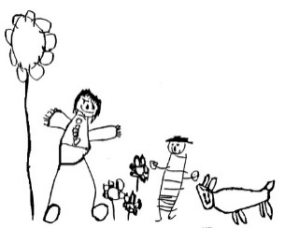

Parental agreement for school/setting to administer medicine
The school will not give your child medicine unless you complete and sign this form, and the school has a policy that staff can administer medicine.
Name of School/Setting
Date
Child’s Name
Class
Name and strength of medicine
Expiry date
How much to give ( i.e. dose to be given)
When to be given
Any other instructions
Number of tablets/quantities to be given to school/setting
Note: Medicines must be the original container as dispensed by the pharmacy
Daytime phone no. of parent or adult contact
Name and phone no. of GP
Agreed by Senior Leader

The above information is, to the best of my knowledge, accurate at the time of writing and I give consent to school staff administering medicine in accordance with the school policy. I will inform the school/setting immediately, if there is any change in dosage or frequency of the medication or if the medicine is stopped.

Parent’s signature: |  | Print Name:
If more than one medicine is to be given a separate form should be completed for each one

Record of medicine administered to an individual child

Date
Time Given
Dose Given
Name of member of staff
Staff initials

Date
Time Given
Dose Given
Name of member of staff
Staff initials

Date
Time Given
Dose Given
Name of member of staff
Staff initials

Date
Time Given
Dose Given
Name of member of staff
Staff initials

