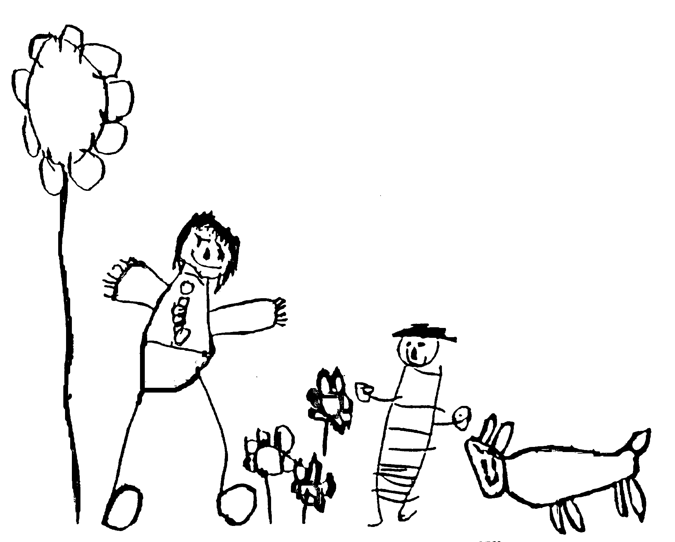
Margaret McMillan Nursery School
and Children's Centre
Hornsey Rise
Islington
N19 3SF
020 7281 2745
www.margaretmcmillan.islington.sch.uk

Missing Child Policy

Background
Margaret McMillan is a large and complex site. Children may use different parts of the site at different parts of the day. As part of Brightstart Children’s Centres we offer a range of services some of which involve informal sessions for parents and children and some which involve a range of professionals working for short periods in school. We need to do everything possible to make sure that the children are safe and secure in each part of the school. Systems are in place to identify which children are in different parts of the school and who is responsible for them. Systems are also in place to move children safely between different parts of the school and to hand over responsibility between teams. Staff teams need to be aware of the children in their area and be alert and in location throughout the session.

Our exits and boundaries are secure and we have planned enclosures between the school doors and the road designed to keep the children safe even if they leave their parents. However safe our procedures are we still need to face the reality that a child could go missing and we need plans in place to deal with this.

What to do if staff think that a child in their care is missing
If staff become concerned that a child is missing they should
- Inform colleagues immediately.
- Check all exits and boundaries are secure and that all the other children are safe and accounted for
- Undertake an immediate search of all the likely hiding places bearing in mind that our children are very young, hiding and den play are common parts of normal development.

If the child is ‘found’ quickly
It may seem as if all is well. This may be the case and staff may simply have lost sight of the child in normal play. Nevertheless the senior member of staff on duty must undertake an immediate risk assessment to ensure that the incident is innocuous and not a “near miss”. If in doubt a risk assessment must be carried out and the incident reported to the school health and safety officer on duty for investigation and action. Any steps needed to make the space secure must be taken. These could include securing or isolating an area or gathering the children for a group time whilst a thorough check is made.

If the child is not ‘found’ quickly within 5 minutes
- A much more thorough search must be started
- The children should be collected together and properly supervised for a group time and head count
- The senior member of staff on duty should phone the office staff to let them know what has happened
- Office staff should immediately alert all sections of the school to ensure all exits are secure

If the child is then found within a reasonable time all the procedures outlined above must be followed and:
- The senior member of staff on duty must undertake an immediate risk assessment to establish why a missing alert occurred
- If in doubt a risk assessment and IRIS(LBI accident reporting database) must be filled in
- The incident and risk assessment must always be reported to the school health and safety officer for investigation and action.
- Any steps needed to make the space secure must be taken. These could include securing or isolating an area or gathering the children for a group time whilst a thorough check is made.

If the child is not found within 15 minutes
The emergency services and the parent / guardian will be contacted. LBI under fives section will be informed of the incident.

After the incident is resolved
A thorough investigation will take place to ensure that measures are in place to ensure that the situation does not arise again. If needed advice will be sought from LBI

In the event of a child being lost on an outing
On all outings regular headcounts will be carried out throughout the outing, at least hourly on longer outings:
- The senior staff member on the outing must be informed as soon as it is realised that a child is missing and they will take charge of the incident
- An immediate roll call and register will be taken of each individual group or the whole group.
- Ensuring remaining staff/child ratios and safety of the children, staff will be deployed with mobile phones to search the immediate area. The senior staff member will contact personnel at the venue if appropriate to alert them that a child is missing and their own procedures need to be put in place.
- If the child is not located the senior staff member will inform the police
- The senior staff member will inform the school who will take responsibility for informing the parents and the LEA
- Practitioners from school will be sent to assist the safe return of the remaining children if appropriate
- The senior staff member will await instructions from the police
- Any incidents must be recorded in writing
- Ofsted will be informed by the head

After the incident is resolved
A thorough investigation will take place to ensure that measures are in place to ensure that the situation does not arise again. If needed, advice will be sought from LBI.

Date reviewed | October 2024
Date of next review | November 2026
Ratified by Governing Body | November 2024

