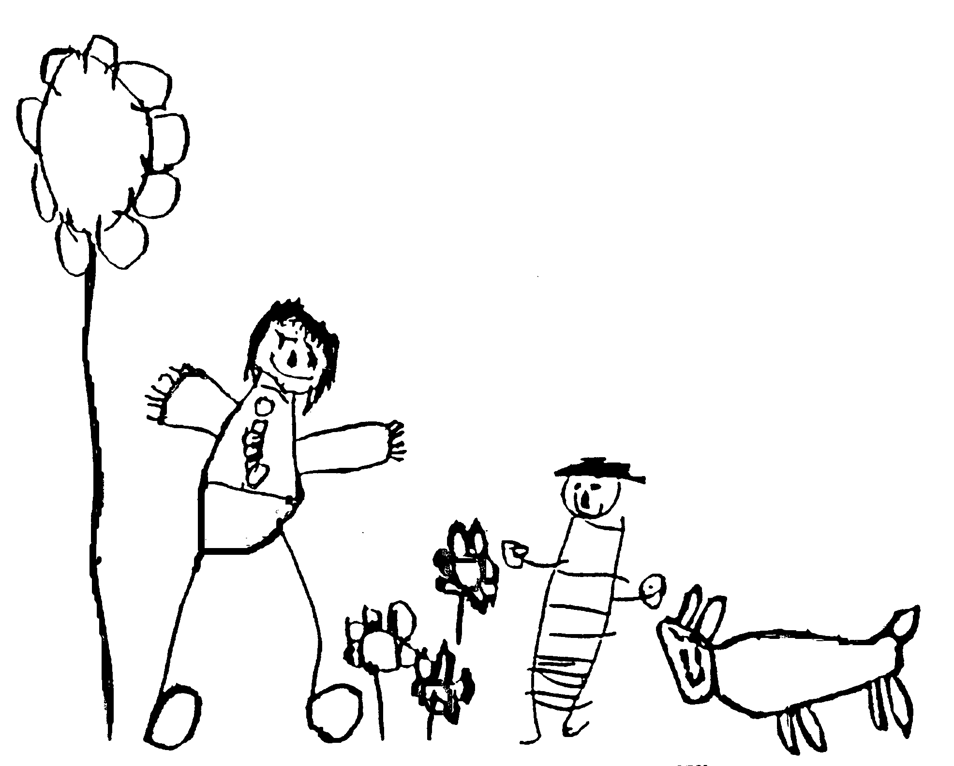
Margaret McMillan Nursery School
and Children's Centre
Hornsey Rise
Islington
N19 3SF
020 7281 2745
www.margaretmcmillan.islington.sch.uk

Safer Handling Policy
1.Introduction
This policy outlines the approach to the use of reasonable force and physical intervention within our Early Years Foundation Stage (EYFS) setting. Our priority is to ensure the safety, welfare, and dignity of all children and staff.
2. Legal Framework
This policy is guided by Section 93 of the Education and Inspections Act 2006 and the EYFS Statutory Framework. Staff may use reasonable force only to prevent a child from:
- Hurting themselves or others
- Causing serious damage to property
- Seriously disrupting a safe environment

3.Principles
- Last Resort: Physical intervention is used only when all other strategies have been exhausted or were likely to fail and there was no time to deescalate.
- Minimum Force: Any intervention must use the minimum force necessary for the shortest time possible to achive the aim of harm prevention.
- Safety and Dignity: Staff must take all reasonable steps to avoid pain, humiliation, or restrict breathing.

4. Positive Behaviour Strategies
Staff will use positive approaches to support behaviour, including:
- Distraction and redirection
- Calming and reassurance
- Clear, consistent boundaries
- Can the child be contained rather than restrained.

5.When Physical Intervention May Be Used
Physical intervention may be appropriate in situations such as:
- A child running into danger (e.g., a road)
- A child physically harms themselves or others.
- Serious damage to equipment or environment
- Consider the quality of “reasonableness” given the situation what would reasonable person do.

6.Recording and Reporting
All significant handling incidents must be:
- Recorded in the incident log
- Reported to the Designated Safeguarding Lead (DSL)
- Communicated with parents/carers on the same day.

7.Staff Responsibilities
Only trained and authorised staff should use physical intervention. All staff must:
- Remain calm and measured.
- Avoid actions that could cause harm.
- Follow safeguarding procedures.
- Act in the best interests of the child while avoiding exposing themselves or others to harm.

8. Parental Partnership
Parents will be informed of this policy and will be notified promptly of any incidents involving physical intervention.

9. Review of Policy
This policy will be reviewed annually or following any incident, to ensure it remains compliant with legislation and best practice.

Date reviewed
Date of next review | October 2026
Ratified by Governing Body | November 2025

