Welcome to Margaret McMillan Nursery School and Children’s Centre

Starting School

Starting school is a very important time for you and your child. This pack and notes were designed by parents and staff to help with all the information you will receive at settling and over the next few years.

The pack contains information about:

- Settling in at Margaret McMillan

- School Organisation and Routines

- Attendance, Timekeeping and Collection of Children

- Security, Health and safety

- Early Years Foundation Stage Curriculum

- Parental Involvement

There might seem like a lot to find out about and do. Don’t worry, staff are there to help, ask as many questions as you like!

We are all looking forward to working with you and your child.
Settling in at Margaret McMillan

Settling programmes are designed individually to best suit the needs of each child.

Every child is allocated a key person. Your child’s key person will be part of a team who will work together to support your child’s learning and development. Your child’s key person is your main point of contact but any of the team members should be able to answer incidental questions.

Children and their families are all individuals with different needs. To allow for this admissions are organised on an individual basis. Staff will want to talk to you about what is best for you and your child.

Some children will be used to being around many different people, others may not. Some children are naturally sociable, others like us, need time to adjust. Some children will settle very quickly, others will take more time. We aim for about a week for the settling in period but understand this may vary according to the needs of your child.

We realise that it may be difficult for some parents to arrange time off to help settle their child, and so we suggest asking another familiar adult to support with this if you are unable to do so yourself.

Every family is different and we like to take this into account. Staff are ready to organise an individual program that best suits your child and you.

If your child is under 3 years old, or will be at school for a long (extended hours) day, a more complex settling program may be needed. Staff will work out the best day care program for your child, as part of their admissions process.

As part of the admissions process we will invite you in to school to complete all the forms necessary. We will then arrange a Home Visit for your child’s Key Person and another member of staff to visit your child in a place where they feel comfortable. This is a wonderful opportunity for staff to get to you know you and your child in a familiar setting and to find out what they are interested in, what motivates them and how we can best support them at school. It is also a great chance for you to ask any questions you may have.

After 6 weeks since their start date, when your child has fully settled, you will be invited to an initial conference to review how your child has settled and plan next steps for them.

School Organisation and Routines

School hours (Class)

All children are entitled to 15 hours free nursery provision from the term after their 3rd birthday. At Margaret McMillan we offer this as 4 part-time sessions (morning or afternoon) and 1 full day.
Part time sessions are:

9.30am - 11.45am or 1.15pm - 3.30pm

There is a 15 minute flexibility window at these times so drop off can be
9.30-9.45am and pick up can be either 11.30-11.45am or 3.15-3.30pm.

Full time sessions are:

9.30am - 3.30pm

This is called the core day.
The 15 minute flexibility window is also available at these times (please see above).

Day-care hours (HomeBase)

Alongside the class places the school is open:

8.00am and 5.30pm for 48 weeks of the year (closed 2 weeks at Christmas and 2 weeks in late August).

There are places for children from 0-5 years. This will include breakfast for your child and tea.

Parents pay for day-care based on hours used and joint family income.

Allocation of places

The first 30% of all places are allocated by the borough, on the basis of a referral by one of the agencies who work with families and young children. This could be the health visitor, a social worker or perhaps the family G.P.

The rest of the class places are allocated to any local parent based on the distance between home and school. The rest of the day-care places are allocated to parents in work or accredited study, based on availability and nearness to the school.
There are a few unsubsidised day-care places called marketed places.
Islington residents and workers are prioritised for these places.
People who live outside of Islington can only have a marketed place.

Parents who wish to change their hours should apply in writing by completing a change request form which can be obtained from the main office.
We may not always be able to meet your request but will try our best to accommodate you where possible.

Classes

There are 2 parallel classes for 3-5 year olds. The classes are open from 9.30am-3.30pm each day, term-time only.

Each class has one teacher and one qualified nursery education worker. Sometimes we have additional support staff working in the classes, depending on the needs of specific children.

As part of our Equal Opportunities Policy and as a fully inclusive Nursery School, we try to ensure that the classes are broadly the same in terms of boys and girls, racial and ethnic mix and the inclusion of children with special needs. The children benefit enormously from being part of the richly diverse community here in school.

In class the staff ratio is 1 adult to 13 children.

Day Care (HomeBase)

There are Government regulations which specify staff to child ratios :

- Children aged under 2 years old:
1 adult to every 3 children

- Children aged 2 years old:
1 adult for every 5 children
However we prefer to work on 1:4 ratio wherever possible.

- Children aged 3-5 years old:
1 adult for every 8 children.

Toilet Training

Staff work alongside parents to start toilet training when their child is ready.

We expect most children to be toilet trained by the time they move up to class when they are 3 years old, where possible. We will work with you and support you in this.

As part of their green initiative Islington subsidises eco nappies. We use these in school for children under 3. Staff will explain the system to parents when their child starts school.

Clothing

We ask every parent to supply a few changes of clothes for their child, especially socks, pants and bottoms. We advise that you provide clothes which are easy for your child to put on and take off themselves, as we encourage the children to be as independent as possible. We recommend older, comfy, washable clothes for your child during their time at Nursery eg. Leggings, tracksuit bottoms, elasticated waists and velcro shoes. These spare items will be kept in a blue box by their pegs.

Staff prepare many interesting activities and your child will want to get really involved. Aprons are provided but clothes may still get messy. We encourage lots of messy play because of the wonderful learning opportunities it creates.

Please mark all your child’s clothes with their full name. Many children wear the same size, style and brand so clothing can easily be mixed up.

Our garden provides the children with wonderfully exciting opportunities for learning and exercise. We ensure that we make the best use of this amazing open space in all weathers. We provide spare welly boots for wet weather and the digging patch. However if you have any old wellies that your children do not wear anymore, we would be very grateful to receive them as spares.

Sensible, sturdy shoes are best to help the children gain most from the garden and ensure they can move around safely. Please also provide shoes that the children can easily take on and off. Velcro straps are always easier than laces!

Attendance, Timekeeping and Collection of Children

Where possible all children should attend school regularly and arrive punctually.

As a Nursery School, children are allocated their own school place therefore we expect regular and consistent attendance. This is an important part of the school experience for your child, supports them in settling each day, and helps to build good relationships with their Key Person, other staff and children.

If your child is unable to attend we ask you to phone us on the first day of absence.

Staff are required to check on absence and to make inquiries about lateness particularly where it is persistent.

At the beginning of each class session a member of staff is on door duty for 15 minutes from 9.30-9.45am (mornings) and 1.15-1.30pm (afternoons). This offers flexibility and ensures that you and your child are greeted on arrival. It also means that staff are available at this time to help settle your child.

Anyone arriving after 9.45am or 1.30pm will need to ring the bell and wait until a member of staff is available to let you in, whereby late attendance is recorded.

Teaching and learning begins daily at 9.45am.

We ask that parents please phone the school office to let us know if they think they will be late by 9.15am as we will need to order school lunch for your child.

If we are not informed of late collection we will telephone the numbers on your admissions form. We are required to monitor time keeping for both arrival and collection.

Collection times for class children are 11.30-11.45am or 3.15-3.30pm.

Children should not be collected at other times except in exceptional circumstances as it interrupts the session and can be disruptive for the children. If parents need to pick up early, we ask to please be notified in advance. In special circumstances, with agreement from the Headteacher, children may be collected at 3.00pm.

Collection times for day care children are specified in their contract.

Late collection may incur additional charges or loss of the place, as well as a meeting with the Headteacher to discuss ways in which we can support you.

If your child becomes unwell in school, staff will contact you to arrange collection.
Security, Health and Safety

Keeping the children safe and secure is a priority. Here are some ways to help:

• Make sure we have up to date information about who is collecting your child. Children can only be collected from school by their parents or by a responsible person nominated by their parents. Only the parents identified on the child’s full birth certificate can nominate an alternative collector.

• Always notify the school of a change in the collection arrangements. You can do this by telling staff on door duty or by telephoning the school office. If someone else is picking up your child that is not on your permission details, we will ask for a password chosen by the parents. If we are at all unsure about collection arrangements we will contact parents to confirm.

- Only persons aged 14+ are allowed to pick up children from Nursery, but this is also at the discretion of the child’s Key Person. If staff feel that person is not able to be responsible for the child, they will contact parents before allowing the child to go home with them.

Absences
- As part of our Safeguarding Policy, our admin team will contact you if your child is absent and we have not heard from you. This is to check that you and your child are okay. We would greatly appreciate it if you could call us in advance and let us know if your child is going to be absent. If we cannot contact you via phone we will send you a text message.
- If on day 2, your child is still absent and we have not heard from you, the admin team will phone, text and email you.
- If children are absent on day 3 and we still have not heard from you, admin staff will try calling emergency contacts. If we are still concerned, the child’s Key Person and a member of SLT will conduct a home visit (wearing lanyards), leaving a note at the house if parents are not answering.
- On day 4 if the child is still absent and we still have not heard from the family, we will call the MASH team (Multi-Agency Safeguarding Hub).

• Please do make sure your child is registered each day. The staff on door duty will do this. If you are late please ensure that staff know your child has arrived.

• Keep your emergency contact numbers up to date.

• Please label your child’s clothing with their full name. The school cannot accept responsibility for items left in school though every effort is made to keep things safe.

• Children should not wear jewellery to school. These items can be easily lost or broken in play. Jewellery can also be dangerous, particularly when playing or engaging in physical activity such as running, jumping or climbing. For these reasons we recommend children only wearing stud earrings.

• Sandals and shoes should have backs on them so that children can move around the space safely.

• Staff can only administer medicine in specific circumstances. Please speak to your child’s Key Person to make any special arrangements. Doctor’s notes will need to be provided for our records.

• Please keep your child at home if they not well enough to attend school. If your child has had vomiting or diarrhea, please leave 2 days (48 hours) before they return to nursery as both can spread very easily.
https://www.nhs.uk/conditions/diarrhoea-and-vomiting/

Children with infections or temperatures above 38 degrees should not come to school. You may need to contact your doctor or pharmacist for advice.

• Please inform your child’s Key Person of any allergies your child has.

Accidents

All young children have falls and minor accidents. If your child has an accident that needs minor first aid, staff will deal with it in school and record it on the accident form. We will let you know at the end of the session and ask you to sign the form. We have several first-aiders in Homebase, day care and Class. If your child receives a bump to their head we will phone you to let you know. We will also give you a specific head bump letter at the end of the session to inform you of what to look out for regarding head bumps.

Fire drill

It is very important that we hold fire drills to ensure we can evacuate the building safely. We cannot always give notice but we do always explain why we need to do this exercise to the children. It is recommended that we alternate regular fire drills with rehearsed drills so staff can explain to the children what is happening as we do the drill.

Child protection


The school is responsible for child protection and safeguarding for all the children. This means that we need to monitor their well-being. For example, if your child comes to school with an obvious cut or bruise and you forget to tell us about it, we will ask you about it. We also need to tell you about accidents in school but if for any reason we miss passing on a message, please do ask. The main point of this is to be sure that all the children are monitored carefully and that they see all the adults who care for them talking to each other. This will help them to understand how to care for themselves in a larger group. Ofsted regulations restrict the use of personal mobile phones and cameras in school, please check with staff before you take photographs. If you are given permission to take photos, please ensure these are only of your children.

Birthdays

We greatly enjoy celebrating your child’s birthday at school. We will sing to them and give great attention to their new age, be it 2 years, 3 years or 4 years old!
We are happy to share a cake with the children if you bring one in but cannot share anything else such as sweets, chocolate or soft drinks. This is due to allergies and also to our commitment to being a healthy school. Alternatively, we are happy to share healthy snacks such as fruit, raisins, cheese, crackers etc.
Please remember:
NO NUTS and only VEGETRAIAN ingredients
to remain respectful of all dietary requirements.

The Early Years Foundation Stage Curriculum

The Early Years Foundation Stage (EYFS), the core statutory framework for children from birth to the end of their reception year, informs all planning.

EYFS identifies 3 prime areas of learning:
• Personal, Social and Emotional Development
• Communication and Language
• Physical Development

And 4 specific areas of learning:
• Literacy
• Mathematics
• Understanding of the World
• Expressive Arts and design

It also identifies 3 characteristics of effective learning:
- Playing & Exploring – engagement
- Active Learning – motivation
- Creating & Thinking Critically - thinking

In the early years the curriculum is based on skills the children need to acquire rather than on information they need to learn. Each year the school makes long term, medium term and short term curriculum plans. This allows us to organise interesting, engaging and motivating activities and programs that support the children in working towards all their specific targets.

At Margaret McMillan we have a child-centred approach where we take great care to provide a structured environment which supports children in becoming active, independent learners. Children learn best when they feel safe to explore and experiment, make mistakes and try again. We aim to create a space where children feel safe and at ease so that they can take charge and become really engaged in their learning.

Our garden is a key part of our curriculum and we expect all children to be able to take part in activities both indoors and outdoors throughout the session and the year. Being active outdoors helps children stay fit and healthy but it is also an important learning space where children can learn to share, take turns, work collaboratively and take risks, as well as to understand more about the world around them.

Monitoring progress

In the nursery, children should be working at their own individual level and pace to achieve their full potential. The EYFS recommends that learning through play is the best way for young children to learn. Staff observe the children and plan activities which help them use their play to extend their learning.

Once the settling period is complete staff continue to monitor children at play. The whole team review the children about once each term. The Class Teacher or the Homebase Senior Nursery Nurses are responsible for compiling these records. Information from the child observations is used to plan and modify the activities for individual children and for the class group as a whole. They are also used to complete a leavers’ record when the children transfer to Reception class.

Every child is a unique child; we focus on using children’s interests to effectively move them on in their learning combined with a clear recognition of different learning styles.

Children learn through positive relationships and enabling environments which engages parents/carers as partners in young children’s learning. Recognising an engaging environment is one that promotes both challenge and independence with effective interactions, which facilitates children to progress rapidly in their learning be it a skill, knowledge, disposition or concept.

We like to meet with parents regularly to share progress and plan ahead. We want to work together as a partnership, finding ways together which best support your child and move on their learning.

If you have concerns or would like to talk about your child’s progress, please speak with your child’s Key Person (the Homebase Senior Nursery Nurses or the Class Teacher), who will be happy to arrange a time to meet with you.

Emotion Regulation

Self-regulation involves children’s developing ability to regulate their emotions, thoughts and behavior to enable them to act in positive ways toward a goal.

Self-regulation grows out of co-regulation, where staff and children work together to find ways to resolve upsets.

Margaret McMillan staff work hard to build strong relationships with the children, whereby they are closely attentive to one another and engage in sensitive, responsive exchanges.

Strategies we use to help children with their co-regulation include adults modeling calming strategies, naming and talking about feelings and ways to manage their emotions. This helps children to recognise their feelings and in turn helps to reduce or manage extremes of emotion.

Key Persons will discuss any strategies used with parents and work together to develop ways to best support children with their emotion regulation.
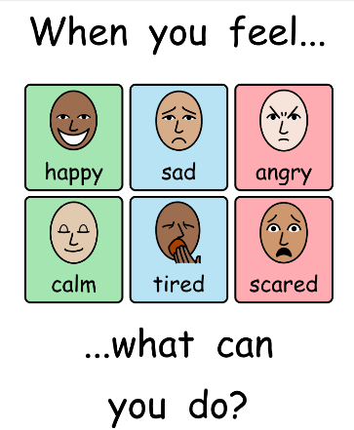

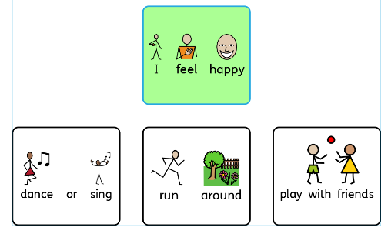

Special Needs

At Margaret McMillan Nursery school we work within the DfE Code of Practice. The school has a Special Needs Coordinator (SENCO).

Children with profound and complex special educational needs have places allocated by a borough panel. The children are fully included throughout the school.

The school has a very positive and inclusive approach to working with all children. The emphasis is always on the child’s strengths and the ways in which they can be developed.

Early intervention helps to ensure that every child is given the best opportunity to benefit from all the experiences available in school. Parents play an important role in sharing the very close understanding they have of their child and in helping to design and implement programmes to support.

Occasionally the help available within school is not enough to support the child. We will always consult with you before seeking additional specialist support.
Equalities

Margaret McMillan Nursery School is committed to valuing diversity by providing equality of opportunity and anti-discrimination practice for all children, families, colleagues and all members of the community who use the premises.

Our aims are:
• To provide a secure environment in which all our children and their families can flourish and in which all contributions are valued.
• To include and value the contribution of all families to our understanding of equality and diversity.
• To provide positive non-stereotyping information about gender roles, diverse ethnic and cultural groups and people with disabilities.
• To improve our knowledge and understanding of issues of anti-discriminatory practice, promoting equality and valuing diversity.
• To use local information and data to ensure that we are meeting the needs of our community.

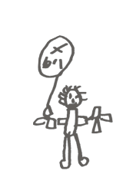
Parental Involvement

Parents’ Workshops

Each term we run workshops for parents during the school day or sometime straight after school at 3.30pm. Each series of workshops is different but all are designed to help you to support your child’s learning at home. Sign up sheets for workshops are put on the drop-off/ collection doors and staff will let you know when a workshop is coming up.

Notice Boards

There are notice boards in each school area which have up to date information for parents/ carers. Please do check these boards regularly for important information.

Complaints

It is very important to us that you and your child obtain the most from these important early years and greatly enjoy your time at Margaret McMillan. If anything seems confusing or unclear please do come in and ask. Class teachers and the Homebase Senior Nursery Education Workers will be able to answer most of your questions, The Deputy Headteacher, SENCO and Headteacher are also available to meet by appointment. If you have a problem or query that you feel is not resolved, you can also speak to your Parent Governor representatives.

Finally, if problems remain there is a formal complaints procedure.

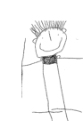
The Governing Body

The school has a governing body. There are:
- four elected parent governors
- staff representatives
- representatives from the local authority
- co-opted governors who bring special skill or advice to the governing body

Governors meet at least once a term to discuss progress in school. They are responsible for finances, appointments, health and safety, special needs and for checking that the school is offering the children the best opportunities within government guidelines.

Governors work through sub-committees which meet more frequently. Once elected or coopted governors can serve for a period of four years even if their child moves on to another school. The list of governors is on the hall notice board and on the school website.

Communications

Most of our communications are done by letter, email or text. Incidental information is displayed on the notice boards in the relevant school areas.

Someone will always be on door duty when you arrive for you to exchange messages. If your child attends Breakfast or Tea there is a book where staff write down important information, so that we can ensure it is passed to parents and carers even when there has been a change of staff.

For babies we have a green book to relay messages re. eating, sleeping and toileting to parents. This is a two-way process and parents/ carers are welcome to write in it as well to give messages to staff about their baby regarding the above.

For urgent messages please telephone us. As the school is open all year round from 8am—5.30pm there is not always someone available to answer the phone. Please do leave a message on 0207 281 2745

We have a school website: www.margaretmcmillan.islington.sch.uk
and the school email is admin@margaretmcmillan.islington.sch.uk

Core school policies are available on our website or via the school office.

Finally... We ask all parents not to use their mobile phone while in school. This is part of our safeguarding policy. Thank you for agreeing to this.

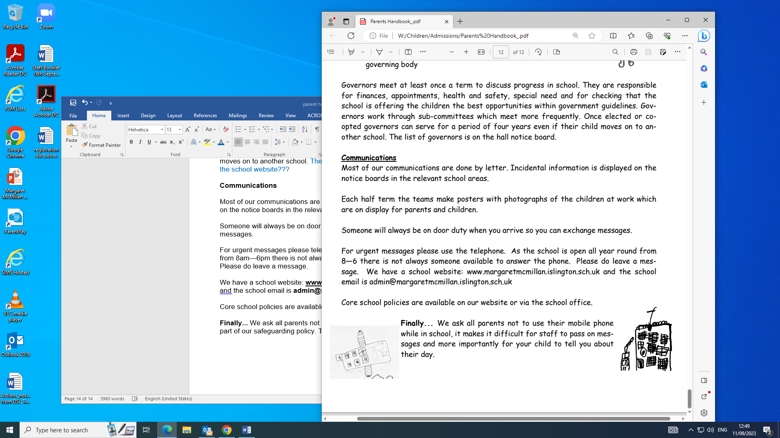
We are greatly looking forward to your child being at Margaret McMillan Nursery and working in collaboration with you to ensure they have the best experience during their time with us.

