Autumn Term 2 Curriculum – Class Three
English   | 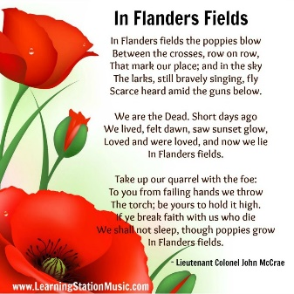  During our first English topic of Autumn 2, we will be studying ‘The Secret Garden’ by Frances Hodgson Burnett. This text will have a narrative focus and as we did in Autumn 1, this will also feed into our Whole Class Reading sessions and SPAG learning. The main writing outcomes for this unit will be setting descriptions, character descriptions and writing a short narrative based on the story.  In the second part of the term, we will have a non-fiction focus, where children will practise the skills of research through reading, leading to the writing of a non chronological report on specific climate zones around the world. We will use the children’s National Geographic text to support this learning.
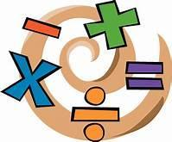  Maths | Our Autumn 2 focus will begin with a continuing focus on Multiplication and Division. Children will learn how to identify common multiples and factors and apply this to a range of problems. We will also work on Fractions, which will take us through until Christmas.
Science  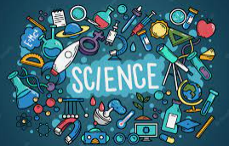 | Our topic this half term is Living Things: Classifying big and small. Within this unit of work, children will revisit ways in which we can classify all living things on earth, based on their characteristics. We will also look at evolution and how living things have adapted over time to be able to thrive in their environment.
History/Geography   | In Geography, we will be exploring the question; ‘Is British topography all the same’? Through this unit of work, children will be learning how to use maps effectively, including the use of grid references on a map. Children will look at different parts of the UK and identify both human and physical features and the impact they have on the people and animals who live there.
  Art/DT | In Art, we will be drawing a World War Two Blitz scene using techniques to show movement, reflection and shadow. The works of the artist, Henry Moore will be our inspiration during this unit.
 | Our unit of work for this half term is ‘Health and Wellbeing’. In this topic, children will learn about the importance of rest and relaxation and the impact that this can have on both mental and physical health. In addition to this, there will be a focus on healthy diets and staying safe in the sun. Children will also think about their goals and the importance pf embracing failure as a tool for future learning and self-development.
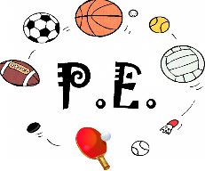 | In PE this half term, for our unit of learning about Dance the children in Class Three will be developing their skills in creativity, collaboration and varying ways to move. They will work in groups to create short routines, which display appropriate movements to different types of music.  Children will also be enjoying a unit on Football. Through this unit of work, children will develop their basic ball control skills, passing, shooting and defending. They take part in both individual and small sided drills, leading to larger games.
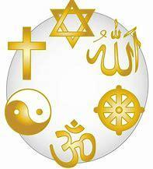  Religious Education | In RE this half term, we will be studying the question ‘Was Jesus the Messiah’?  By the of this unit, children will understand that Jesus was Jewish and understand the word Christ is a Greek word meaning ‘Messiah’. Children will learn that most Christians believe that Jesus is God incarnate and that they see Jesus as their saviour.  Children will opportunity to study these beliefs and discuss their own personal beliefs, offering reasoning to support their view.
  Music | The focus for this half term’s music is ‘Blues’. Children will listen to, appraise and identify common themes within this style of music and have the opportunity to use some of the instruments present in Blues music.
  French | In French, our topic this half term is ‘meet my family’. In this unit, children will learn how to introduce the people in their family, including being able to say where they live and with whom.
Computing   | Our unit of work in Computing is ‘Video production’. The focus of this unit will be on children learning how to capture and edit short videos using mainly ipads. Children will work in pairs and small groups to create videos using different techniques, including a range of camera angles. Where possible, this learning will link to other curriculum areas.

