Autumn Term 1 Curriculum – Class Three
English  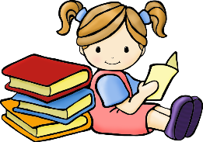 | During our first English topic we will be reading the story, Letters from the Lighthouse by Emma Carol. Using the text, we will develop a range of reading skills including predicting, inferring, sequencing and questionning. The children will write for a range of exciting purposes including a postcard from the perspective of an evacuee and an adventure story about evacuation! After, the children will read Anne Frank by Josephine Poole and Angela Barre before writing an obituary and newspaper article.  Finally, we will create World War poetry using imagery.  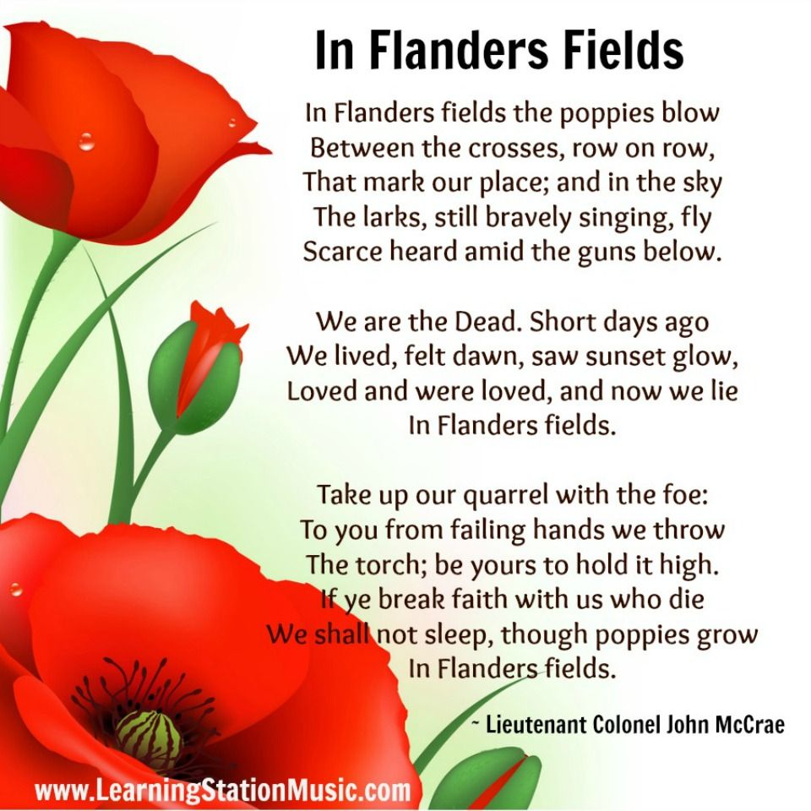  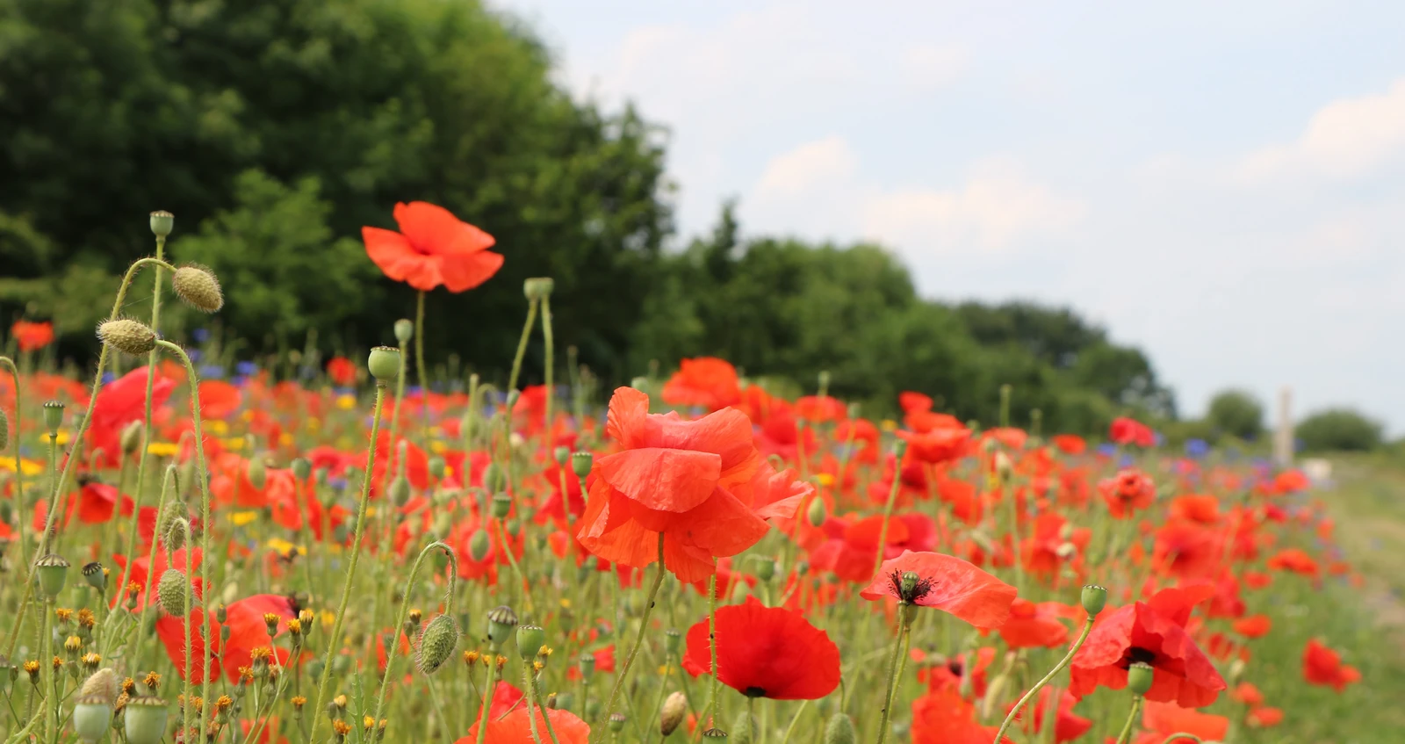  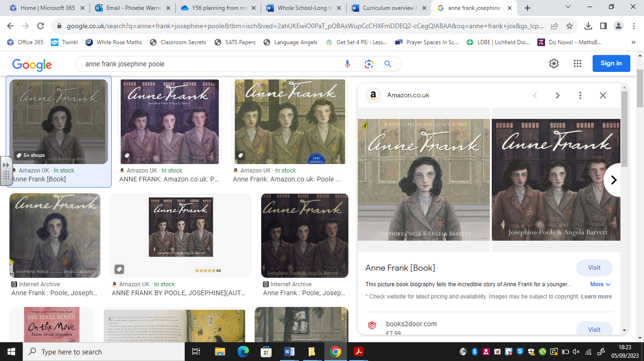  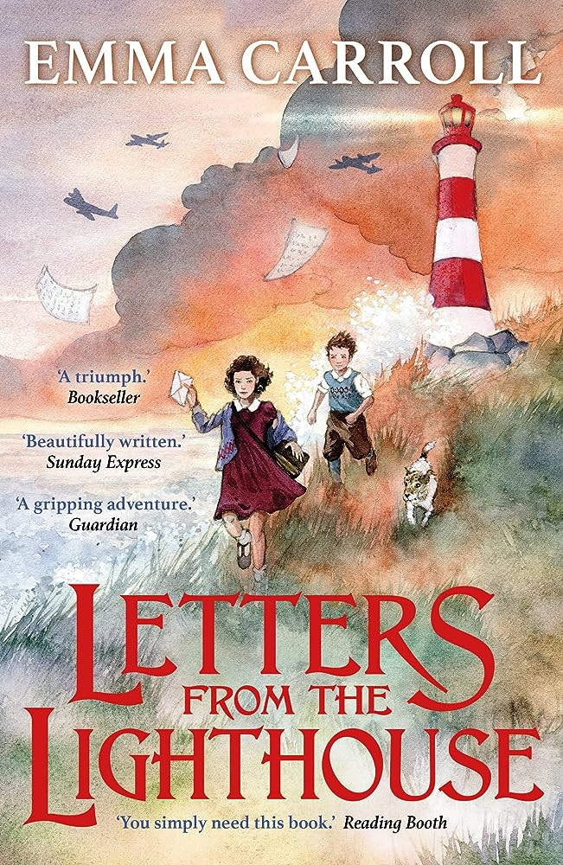
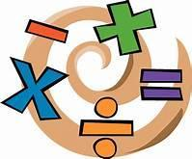  Maths | Our Autumn term topics will be Place Value followed by Addition and Subtraction. We will develop our number bond recall through the Mastering Number initiative.
Science  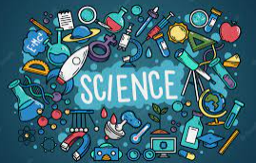 | Our topic this half term is Everyday materials and their uses. We will investigate a range of materials from around our classroom and the school environment. We will distinguish between an object and the material it is made from and describe the properties of materials using a range of vocabulary. Next, we will sort materials and decide their sustainability for specific purposes.
History/Geography  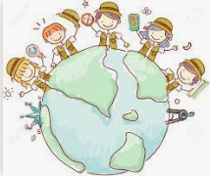 | In Geography we will locate our school on an aerial photograph. We will look at a variety of different maps and create our own of the classroom ad playground, creating a key of features. We will survey opinions of our playground and design a new map with improvements.
  Art/DT | In Design and Technology we will identify a range of different fruits and vegetables. We will find out where they grow and the different parts that are eaten. We will learn how to wash and prepare vegetables safely in order to follow instructions to make pumpkin soup.
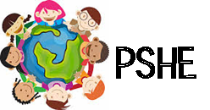 | Our topic for discussion is “Families and Relationships.” We will explore how families can be different and the characteristics of positive friendships. We will learn that issues can be overcome and people show their feelings differently. We will also investigate manners and develop an understanding of self-respect.
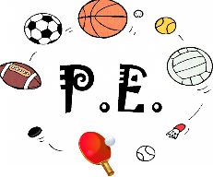 | We will learn to explore and develop basic gymnastic actions on the floor and using apparatus. We will develop skills in jumping, rolling, balancing and travelling to create short sequences.  We will develop our understanding of invasion games and the principles of defending and attacking, learning how to follow rules and score points.
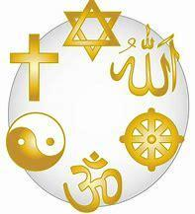  Religious Education | The question we will answer is about Creation “Who made the world?”  We will understand that Christians believe that God created the universe. That the earth and everything in it are important to God. We will understand that the creation story includes a day of rest and that Harvest Festival is a time when Christians say thank you to God for creation.
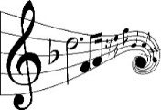  Music | We will link music to our English work and learn that an instrument or a rhythm can represent a character in a story. We will find out how our voices can create different timbres (sounds) to help tell a story.

