

|  |
| --- |
| **he Mease**  **Federation**  **Mary Howard St. Andrew’s**  **Spirituality Policy**  **2023-2024** |

**Our Vision:**

The parable of the mustard seed (Matthew 13: 31-32) inspires us that even from very small beginnings, something amazing can grow. At The Mease Federation, we are aspirational for the future of all our pupils and adults, in that they will learn how to **grow and flourish** as healthy and fulfilled individuals who are passionate about life and learning.

**What is Spirituality?**

The concept of spirituality is difficult to define. Spiritual development relates to fundamental questions about the meaning and purpose of life which affect everyone and is not dependent on a religious affiliation; a person can be spiritual without following a faith. Spirituality is very personal and can change within a person during their lifetime. Each person is unique and will therefore develop spiritually in different ways.

**Spiritual Development at The Mease Federation:**

To be in touch with your spiritual self means that you are self-aware.  Inevitably, spirituality requires reflection, introspection, questioning and engagement with ideas.  If we can breed the children’s spiritual being then we can enhance their self-esteem, we can improve their empathy and relationships; we can allow them to find their place in the world, to value others and themselves.  Beyond academic learning, we can support children to be founded, strong, meaningful and engaging citizens of the world who can bring greater value into their own lives and those of others. We appreciate that spiritual development is very personal and we encourage children’s spirituality to **grow and flourish** in their own time.

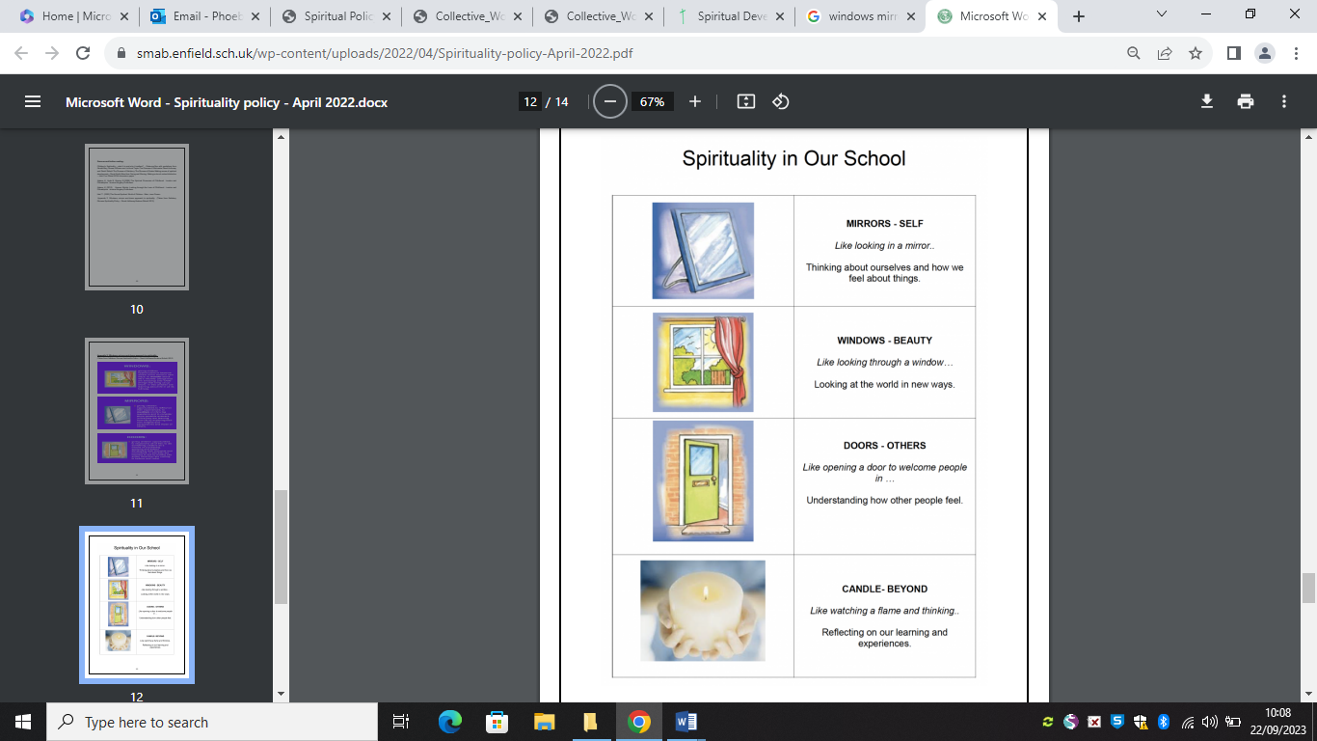To help the children understand their developing spirituality we explain it using clear language and symbols.

**How is Spirituality Nurtured at** **The Mease Federation?**

At **The Mease Federation**, we provide rich opportunities for our children’s spirituality to **grow and flourish**. We aim to develop our children’s ability to reflect on their own beliefs (religious or non-religious) and their perspective on life. At **The Mease Federation**, we support children in developing their knowledge of, and respect for, various faiths, feelings and values**.** We strive for children to use their imagination and creativity when learning and we encourage our children to be willing to reflect on their experiences. We aspire to develop our pupils’ sense of enjoyment and fascination in learning about themselves, others and the world around them.

We grow spiritually more aware when we notice the opportunities of everyday (the ‘NOWs’), when we reflect upon or question life’s ‘WOWs’ (things are awe-inspiring) and ‘OWs’ (the challenges we face in life). Through noticing life’s ‘NOWs, OWs and WOWs’, we learn about life in its fullness.

Consistent opportunities for spiritual development are offered in our classroom reflection areas where children can access varied activities. During Religious Education and collective worship, we ask, discuss possible answers to and search for the meaning of ‘Big Questions’. We celebrate children’s ‘wow work’ by displaying in classrooms, publishing on our newsletters and awarding during our celebration worships every half term. Each week, class teachers read Bible stories to the children to support the growth of our children’s theological knowledge and also to support their faith development and understanding. At **The Mease Federation**, we encourage our pupils to be agents of change by offering our support and responding to local, national and global issues.

As part of our long-term plan for Religious Education, we enter a selection of children into the ‘Spirited Arts’ competition. This presents our pupils with the opportunity to reflect upon their own spirituality by considering some challenging questions. Our children respond through one of the following ways: art, poetry, photography, dance, music, drama or sculpture.

**What is the Role of the School Community?**

All members of the school community are responsible for supporting and nurturing spiritual development.

**How School Staff can support**

School staff can build and maintain positive rapports between pupils, parents and staff. School staff deliver and attend collective acts of worship. Staff should ensure that they conduct themselves in an exemplary manner to our pupils and members of the wider community. Staff lead by example in respecting others regardless of differing beliefs and opinions, showing compassion and consideration towards others, modelling the importance of persevering and using wisdom to make responsible decisions. Having a positive attitude towards the value of spiritual development is essential.

**How Pupils can support**

Pupils can choose to spend some quiet time participating in reflective activities within classroom reflection areas. They can live out our school values within and outside of school to ensure they are conducting themselves respectfully and responsibly. Pupils can show an understanding of and respect for the different beliefs held by others. Pupils can apply and join our school Spiritual Council to be involved in the planning and delivery of bible meditation worships which follow a windows, mirrors and doors approach to support spiritual development.

**How Parents and Carers can support**

At **The Mease Federation**, we encourage parents and carers to read to or with their child everyday as stories feed the imagination and offer opportunities for rich discussions around important themes such as: courage, good and evil and weakness. Times of quiet are encouraged outside of school and are shared between us as a community during reflective periods within church and during whole-school assemblies. Keeping in touch with larger communities is another step to spiritual development. We regularly gather as a collective throughout the year but also direct parents and carers to events happening within the community at church during weekends and school holidays too. Singing is a way to share joy amongst others and we regularly sing during services at our local church. Listening to our children is a vital method in showing an awareness of their feelings and another step to supporting spirituality. A key practice that we encourage our parents and carers to live out is the reflection on and admitting to mistakes before most importantly, apologising.

**Wisdom-Love-Perseverance**