Numeracy | Literacy | Science
- TT Rock stars battle  - Active learn online games  - White Rose Maths - https://whiterosemaths.com/homelearning/year-4/  There are daily lessons on here to work through. | Reading activity  Complete at least 5 activities on Read Theory.  Reading Quiz  The accelerated reading link will be published on Facebook so you can quiz on the books you are reading at home.  Spelling Shed  Continue to challenge yourself on Spelling shed!  Talk for writing – Home learning booklet  https://www.talk4writing.co.uk/wp-content/uploads/2020/04/Y4-Unit.pdf  Don’t worry if you don’t have a printer! You could download the document on a tablet and screen shot the pages which you’ll then be able to edit with voice notes etc.  This booklet is designed to last a few weeks. | Watch the video to find out what a habitat is  https://www.youtube.com/watch?v=ZrSWYE37MJs  Make a home for an animal  http://www.treetoolsforschools.org.uk/activitymenu/?cat=helping
 |  | Cooking!
https://www.bbcgoodfood.com/howto/guide/kids-baking-recipes-without-flour

Have a go at baking something this week – the above link is some suggestions that don’t include flour (we know it’s hard to find!)
Geography | PE | Birthday Card!
What is sustainability?  See activity sheet from last week.  Carry on with this task. Once completed, see if you can practise some of the ways to be more sustainable. | - Joe Wicks is on TV each morning at 9am.  - Have a go at trying a new sport this week! | 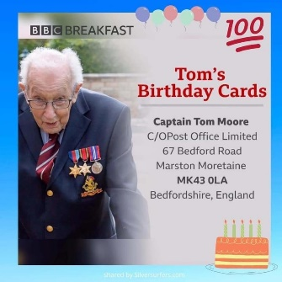  What do you know about Captain Tom? Find out how old he is going to be and what he has been doing.  It would be really kind to design and send him a birthday card.
Home Learning Tasks W.C 20th April 2020

