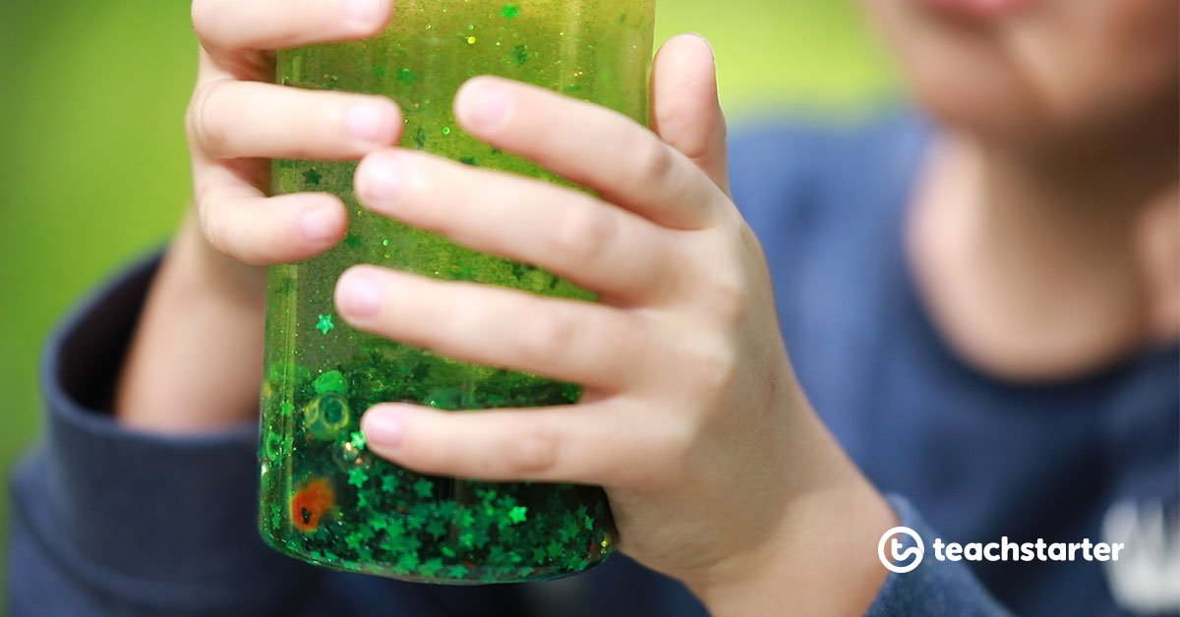
Mindfulness activity:
Glitter Jar

This is an activity I had planned to do with the children because it was something they all wanted to do at the beginning of the year.
Use this familiar sensory bottle concept as a mean to explicitly teach how mindfulness can help to calm us when we are feeling stressed, anxious, sad or angry.
Preparation
- Fill a bottle or jar with water, leaving 2-3 cm of space at the top.
- Add a generous amount of glitter glue to the bottle (or a combination of PVC glue and regular glitter).
- Seal the bottle well!
Directions
- Shake the bottle well to mix the glitter, water and glue.
Here’s a little activity you can do with your child:
“Imagine that the glitter is like your thoughts when you’re stressed, mad or upset. See how they whirl around and make it really hard to see clearly? That’s why it’s so easy to make silly decisions when you’re upset because youre not thinking clearly. Don’t worry this is normal and it happens in all of us (yep, grown-ups too).
[Now put the jar down in front of them.]
Now watch what happens when you’re still for a couple of moments. Keep watching. See how the glitter starts to settle and the water clears? Your mind works the same way. When you’re calm for a little while, your thoughts start to settle and you start to see things much clearer.”

