Home Learning
Little Acorns
WB 04 / 05 / 2020
Please feel free to join in with our weekly home learning activities. It would be lovely if you could post pictures and videos on your child’s Tapestry account.
If you have any issues with accessing your account please email Miss Pape on emmapape@maryport.cumbria.sch.uk.
Thank you.
- Count everything you can.
Over the next week encourage your child to count at every opportunity. It would be wonderful to see some videos of this on tapestry.
Some ideas for counting…
- Tins in cupboards.
- Toy into or out of the toy box.
- Stairs
- Socks
- Sweeties
- Pebbles
- Leaves
- Flowers
At any opportunity you can, it is a good idea to line the items up before counting and encourage your child to use their index finger slowly.

2) Colours.
Can your child find colours in their home environment?
Walk around the house with your child and talk about the colours of everyday items. Describing the shade of colours will develop their vocabulary- light blue, dark blue…

You could even take this activity outdoors or on your daily walk.

As an extension to this activity, you could collect several objects and ask your child to sort into the correct coloured piles.

3. Finger painting- a messy but fun activity!
Tape a large piece or multiple pieces of paper to the table. Give your child small pots of different coloured paint (if possible) and allow them to take control and paint what his/her heart desires.
This activity develops motor sensory skills.
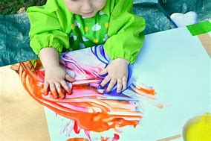

Remember to post pictures/videos on Tapestry.
Have fun!

