Home Learning
Little Acorns
WB 08/06/2020
Please feel free to join in with our weekly home learning activities. It would be lovely if you could post pictures and videos on your child’s Tapestry account.
If you have any issues with accessing your account please email Miss Pape on emmapape@maryport.cumbria.sch.uk.
Thank you.

1-Picture talk.
Part one - Ask your child to look at the picture and talk about what they can see.
Ask the first set of questions- (can your child identify the animals?)
Part two- Ask your child the next set of questions- this will check for understanding of simple positional language.
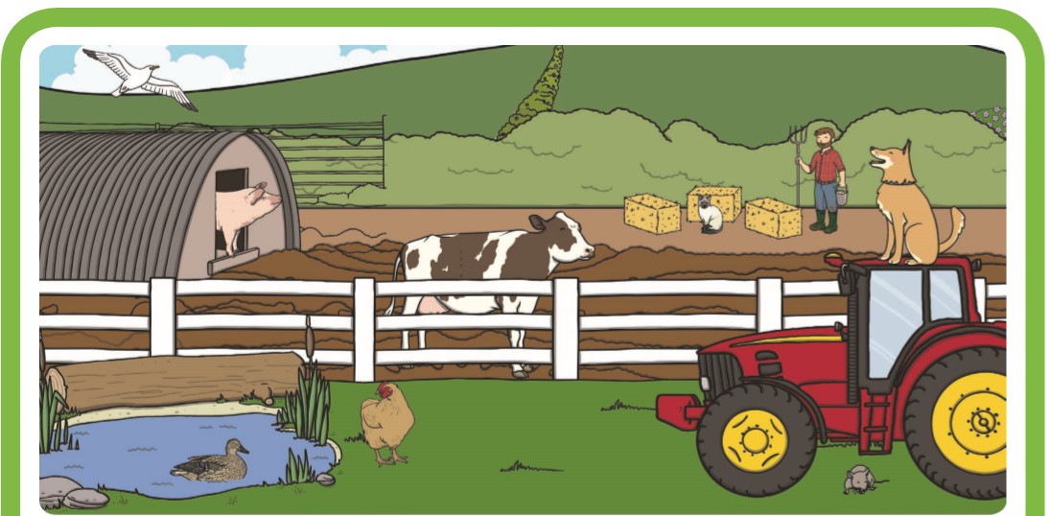
If you can print out the picture on a large scale, this would be much better.

2- Music

2- Build a tower.
Take turns with your child to build a tower with materials from around your home. You could use blocks, cardboard boxes, cotton reels or anything that will build and balance. This activity encourages hand eye coordination, fine motor control and turn taking.

3- Counting the shopping.
You could use play food for this activity, fruit from the fruit bowl, tinned food, packets of crisps….
Line up a selection of food/playfood and encourage your child to use their index finger ‘Peter Pointer’ to count. Any opportunity to count like this will really support your childs understanding of counting. Ensure that your child touches each obect before counting. If they speed up and miss out objects, please encourage them to slow down.

