Home Learning
Little Acorns
WB 11/04/2020
Please feel free to join in with our weekly home learning activities. It would be lovely if you could post pictures and videos on your child’s Tapestry account.
If you have any issues with accessing your account please email Miss Pape on emmapape@maryport.cumbria.sch.uk.
Thank you.
1-Painted rocks for the memorial garden.
Lots of children are getting involved in painting rocks to make a pretty trail all around the memorial gardens- this will mark the Coronavirus Lockdown. Rocks can be added to the trail but must not be removed from this area. It would be lovely if we could get involved with this activity. If you cannot paint the rocks, please try and pop down during your daily exercise to admire this lovely idea.
Please only take part in this activity if it is safe to do so.
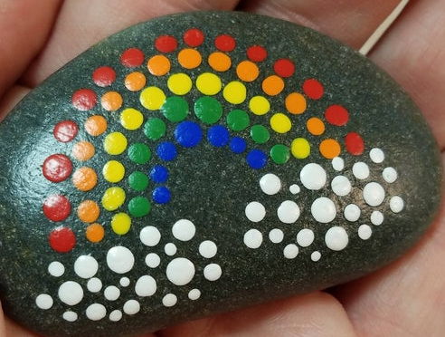

2- Make play- dough together.

Download a simple play dough recipe (some recipes are made on the hob, microwave or with hot water)
Allow your child to help you make the dough.
Add colouring, essence or glitter (if you can).
Once cool, enjoy playing with the dough. Introduce vocabulary and skills such as…
- Roll
- Squish
- Squash
- Flatten
- Stretch

3- Ball skills.

If you have access to a ball of any size (bigger the better), engage your child in a turn taking game of kicking a large ball to each other.
Aim- can kick a large ball.

Remember to post pictures/videos on Tapestry.
Have fun!

