Home Learning
Little Acorns
WB 18/04/2020
Please feel free to join in with our weekly home learning activities. It would be lovely if you could post pictures and videos on your child’s Tapestry account.
If you have any issues with accessing your account please email Miss Pape on emmapape@maryport.cumbria.sch.uk.
Thank you.
1-Object line tracing.
- Place a few objects on a white sheet and encourage your child to trace lines around it, with chalk or crayons. “let’s make our wiggly worm”. You may need to model this with your child initially. You can even try with different objects.
- To make this even different (if you have the resources to do so) you could take this activity outdoors on a larger scale with chalk. Draw around bigger objects. You could even draw around each other!

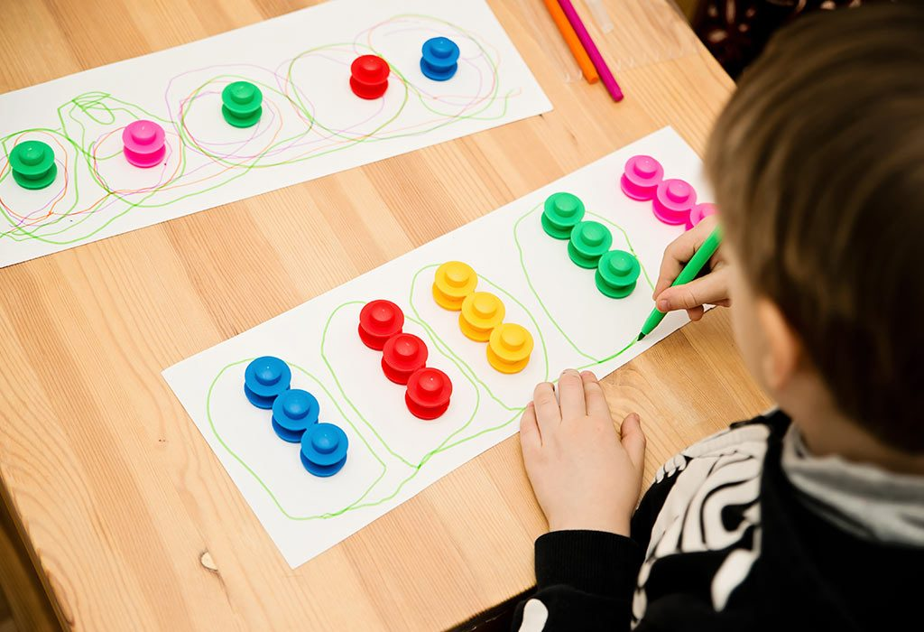
What Does it Teach?
- Self-control
- Fine motor skills

2- Obstacle course.
This activity really does depend on the resources that you can get hold of.
Use any available resources to make a short obstacle course for your child to enjoy.
Think about different skills and movements such as…
- Under
- Around
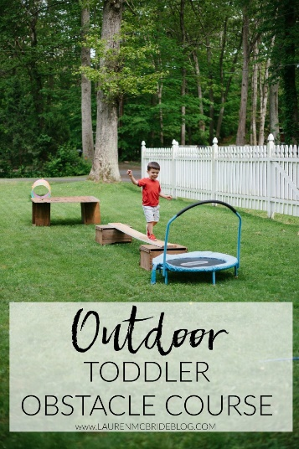
- Over
- In and out
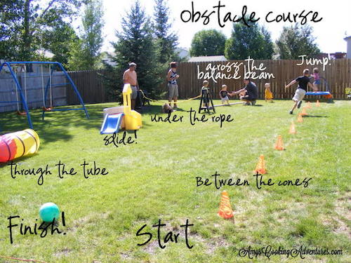
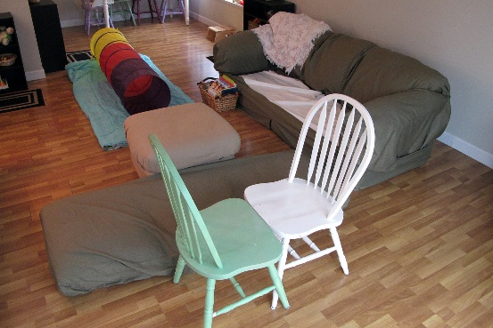
Examples-

3- Tuning into sounds.
- Show your child 3 items that make very different sounds. E.g.- bells, crisp bag, dogs’ squeaky toy.
- Allow your child to make the different sounds.
- Cover up the items
- Ask your child to close their eyes.
- Make a noise with one of the items.
- Can your child guess the sound correctly?
Ideas- crisp bag, dog toy, bottle of water, bells, motorised car, stones in a tin, box of rice- anything at all that makes a noise.
You can mix this up by using different items, adding more sounds or even asking your child to make the sounds for you to guess.
Remember to post pictures/videos on Tapestry.
Have fun!

