Home Learning
Little Acorns
WB 13/04/2020
Please feel free to join in with our weekly home learning activities. It would be lovely if you could post pictures and videos on your child’s Tapestry account.
If you have any issues with accessing your account please email Miss Pape on emmapape@maryport.cumbria.sch.uk.
Thank you.
- Memory Game- Kims Game
- Begin with a collection of 4 objects from around the house.
- Ask you child to name each object.
- Cover up the objects with a piece of material.
- Ask your child to close their eyes.
- When you lift up the material, take away one of the objects.
- Can your child identify the missing object?
- Add more objects if your child finds this easy.
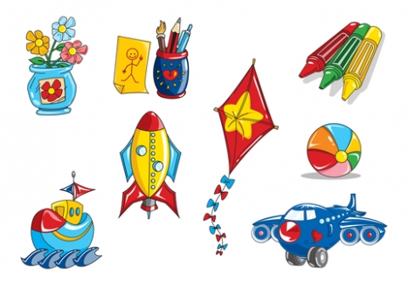

- Matching socks-

Give your child a selection of socks. Show your child how to find 2 matching socks that make a pair.
Can your child help to find the matching socks?

- Can you sing me your favourite nursery rhyme?
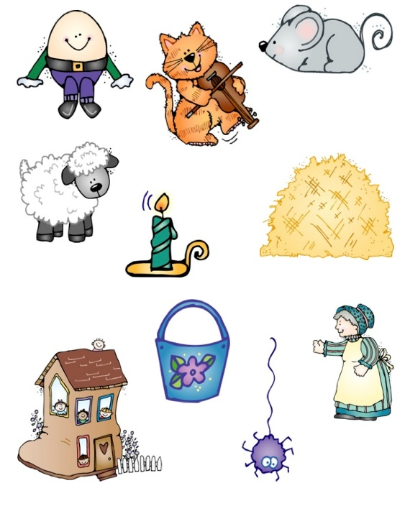
I would love to see a video of challenge 3 and 4!

- Let’s dance…
Put on your favourite song and let me see your moves!

Remember to post pictures/videos on Tapestry.
Have fun!

