Home Learning
Little Acorns
WB 27/04/2020
Please feel free to join in with our weekly home learning activities. It would be lovely if you could post pictures and videos on your child’s Tapestry account.
If you have any issues with accessing your account please email Miss Pape on emmapape@maryport.cumbria.sch.uk.
Thank you.
- What can you feel?
The purpose of this activity is talk about different textures. If you have the equipment, you could make a lovely collage picture too!
- Adult to collect a number of materials, cotton wool, plastic, felt, sweetie papers, bottle tops, card, foil, sticky tape… (whatever you can get hold of).
- Allow your child to explore the materials and talk about what they feel like. Adult to introduce new language- bumpy, squishy, soft, rough…
- If the materials are scrap and you have access to paper and glue, make a lovely picture with your textured materials.
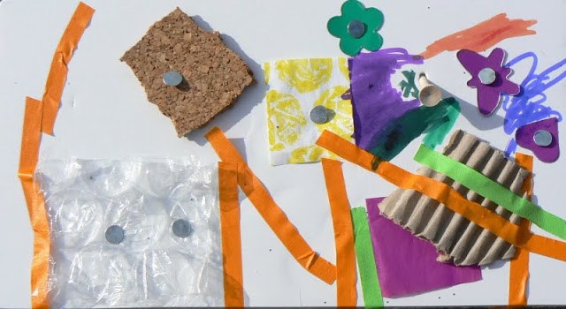

2) Musical ‘stop and go’.
This activity supports listening skills.

- Play your child’s favourite song. Let them listen to it and dance for a little bit before introducing some rules.
- Explain that when the music stops, they must stop dancing. When the music starts again they are allowed to dance.
- If your child finds this simple, you may change this game into musical statues or bumps.

- Family Photographs.
During a time when we all miss our friends, family and loved ones, I thought that this would be a lovely opportunity to dig out the photo albums. This can be on mobile phones or actual photographs.
Chat to your child about their family members. Encourage them to talk about what is happening in the pictures.
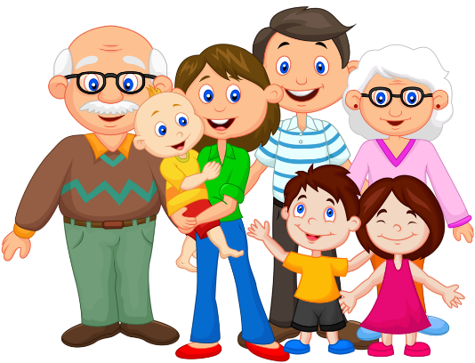

Remember to post pictures/videos on Tapestry.
Have fun!

