TTRS Battle of the Bands
25 Arena Sessions
Starts: 9am on 8th June Ends: 15.30 on 12th June

White Rose Maths
To access this week’s White Rose Maths home learning activities, please follow the link below:
https://whiterosemaths.com/homelearning/year-3/
A copy of this week’s worksheets can also be found on our school website.

Please see below for more information regarding this week’s suggested tasks. Pictures of completed activities can be sent to either Miss Huddart or Mr Ward on Seesaw.

Local History
Fletcher Christian
Task
Follow the link to find out all about Fletcher Christian, Can you answer all the questions on him below?
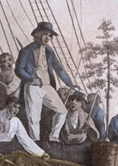
https://kids.kiddle.co/Fletcher_Christian

- Who was Fletcher Christian?
- When and where was Fletcher Christian born?
- What were his parents called?
- Who was Fletcher Christian named after?
- How old was he when he first went to sea?
- When he was a sailor on the ship ‘Cambridge’ who else was on the boat with him?
- Where did he sail to on the ship ‘Britannia’?
- Who did Fletcher Christian marry?
- What was Fletcher Christian’s son called?
- When and where did Fletcher Christian sail to on ‘HMS Bounty’? What was he collecting?
- What does the word ‘mutiny’ mean?
- Which island did Fletcher Christian live on?
- How was Fletcher Christian Killed?

Task
Create an information leaflet, PowerPoint presentation, poster, artwork, video or other piece of information all about Fletcher Christian.

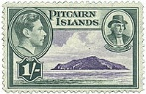

Notan Artwork

What is Notan art?
Notan is a Japanese term which literally means "light dark harmony". Artists use "notan studies" to explore different arrangements of light and dark elements in a painting, without having the distraction of other elements like color, texture and finer details.
Notan art involves painting the darks with black and the lights with white (known as a 2 value notan). Sometimes, gray is also used as an intermediate value (3 or 4 value notans).

Task
Create your own piece of Notan artwork. Follow the link below to watch a Notion for Beginners video tutorial:
https://www.youtube.com/watch?v=vt_HZv0tNZk
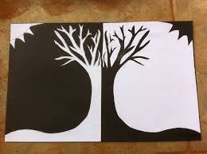
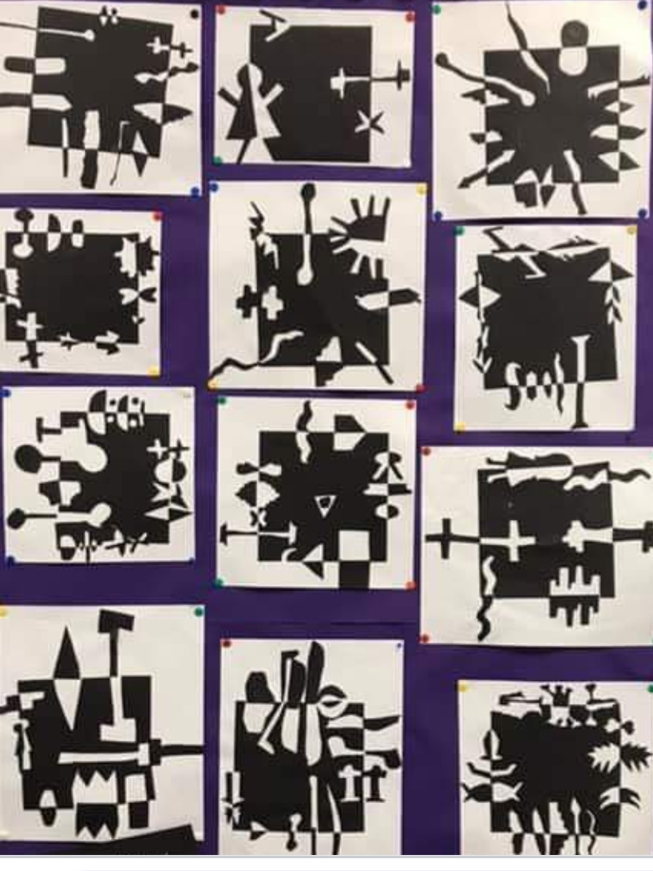

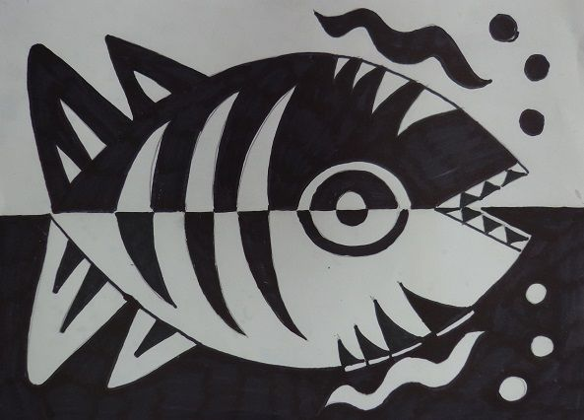

Garden Wildlife Week

Last week (1st-7th June) was Garden Wildlife Week. Why not give nature a hand by creating a feeder for those flying in for a snack, a hotel for important insect guests or a shelter for the visitors who scurry around at night?
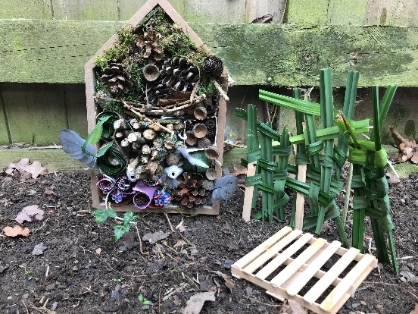
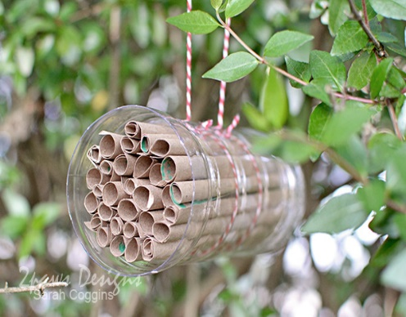
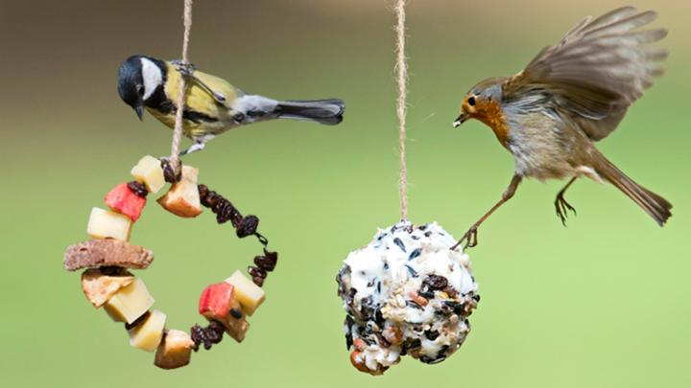
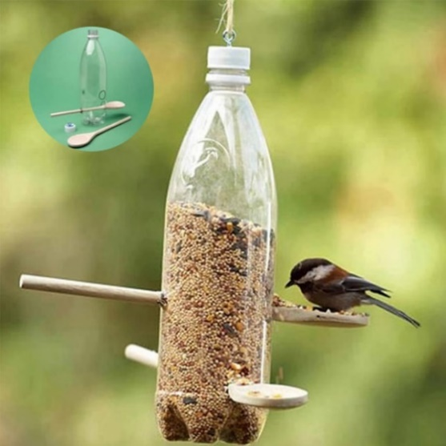
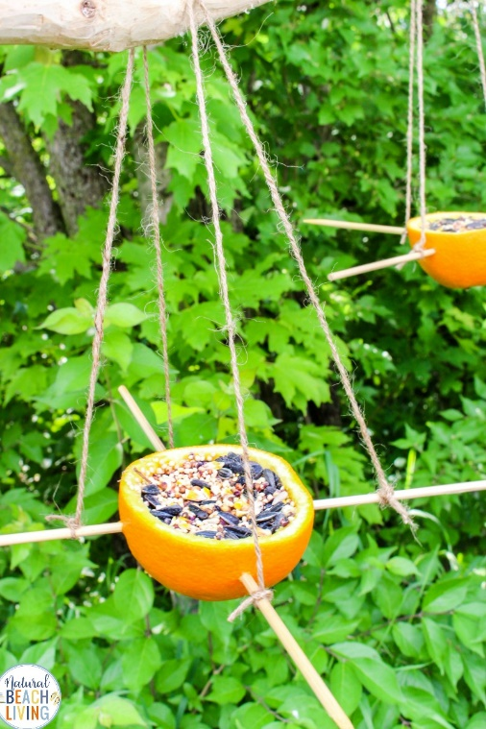
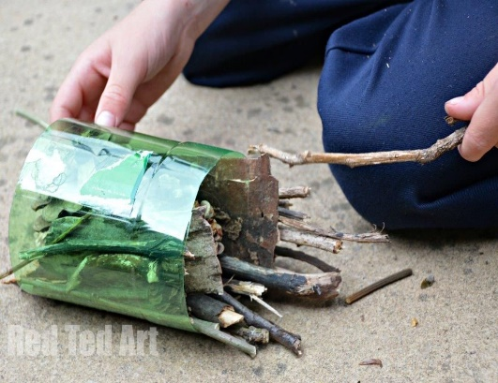
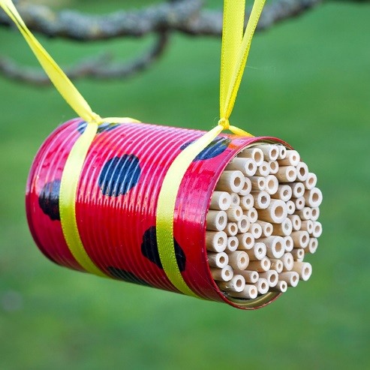

Please see the links below and supporting sheets (these have been uploaded to our website) for instructions on how to make a feeder or home for nature.

How to make a recycled bird feeder
https://www.rspb.org.uk/fun-and-learning/for-kids/games-and-activities/activities/make-a-recycled-bird-feeder/

Make a bird kebab
https://www.rspb.org.uk/fun-and-learning/for-kids/games-and-activities/activities/make-a-bird-kebab/

Make a speedy bird cake
https://www.rspb.org.uk/fun-and-learning/for-kids/games-and-activities/activities/make-a-speedy-bird-cake/

Loo-roll bird feeders
https://www.rspb.org.uk/get-involved/activities/birdwatch/birdwatch-extra/make-your-own-loo-roll-bird-feeders/

Homes for nature
https://www.rspb.org.uk/fun-and-learning/for-teachers/lesson-plans-and-supporting-resources/homes-for-nature/

Animal Fact File
Task
Create a fact file on an animal you might find in your garden or local area. Remember to include a picture of your chosen creature, a description of what it looks like, what it eats (its diet), where it lives (its habitat), as well as some other interesting facts. Try and include some good adjectives (describing words) in your sentences.
Please see below for the animal fact file template and adjectives word mats.

Useful website:
https://www.woodlandtrust.org.uk/
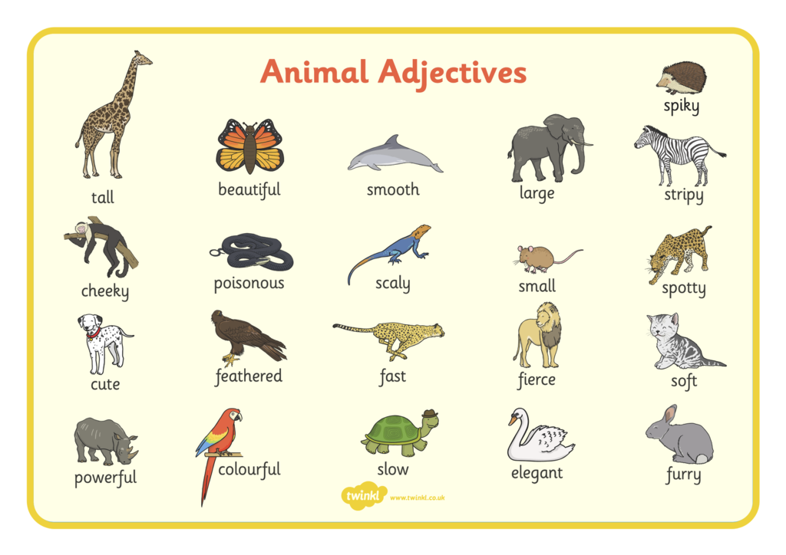
Please see below for the attached fact file template and adjectives word mat.

