TTRS Battle of the Bands
25 Garage Sessions
Starts: 9am on 22nd June Ends: 15.30 on 26th June

White Rose Maths
To access this week’s White Rose Maths home learning activities, please follow the link below:
https://whiterosemaths.com/homelearning/year-3/
A copy of this week’s worksheets can also be found on our school website.

Please see below for more information regarding this week’s suggested tasks. Pictures of completed activities can be sent to either Miss Huddart or Mr Ward on Seesaw.

RE: Buddhism
Who was Buddha?
Watch the video clip: What is Buddhism?
https://www.bbc.co.uk/bitesize/topics/zh4mrj6/articles/zdbvjhv

Task
Read the story of Prince Siddhartha on the PowerPoint slides (provided on the school website), explaining how he left a life of wealth and luxury to live a poor life in search of the Truth.

Re-write the story of Prince Siddhartha (Buddha) in your own words, using the characters and basic outline of the story provided on the PowerPoint. For example, you could turn this story into a comic strip, booklet, video or play.
*Please see the school website for the comic strip template.
What is Wesak?
People who follow the Buddha’s teaching are called Buddhists.

Wesak is the Buddha’s birthday. It is celebrated on the full moon in May and is the most important Buddhist festival.

Wesak is celebrated in lots of different ways. Watch the BBC Bitesize video ‘What is Wesak?’ to find out more.

What is Wesak? https://www.bbc.co.uk/bitesize/topics/zh4mrj6/articles/zbsp92p

Task
Create your own Wesak lantern. See below for instructions.

Instructions
How to make a Wesak Lantern

- First, fold the piece of card in half lengthways.

- Carefully, cut 8 slits, starting at the folded edge. Make sure you do not cut all the way to the edge.

- Open the card out and lay it flat on the table.

- Decorate it by sticking glitter or sequins or colouring it with
pencils or pens.

- Stick ribbon along the top and bottom edges.

- Wait for it to dry. Then, bend the card around into a cylinder shape, making sure the decorations are on the outside. Use sticky tape to secure it.

- Make a handle for the lantern using ribbon secured on opposite sides of the lantern’s top edge.

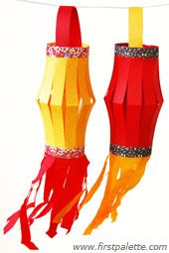
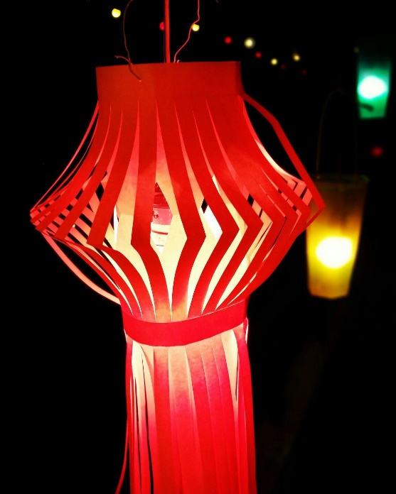

What is a Mandala?
A mandala is a spiritual and ritual symbol in Hinduism and Buddhism, representing the universe.
A mandala is a decorative picture which usually includes very complex designs.
The designs, which include a range of patterns and symbols, start
from a central point, created in a cyclical image. The shapes are often geometric (decorated with lines and shapes) and recognisable.

A mandala can have special meanings for the person who has created it. The designs are a representation of the soul and therefore, the images used reflect the person’s innermost hopes, dreams and sometimes, worries.

Task
Create your own mandala like the ones below.
*Please see the school website for some Mandala templates and colouring sheets.
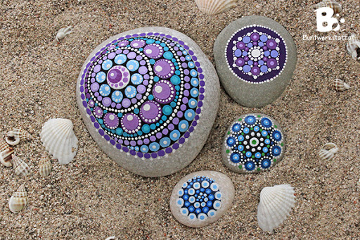
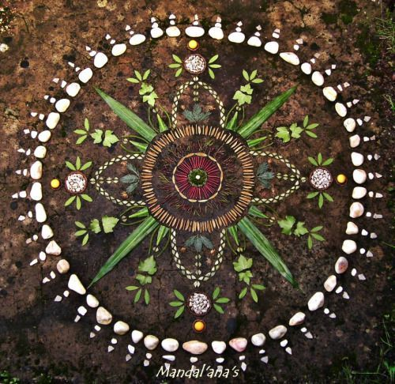
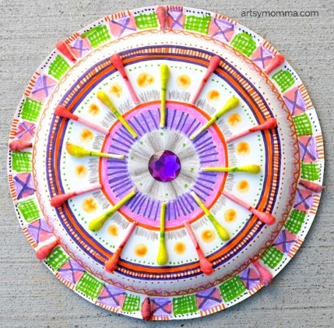

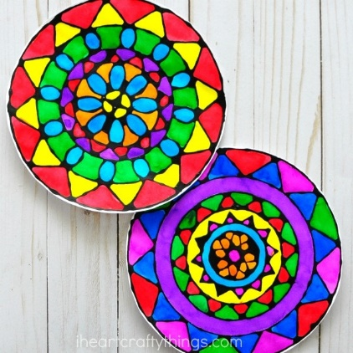
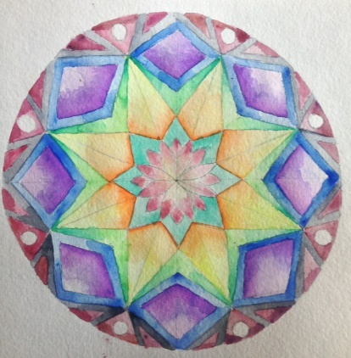
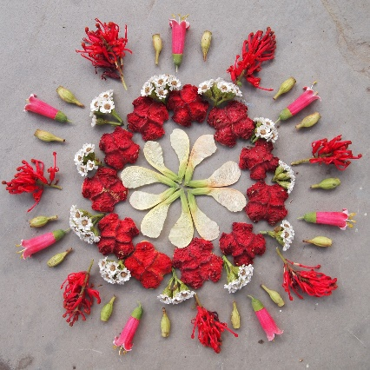

Reading Comprehension
James and the Giant Peach
Task-Read the following passage and answer the questions below.

‘Good gracious me!’ Aunt Spiker said, ‘What’s that awful noise?’
Both women swing round to look. The noise, of course, had been caused by the peach crashing through the fence that surrounded it, and now, gathering speed every second, it came rolling across the garden towards the place where Aunt Sponge and Aunt Spiker were standing.
The gaped. They screamed. They started to run. They panicked. They both got in each other’s way. They began pushing and jostling and each one of them was thinking only about saving herself. Aunt Sponge, the fat one, tripped over a box that she’d brought along to keep the money in and fell flat on her face. Aunt Spiker immediately tripped over Aunt Sponge and came down on top of her. They both lay on the ground, fighting and clawing to get up again, but before they could do this the mighty peach was upon them.
There was a crunch. And then there was silence.

Write the answers in full sentences:

- What did the peach crash through?
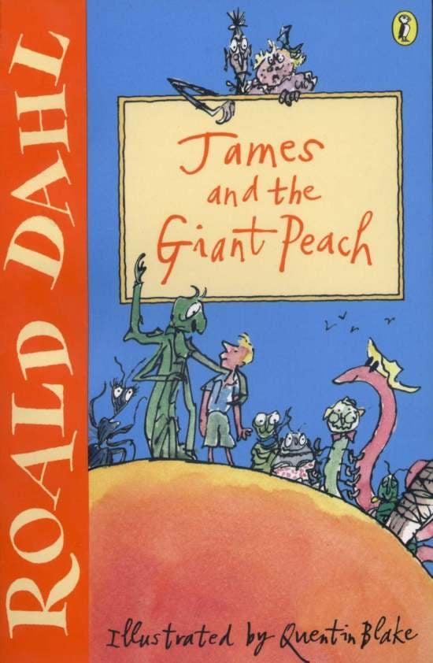
- What was the peach rolling towards?

- Write 3 things that the Aunts did when they saw the peach rolling.

- Which Aunt tripped over a box?

- What did Aunt Spiker trip over?

- What do you think made the ‘crunch’ noise?

- What do you think was happening inside the peach at this time?

