Pictures of completed activities can be sent to either Miss Huddart or Mr Ward on Seesaw.



TTRS Battle of the Bands

20 Arena Sessions

Starts: 9am on 6th June Ends: 15.30 on 10th July

White Rose Maths

To access this week’s White Rose Maths home learning activities, please follow the link below:

<https://whiterosemaths.com/homelearning/year-3/>

A copy of this week’s worksheets can also be found on our school website.

Y3 Literacy Shed Reading Comprehension Pack

A copy of this pack has been uploaded to the school website. It can also be found at the following address. This pack includes a range of reading comprehension texts, complete with questions and answers, for you to choose from.

<https://www.literacyshedplus.com/en-gb/resource/stage-3-reading-pack>

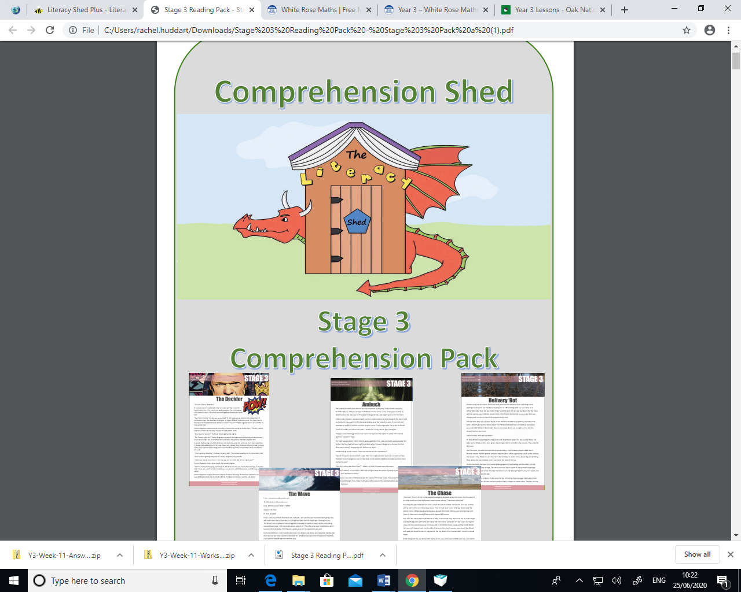

Oak Academy Literacy

Please follow the link below to access the Oak Academy online learning resources.

<https://classroom.thenational.academy/schedule-by-year/year-3>

They also provide learning materials for others subjects which you might like to try- just click on the ‘subjects’ tab in the top right-hand corner.

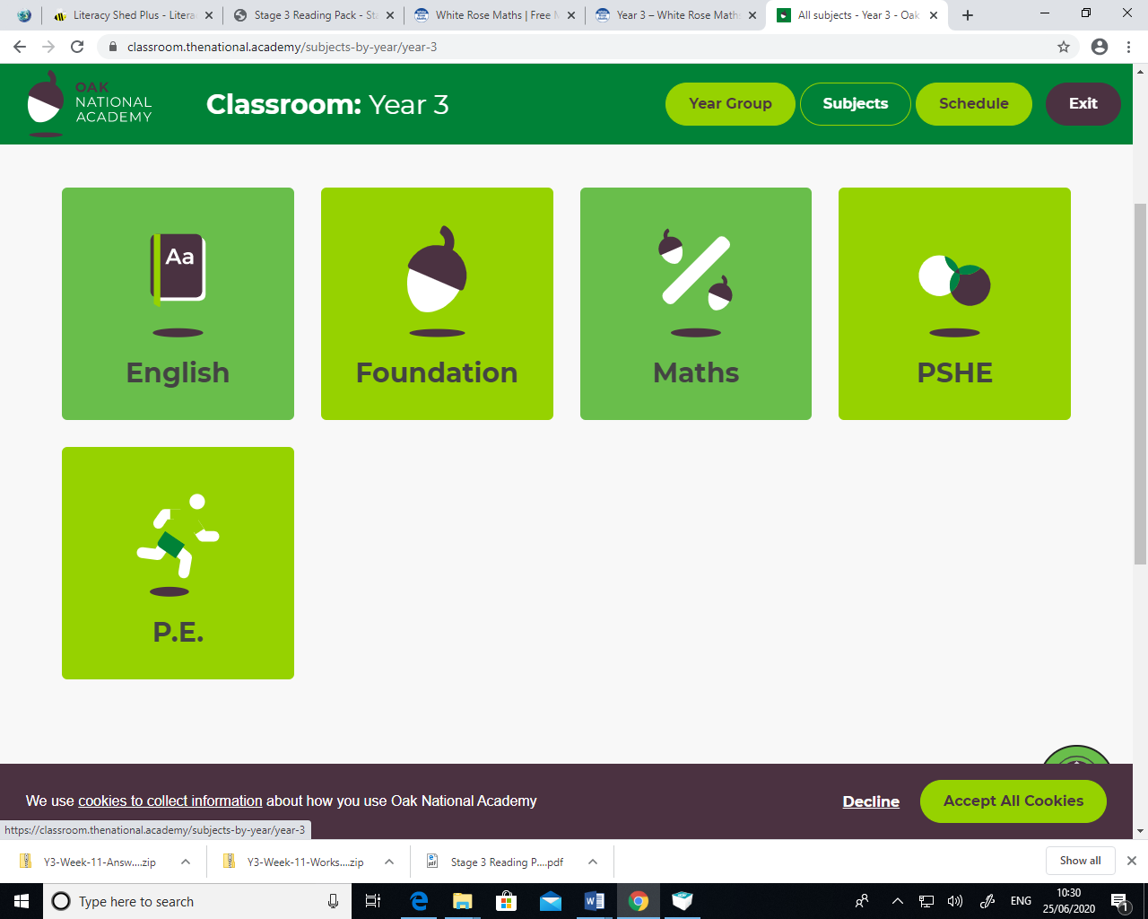

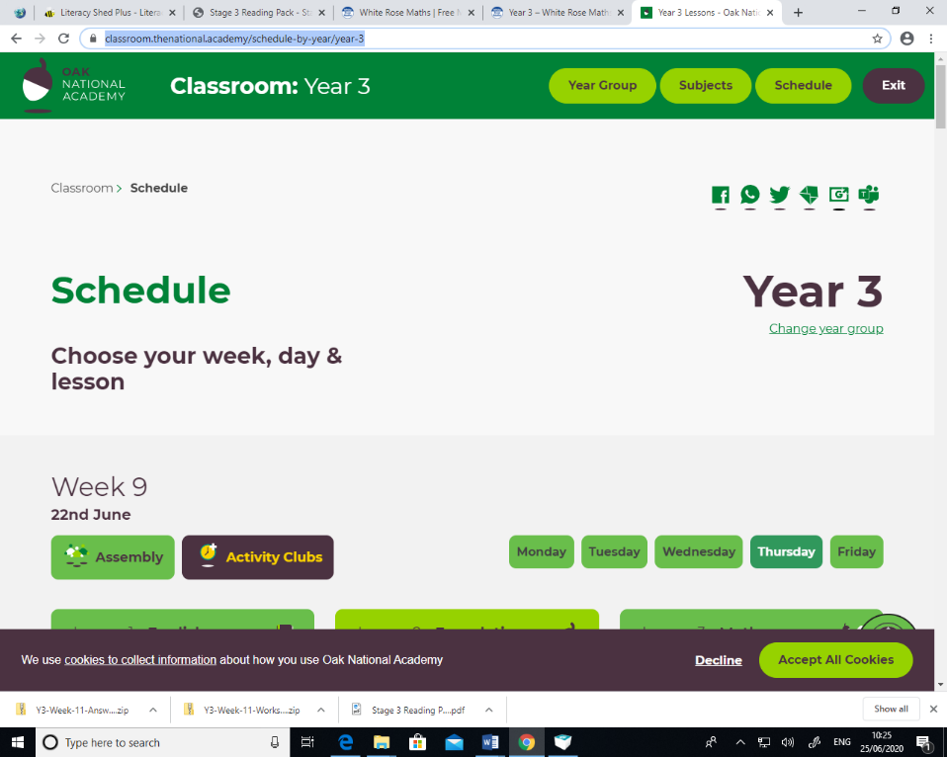

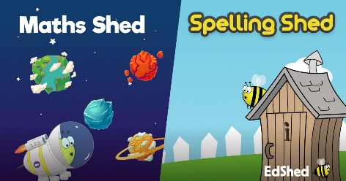

Spelling Shed

Year 3/4 spellings words to practice:

<https://www.spellingshed.com/en-gb>

Maths Shed

Develop maths fluency through times-tables, number bonds, powers of ten and more:

<https://www.mathshed.com/en-gb>

\*You can use either web address to access both the spelling and the maths resources.

Geography with Sir David Attenborough

Learn what the Earth can tell us about the weather with Sir David Attenborough:

<https://www.bbc.co.uk/bitesize/articles/zw7vtrd>

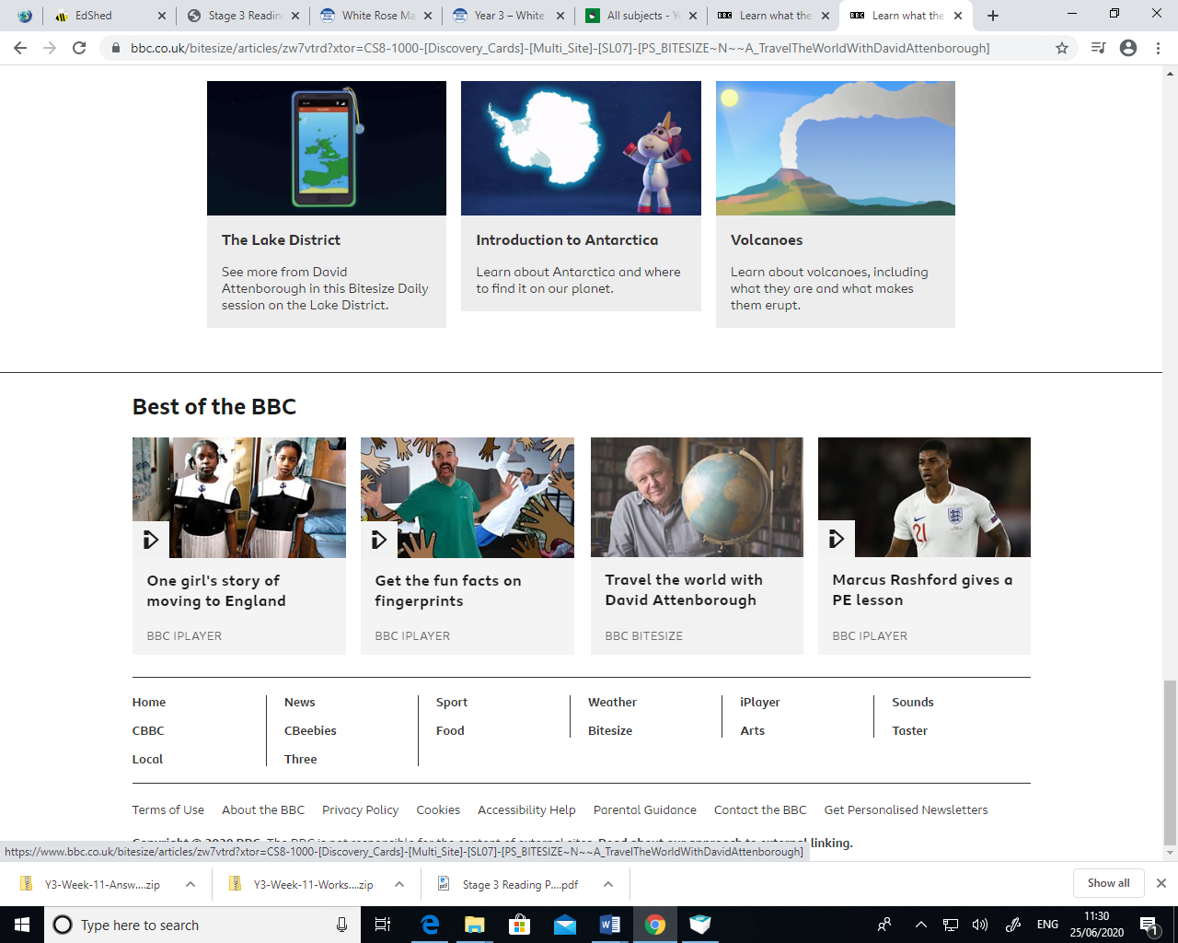

The Lake District

Learn about the Lake District, including where it is and what it is like.

This lesson includes:

* One short film on the Lake District
* A collection of photographs of the Lake District and its nature
* Two activities to build your knowledge (newspaper template provided below)

<https://www.bbc.co.uk/bitesize/articles/zd49ydm>

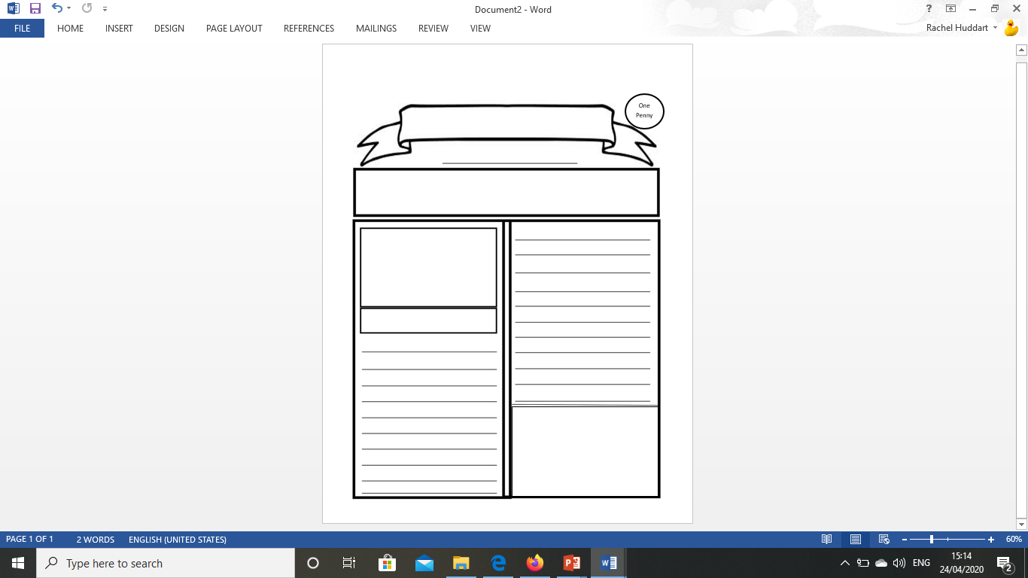

PHSE

Watch the short story <https://www.youtube.com/watch?v=8Wi0UWLeT9I>

What is the moral of the story? A moral is the lesson of the story. Think of a time when you were kind to someone. How did this make you feel? How do you think it made the other person feel? Has there been a time when somebody was kind to you? How did this make you feel?

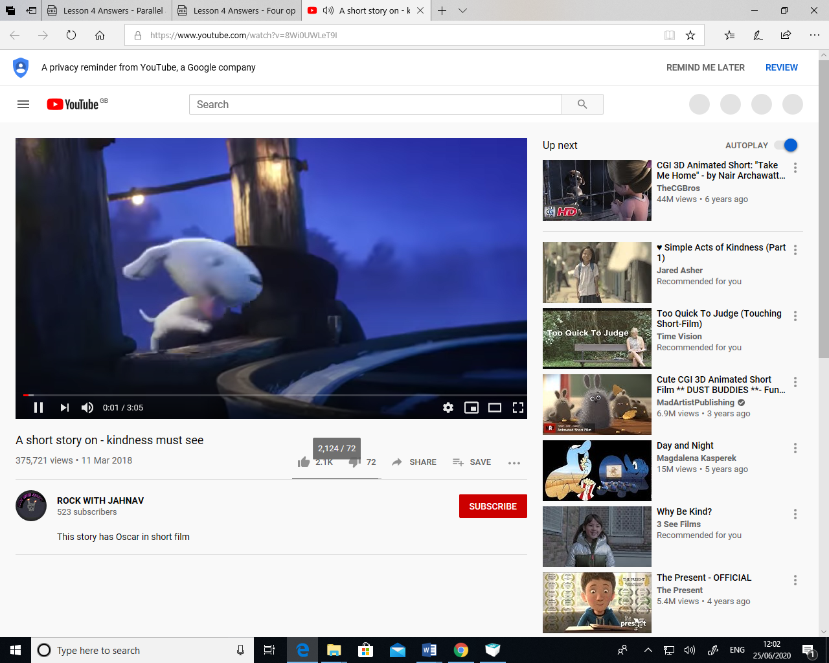

Acts of kindness

Create a poster to educate other people about how to be kind. You should include:

\*A definition of what the word ‘kindness’ means to you.

\*A written explanation or drawing of what you think kindness looks like or how it makes you feel.

Or

Draw a flower with five petals. In each petal, write about or draw a picture which shows a kind act you have completed this week.

Art

Ancient Egyptian art lessons

<https://artyfactory.com/egyptian_art/egyptian_art_lessons.htm>

* Learn about the Ancient Egyptians through their Egyptian Art Lessons
* Discover the mysteries of Egyptian art, gods, crowns, and hieroglyphics
* Create an Ancient Egyptian portrait using a mixed media technique called Paper Batik
* Find out about the lives of the Ancient Egyptian Gods and what they looked like
* Discover the different Crowns of the Pharaohs and when they were worn
* Use our Hieroglyphic Alphabet to translate your words into Hieroglyphic images
* Design a Cartouche of your own name using Ancient Egyptian Hieroglyphs
* Test your knowledge of the Ancient Egyptians on our Quiz Page

