TTRS Battle of the Bands
Lime JW vs Lime RH
Starts: 9am on 18th May Ends: 15.30 on 22nd May
Let the battle commence…

White Rose Maths
To access this week’s White Rose Maths home learning activities, please follow the link below:
https://whiterosemaths.com/homelearning/year-3/
A copy of this week’s worksheets can also be found on our school website.

Coram Life Education (PHSE and Wellbeing)
For home learning resources on PSHE and wellbeing and news about Coram Life’s special Return to School toolkit – Staying Safe with SCARF, please follow the link below:
https://www.coramlifeeducation.org.uk/SCARF-home-learning-plans-set-3
The theme is KINDNESS – also the focus of this year’s Mental Health Awareness Week campaign (18th to 24th of May). The activities help children of all ages to learn how kindness can help them, as well as others.

Please see below for more information regarding this week’s suggested tasks. Pictures of completed activities can be sent to either Miss Huddart or Mr Ward on Seesaw.

Parts of a plant
Parts of a plant video clip: http://flash.topmarks.co.uk/3334
Life Cycle of a plant Video Clip: https://vimeo.com/218127170

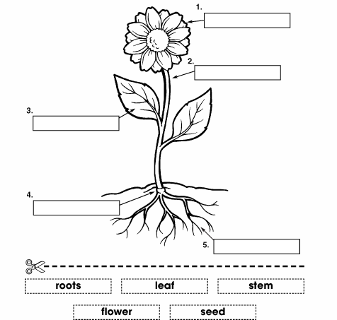
Match the labels to the correct part of the plant
Alternatively, why not draw or make your own plant to label like the ones below:
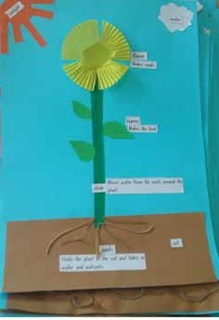
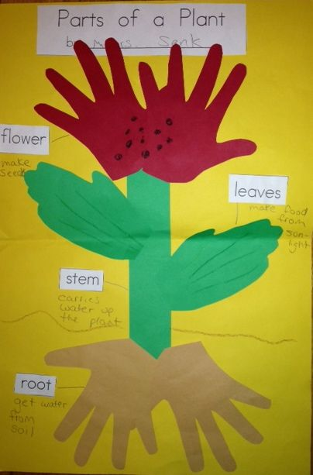
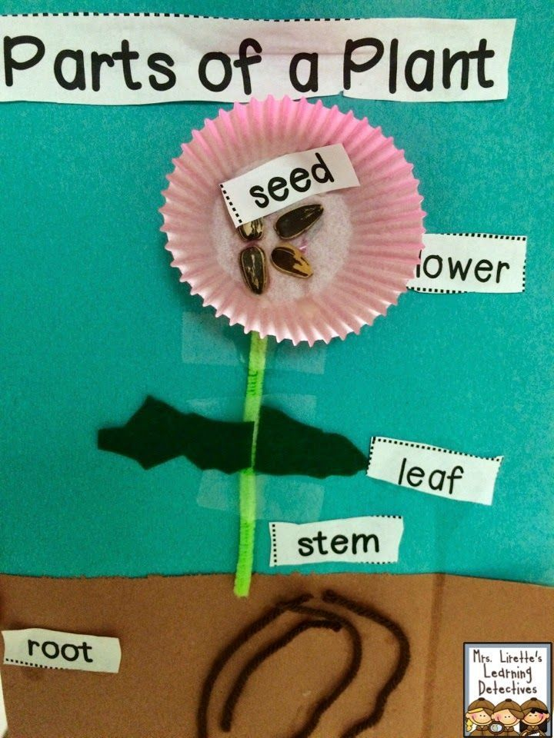

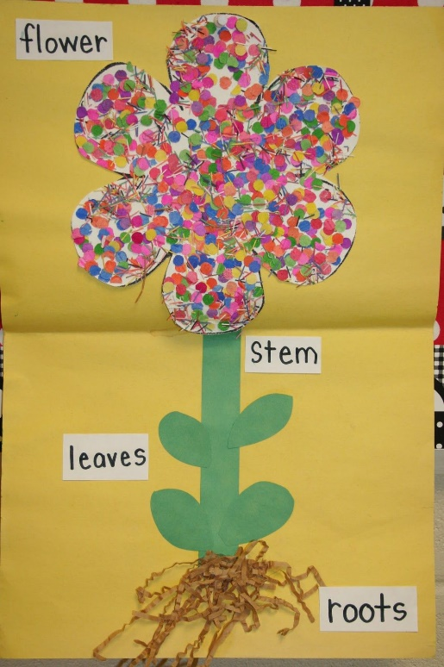

What do plants need to grow well?
Video 2- What do plants need to survive?
https://www.bbc.co.uk/programmes/articles/Mf5rhbTkHLZ3fbJzScyDvC/primary-science-plants
Video clip and quiz:
https://www.bbc.co.uk/bitesize/topics/zpxnyrd/articles/zxxsyrd
Helping plants grow well game:
http://flash.topmarks.co.uk/4013
The Lucky Seed Story clip:
https://learnenglishkids.britishcouncil.org/short-stories/the-lucky-seed

Activity on next page

What do plants need to grow well?

What does a plant need to help it grow big and strong?
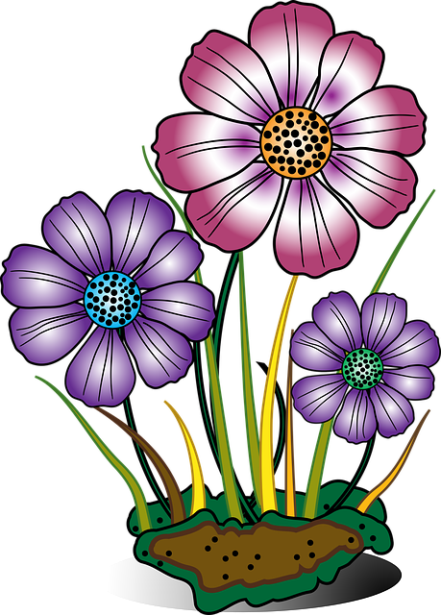

Why do plants have leaves?
Video clip- Why do plants have leaves?
https://www.bbc.co.uk/bitesize/clips/z2k4d2p
Label the parts of a leaf. Which part is the vein? Which part is the petiole (the part that attaches to the main stem)? Which part is the blade (foliage)?

Complete the following passage:
The l…………… part of the plant has tiny p………………all over its surface. Water that has been taken in by the r…………. evaporates and escapes through these pores. Plants make a substance called c………………….. in their leaves. This chemical makes the leaves g………… and helps to turn s……………… and air into f……….. for the p…………....

food leaf sunlight pores green chlorophyll plant roots
Flower Power

Video Clip 4- What is pollination and how does it work?
https://www.bbc.co.uk/programmes/articles/Mf5rhbTkHLZ3fbJzScyDvC/primary-science-plants
Task
Try dissecting your own flower using your fingers or a pair of tweezers. Stick each part of the flower to a piece of paper using sticky tape.
Label the different parts of the flower using the word bank below. Can you count how many of each part your flower has?
Word Bank
Petal | Anther
Stem | Ovary
Stigma | Style
Filament | Sepal
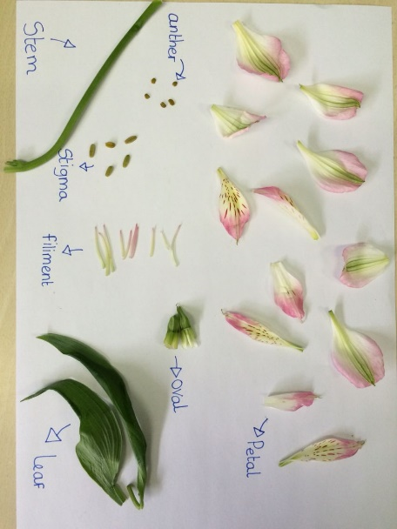
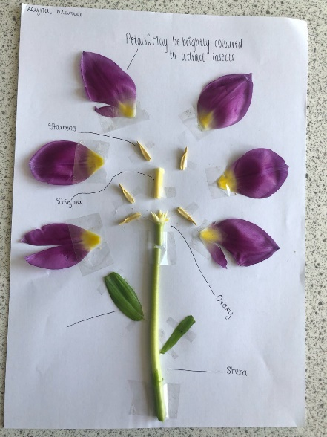

Or
Create a comic strip to show how a bee pollinates a flower. Use the word bank to help you complete the descriptions. You may choose to use your own template/design on the computer, iPad or separate piece of paper if you wish.
(Worksheet provided on next page)

Flower Power
Create a comic strip to show how a bee pollinates a flower. Use the word bank to help you complete the descriptions.
Attracted by its colourful………………… and smell of nectar, a bee flies over to the flower. | As it drinks the ………………, pollen from the ………………sticks to the bee.
The bee flies off in search of another flower full of …………………….. . | As the bee drinks from the new flower, the pollen it was carrying from the previous plant sticks to the …………………………
Word Bank

seeds
nectar
petals
stamen
stigma
ovary
The flower is pollinated!……………………. start to grow inside the ………………… .
Water Transportation

Video clip 5- How does water gets from the roots to leaves of a plant? https://www.bbc.co.uk/programmes/articles/Mf5rhbTkHLZ3fbJzScyDvC/primary-science-plants
Video clip:
https://www.bbc.co.uk/bitesize/topics/zy66fg8/articles/zcxh4qt

Task
Why not carry out your own experiment to see how water is transported in plants?

Equipment
- Food colouring
- Water
- Container
- Flower or celery stick (with leaves on if available)

Method
- Pour some water into a container.
- Add food dye to the water, a few drops at a time, until it is brightly coloured.
- Place the celery or flower in the coloured water.
- After a couple of hours, look carefully at your celery or flower. You may need to cut into it to notice any changes.
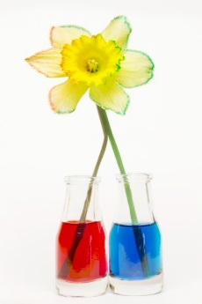
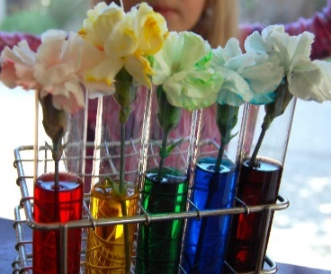
- Draw a picture or take some photographs or your experiment.

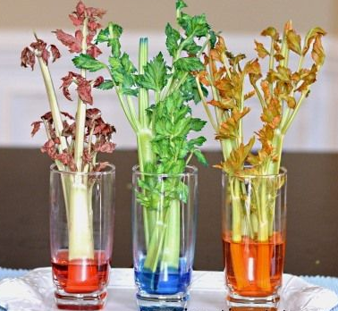
Seed Dispersal -How do plants spread their seeds?

Seed dispersal video clips:
https://www.bbc.co.uk/bitesize/clips/znvfb9q
https://www.bbc.co.uk/bitesize/topics/zxfrwmn/articles/z28dpbk

Please see below for the seed dispersal activity.
Grow your own!
Why not have a good at growing your own plant from a seed or cutting?
Two examples are provided below but you might have other plants you would like to try and grow instead.

Grow Beans in a Jar
You will need:
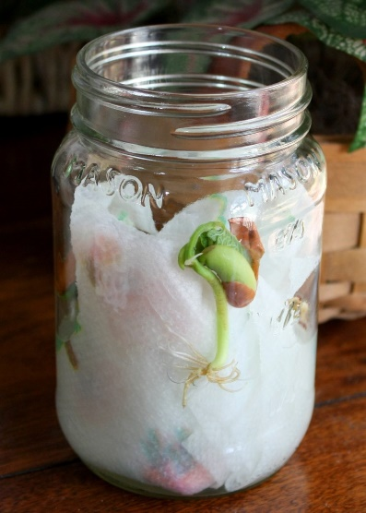
- An empty jar or clear plastic cup
- Broad bean seeds
- Blotting paper/ kitchen paper (doubled)/ paper towels
- Scissors
- Water

Method
- Cut the botting paper/ kitchen paper (doubled)/ paper towels so it fits snugly round the inside of a jar/ plastic cup.
- Place a bean between the paper and the side of the jar.
- Pour a little water in the bottom of the jar and watch the paper soak it up.
- Keep the paper moist and watch the bean sprouting shoots and roots.

How to Grow a Sunflowers

Equipment

- Small plant pot or empty container with a hole in the bottom for drainage
- Sunflower seed
- Soil
- Water

Method
- Place the sunflower seed in the ground.
- Gently push the sunflower seed into the soil.
- Cover the sunflower seed with dirt.
- Press down firmly.
- Give them plenty of room to grow.
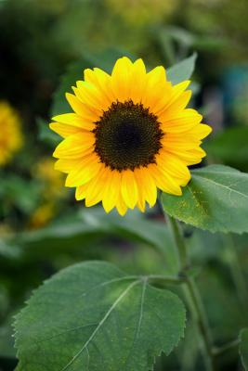
- Water sunflower seeds.

*Sunflower seeds can sometimes be found in bird food- you might be able to find one in a bag if you have some at home.
Famous Scientist

Research a famous scientists that is linked to plants. You could create a poster, leaflet, drawing or PowerPoint presentation all about them.

Below are the names of three scientists you might want to choose from:

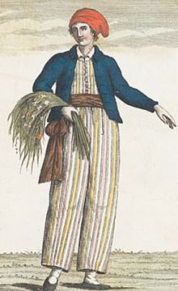
- Jeanne Baret

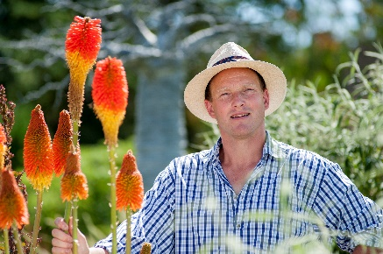
- Tom Hart Dyke

- David Douglass
