September 2025

Dear Parent/Carer,

Parents have legal responsibility to ensure their child attends school regularly. Regular school attendance is essential for every child and young person. It supports their learning, wellbeing, and future opportunities. Regular attendance means attending every day that school is open unless absence is authorised by the school (eg illness). As the local authority, we work closely with schools to ensure that all pupils attend regularly and punctually, and that families are supported in meeting their legal responsibilities.

Under the current national guidance, parents and carers are required to:

• Ensure their child attends school every day it is open, unless there is a lawful reason for absence (eg illness)

• Inform the school promptly if their child is absent unexpectedly and the reason for absence

• Schedule medical appointments outside of school hours where possible

• Request leave of absence only in exceptional circumstances and submit requests in advance

(Please note: family holidays during term time are not generally considered exceptional and are unlikely to be authorised)

In accordance with the Department for Education’s National Framework for Penalty Notices (effective from 19 August 2024), schools are required to consider enforcement action when a child or young person has 10 or more sessions of unauthorised absence (equivalent to five school days) within a rolling 10-week period. While support will always be offered in the first instance, continued unauthorised absences or term-time holidays taken without permission may result in a Fixed Penalty Notice (FPN), or lead to prosecution where appropriate.

In exceptional circumstances, the Local Authority may issue a FPN even if the national threshold has not been met. This may apply where there is evidence to suggest that a parent or carer is deliberately manipulating attendance patterns to avoid enforcement action.

In the last Academic year nearly 2000 FPNs were issued across Cumberland Local Authority for taking children out of school for holidays in term time.

Key points regarding those Fixed Penalty Notices:

• Each FPN issued is a direct alternative to prosecution (so if the Penalty is not paid prosecution is likely).

• Each parent/carer may receive up to two FPNs per child within a three-year period.

• If a third occasion arises, further legal action may be considered, including a prosecution.

• FPNs are issued individually to each parent/carer.

• A number of prosecutions were brought against parents who did not pay the FPN, or FPNs if more than one child was concerned, resulting in criminal convictions and fines/costs of up to several hundred pounds.

We understand that circumstances can vary, and our aim is always to work in partnership with families to support good attendance. If you are experiencing difficulties that may affect your child’s attendance, we encourage you to speak with your child’s school or contact our Access and Inclusion Team.

Thank you for your cooperation in helping us ensure that every child receives the full benefit of their education.

Yours sincerely,

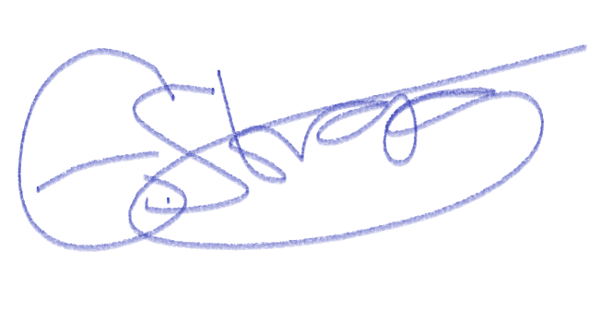

Ed Strong

Senior Manager for Access & Inclusion

Yours sincerely

