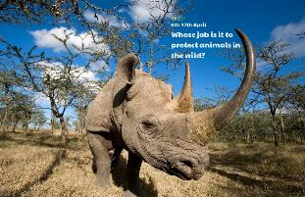

Locate the UK on a world map. The black rhino can be found in Africa. Locate Africa on a world map. Can you find out what other wild animals live in Africa?

Read and research the history of the black rhino. What was the cause of the rapid decline in the population of the black rhino and when did this happen? What has been done to tackle this?

If a black rhino’s horn grew 7cm per year. How long would it be after 2 years? 5 years? 24 years? Can you record this in mm, cm and m?

Animal watch! Find out what animals you can see from your home. Are they somebody’s pet or a wild animal? Keep a record.

Design and make your own 3D junk model of an animal. Use empty cereal boxes, kitchen roll tubes etc.

Create your own wild animal! Think about its name, habitat, diet, behaviour, appearance and how it is adapted to its environment.

**Learning from Home**

Use the ideas below, alongside this week’s resource, to support your home learning.