Pupil premium strategy statement

This statement details our school’s use of pupil premium (and recovery premium for the 2021 to 2022 academic year) funding to help improve the attainment of our disadvantaged pupils.

It outlines our pupil premium strategy, how we intend to spend the funding in this academic year and the effect that last year’s spending of pupil premium had within our school.

School overview
Detail | Data
School name | Maryport CE Primary School
Number of pupils in school | 309
Proportion (%) of pupil premium eligible pupils | 14%
Academic year/years that our current pupil premium strategy plan covers (3 year plans are recommended) | 2021/22
Date this statement was published | October 2021
Date on which it will be reviewed | October 2022
Statement authorised by | Joanne Ormond
Pupil premium lead | Alex Moore
Governor / Trustee lead | Sue Carruthers
Funding overview
Detail | Amount
Pupil premium funding allocation this academic year  Post LAC | £49, 765  £ 4, 690
Recovery premium funding allocation this academic year | £5655
Pupil premium funding carried forward from previous years (enter £0 if not applicable) | £0
Total budget for this academic year | £60, 110

Part A: Pupil premium strategy plan

Statement of intent
Our strategic decision making has taken account of the views of school staff and parents to inform our priorities in spending for the next three years. We have considered the demographics of the school context and the challenges presented to us. Our school data and an analysis of the strengths and weaknesses across the school have contributed to the choices we have made in this plan. We have also closely considered the research conducted by the EEF and the Pupil Premium Lead has undertaken five days training from the Shotton Hall Research School based on how spending is best utilised to have the most impact. We have recognised that following the EEF Implementation plan, a sustained approach to improvement is desirable.
Common barriers to learning for disadvantaged pupils can be: less support at home, weak language and communication skills, lack of self-confidence, behavioural difficulties and attendance and punctuality issues. In addition to this, there can be complex family issues that hinder children’s progress both academically and socially-emotionally.
Principles
- We ensure that teaching and learning opportunities meet the needs of all pupils
- We ensure that vulnerable individuals and groups are well catered for, this has been a priority in our decision making process.
- We acknowledge that not all pupils in receipt of PP funding are socially disadvantaged. There are a number of our pupils who the school has identified as having a greater need than some of those on the allocated list.
- Pupil Premium funding will be tailored from the needs analysis taken from the data, understanding of family issues and discussions with school staff.
Demography and School Context
Maryport Church of England Primary School is located in West Cumbria. We have two year groups of two form entry (Y6 and Y3) and 4 year groups of 1.5 forms. This picture will continue due to demand for places.
The map below displays the Index of Deprivation Score for the area surrounding our school. Some areas around our school have lower than average areas of deprivation, however our school catchment covers a vast area which includes some of the deeper areas of red on the map.
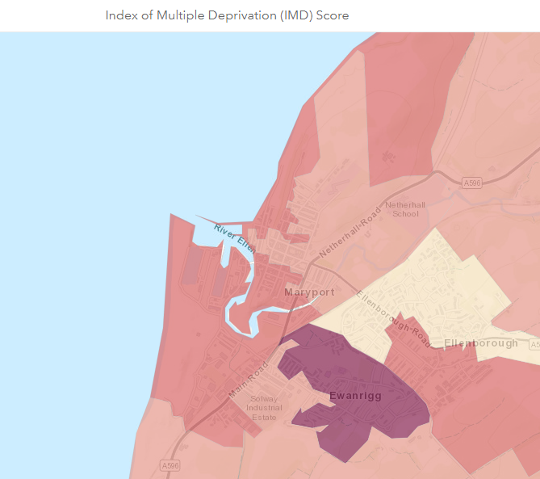
Our ultimate objectives are:
- To close the attainment gap between disadvantaged and non-disadvantage pupils
- For all disadvantage pupils in school to meet or exceed the Nationally expected progress rates
- To support our children’s health and well-being to enable them to access learning at an appropriate level.
Achieving these objectives
The range of provision for Governors to consider making for this group include and would not be limited to:
- Reducing class sizes, improving opportunities for effective teaching and accelerating progress
- Direct Catch Up funding, Recovery Premium funding and the School Led Tutoring Allowance to provide 1:1 or small group tuition for identified, targeted pupils through use of school staff
- Additional teaching and learning opportunities provided through trained LSAs or external agencies
- Pupil Premium funding will be used to accelerate progress and ensure children meet age related expectations.
- School enrichment activities, residentials (50%), educational visits (100%) and music lessons (100%)
- Learning mentor to provide support during lunchtimes by providing small group activities to offer tailored support for pupils
This list provides a flavour of what we provide and may change according to needs that our disadvantage pupils require.

Challenges

This details the key challenges to achievement that we have identified among our disadvantaged pupils.
Challenge number | Detail of challenge
1 | Weak communication and language skills on entry
2 | Low attainment on entry to the EYFS in all areas- see Nursery baseline data
3 | Complex family issues and involvement with external agencies
4 | Attainment and progress of disadvantage pupils
5 | Attendance of some particular families

Intended outcomes
This explains the outcomes we are aiming for by the end of our current strategy plan, and how we will measure whether they have been achieved.
Intended outcome | Success criteria
Progress in Reading | Achieve above National average progress scores in KS2 Reading
Progress in Writing | Achieve above National average progress scores in KS2 Writing
Progress in Maths | Achieve above National average progress scores in KS2 Maths
Phonics | Achieve above National average of expected standard in PSC
Other | Ensure attendance of disadvantaged pupils is above 95%

Activity in this academic year
This details how we intend to spend our pupil premium (and recovery premium funding) this academic year to address the challenges listed above.

Teaching (for example, CPD, recruitment and retention)
Budgeted cost: £20, 550
Activity | Evidence that supports this approach | Challenge number(s) addressed
Speech and Language  £1, 000  The speech and language therapist will screen children flagged up by staff and provide staff with a range of strategies to support the children in class and in small group interventions. | Our baseline data for Reception (Sept 21) has indicated that the children have struggled with basic naming vocabulary e.g. animals and 81% are working below age related expectations. | 1, 2
Reduced class size in Year 4  £18, 450 | Following the whole school data analysis (July 2021) it was evident that the year groups that had been most heavily impacted by the Covid disruption was the Y4 pupils.  The combined standard for this year group was 30% (July 2021)  Achievement in writing is lower than in other subjects which has impacted on the number of pupils achieving the combined standard. | 1, 2, 3, 4
Staff CPD- Read Write Inc  £1100 | High quality staff CPD provided by Sarah Jones (RWI consultant) and followed up by the English Hub (1/2 termly support).  Reading Teacher released for a day per half term. | 1, 2,3, 4

Targeted academic support (for example, tutoring, one-to-one support structured interventions)
Budgeted cost: £30, 322
Activity | Evidence that supports this approach | Challenge number(s) addressed
Learning Mentor to be proactive in preventing issues widening  £26,000 | With an increase in pastoral issues across the school (evidenced by CPOMS entries) we recognise that this role is essential to address the growing needs of our families. | 1, 2, 3, 4, 5
Early Years resourcing to meet the needs of the new curriculum  £3170.85 | The proportion of children achieving a Good Level of Development by the end of the Foundation Stage was 56% last year which is well below the National (72% in 2019). Many of our children begin Nursery with very low starting points.  We have invested in high quality resources to enhance our provision through Early Excellence to ensure that we are fulfilling the new EY curriculum  - New small world unit  - Malleable materials  - Brio construction  - Puppets/ reading resources | 1, 2, 3, 4
EYFS and KS1 reading books investment to promote Reading for Pleasure  £1, 152 | Our English Hub consultant has identified that our next school priority is to develop Reading for Pleasure at home. We are investing in a new EYFS/KS1 lending library to ensure that the children have access to high quality texts for sharing at home as well as their home reading books matched to their phonics ability. | 1, 2, 3, 4

Wider strategies (for example, related to attendance, behaviour, wellbeing)
Budgeted cost: £27, 390
Activity | Evidence that supports this approach | Challenge number(s) addressed
Safeguarding team extension  £180 | Following the issues that have arisen during the period of Covid disruption, we are training another member of staff to level 3 Safeguarding to deal with the increase in the volume of cases and external agency involvement. | 3, 5
Breakfast club extension  £15, 876  Free snack  £1,634 | Uptake for school breakfast club places has increased two fold this academic year which has resulted in another staff member being employed during this time and breakfast club being moved into the main school building to accommodate the extra children in attendance.  Identified pupils are targeted for support by the school learning mentor who invites them to breakfast club. This has impacted on attendance and punctuality. | 1, 2, 3, 4, 5
Residential costs  £2000 (London) + £1, 050 York | To increase our cultural capital opportunities, we subsidise our school residentials by 50%.  Y3- tbc  Y4- Outdoor Adventure in the Lake District (2 days)  Y5- York  Y6- London | 4
Guitar tuition  £6, 650 | Every child has the right to be able to play an instrument

Total budgeted cost: £78, 262 (the school makes up the shortfall by adding to the PP funding)

Part B: Review of outcomes in the previous academic year

Pupil premium strategy outcomes
This details the impact that our pupil premium activity had on pupils in the 2020 to 2021 academic year.
Disadvantaged pupil progress scores for last academic year
Reading- N/A
Writing- N/A
Maths-N/A
Strategy aims for disadvantaged pupils
Measure
Meeting expected standard at KS2 RWM
Reading 100%
Writing 80%
Maths 80%
Achieving high standard at KS2 RWM
Reading 40%
Writing 40%
Maths 0
16% of the year group were identified as disadvantaged. Overall the group performed well as highlighted by the percentages above, the area for improvement is Greater Depth Maths.

