Nursery home challenges W/B 04-05-2020
- Tell a story using props/puppets.
Think of a story that your child is very familiar with. Traditional tales are always a good starting point, as most of them are very repetitive. The idea of this activity is to tell and follow stories without the use of a book.
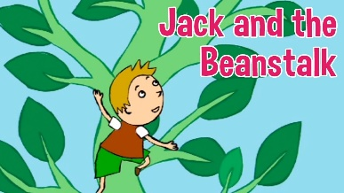
Work together with your child to retell a story. Use props or even make your own characters/puppets.

Ideas-
- Goldilocks and the Three Bears- make puppets of the main characters. Use real props such as different size bowls, spoons, chairs etc…
- The gingerbread Man- make a Gingerbread Man puppet and use plastic animals/soft toys. Change the characters if you wish!
- Three Little Pigs- use sticks, straw, bricks. Make masks, puppets with lolly sticks, boxes etc…
If your child finds this difficult, you could use the book to familiarise them with the story before using props and puppets. Be as creative as you wish!

2)- How many shapes?
Adult to draw 4 shapes on an A4 piece of paper.
Circle, square, rectangle and triangle.

Encourage your child to walk around the house and look out for the shapes in their environment. This activity might need modelled at first. Each time they see a familiar shape, make a tick next to the matching shape on the sheet. At the end of the activity, talk about their findings. You could ask the following questions…
- Which shape has the most ticks?
- Which shape has the least ticks? (this might need explained).

Yellow challenge.
- If your child has two shapes with the same amount of ticks, you could introduce the language of ‘the same amount ‘and explain what this means.
- Have some numerals at hand. When your child has counted the amount of ticks beside each shape, ask them if they can find the matching numeral.
- Can they write the numeral beside the ticks?

3) Nature printing.
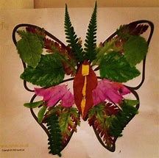
If you are lucky enough to venture out on any walks this week, I thought it would be a nice idea to collect some natural resources to make pictures.
If you have paint and paper at home, allow your child to dip the natural resources into the paint and make prints on their paper. Encourage them to chat and make comments about the marks they are making.
Ideas of resources to collect on your walk…
A variety of leaves, twigs, pebbles, pine cones, grass, dandelions, bluebells, other flowers.
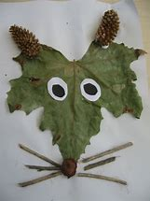
Alternatively, if you do not have any paint you could make sticky pictures or place the materials on the paper and take a photograph.

Please email me on emmapape@maryport.cumbria.sch.uk if you have any questions around any of the home learning challenges. Alternatively, you can send me a post on Tapestry.
Thank you
Miss Pape

