Nursery home challenges W/B 06-07-2020
Hi everyone, I hope that you are all keeping safe, well and happy. Please find this week’s home learning below…
This week is a crafty week.
- Fruit & vegetable printing.
Following on from our healthy eating chat last week, I would like the children to create a colourful picture using different fruit and vegetables with paint to print.

Can your child identify the fruit / veg?
You may use different colours.
Can your child make a simple repeating pattern with the prints?
Most importantly, allow your child to explore and have fun!

Good fruit/veg to use…
Pear, Potato, end of banana, apple, lemon, celery, onion.
This will work with any fruit or vegetable that is going out of date, you do not need to make a special purchase.

- The Rainbow Fish.

The Rainbow Fish is a classic story about friendship. It is a perfect story to talk about the feelings and wishes of others. If you do not have this book, you will find it on YouTube.

Questions to ask your child about the story-
- How do you think the little blue fish felt when The Rainbow Fish refused to share his scales?
- It is good to have friends, who are your friends?
- How did The Rainbow Fish feel at the end of the story?
- Do you share your toys? Why?

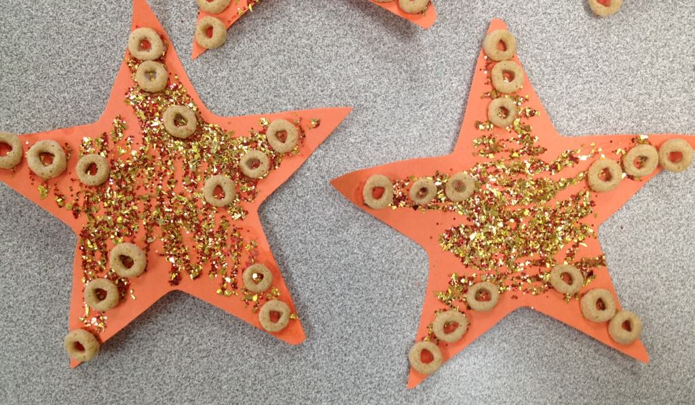
- Cheerio Starfish
You will need…
- Paper
- Glue
- Cheerios
- Glitter (optional)
- Pens

A lot of star fish have 5 arms.
Adults need to draw a star for their child. Child to use ‘Peter Pointer’ to count the arms.
Beside each arm I would like you to write a number from 1-5.
Ask your child to stick the correct number of cheerios to each arm. (if you don’t have cheerios, you could draw the circles or use buttons!)
It might be useful to look up pictures of starfish on the internet.

