Nursery home challenges W/B 08-06-2020
Hi everyone, I hope that you are all keeping safe, well and happy. Please find this week’s home learning below…
- Bumblebear.
Part 1-
If you happen to have the story- Bumblebear, please read this book to your child. The story is also available on YouTube. Once you have read the story, you can encourage further thinking by asking the following questions. You might need to revisit this story and talk it through more than once. At school, we would read it every day in order to really understand the text.

- Colours.

Part 2-
Dance like bees.
Pay attention to the part in the story where the bees do the ‘waggle dance’. Explain to your child that honeybees do this to talk/communicate to the other honeybees when they have found food!
With this activity, you might need to create a FREE account with
BBC sounds. You then need to type bee waggle dance in the search bar. This is a dance session that we would teach with the whole class, you do need a little space and might need to complete in 2/3 sessions.
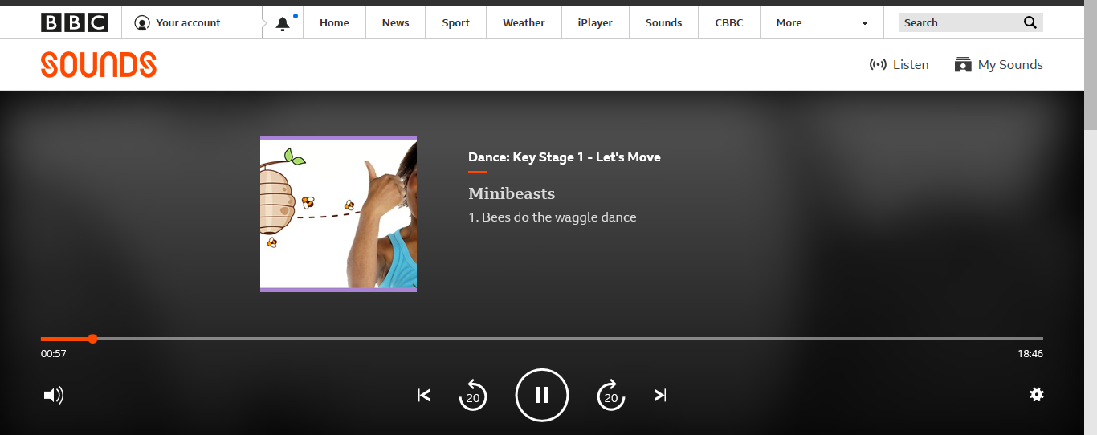

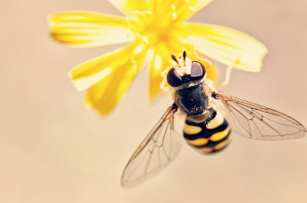

- Bee jobs

2 Patterns everywhere!
Following on from our activity based around pattern last week, can you and your child create patterns with objects from around your house. Be as creative as you like.

3 Nursery Rhyme Humming.
This is another phase 1 listening activity that does not require any resources other than your voice! Begin by singing some of your child’s favourite nursery rhymes, next explain that you are going to hum a rhyme and they must guess what it is. At first, hum the rhymes that you have sang, before humming different ones to challenge them further. This encourages your child to tune into the sounds that they hear, without using any visual prompts.

Please email me on emmapape@maryport.cumbria.sch.uk if you have any questions around any of the home learning challenges. Alternatively, you can send me a post on Tapestry.
Thank you
Miss Pape

