Nursery home challenges W/B 11-05-2020
Hi everyone, I hope that you are all keeping safe, well and happy. Please find this week’s home learning below…
- Story- What the Ladybird Heard.
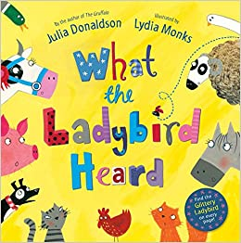
If you do not own this story, please type in the name of the book in YouTube, there are a few versions to choose from on here.

Over the next few weeks we are going to be looking at different insects. This week we will focus on ladybirds, based around another famous Julia Donaldson story- ‘What the Ladybird Heard’. If you have this story at home, please read it to your child. Talk about the illustrations and the characters. Please pay close attention to the sounds that the animals make, especially the ladybird and how he does not make a sound. Focus on how he is very good at listening! Allow your child to help make the animal sounds too!
Next, type in YouTube- What the Ladybird Heard listening game. Explain to your child that you are going to play a game but they need to listen very carefully, just like the ladybird from the story- (ask them to switch on their listening ears). Play the video (don’t let your child see the screen). Pause the video if you need to and allow them time to process what they ear. Can your child identify the animal? Once they have attempted to guess, show them the screen. Praise for attempting, even if they guess incorrectly.

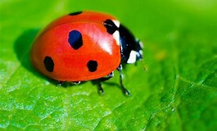
2) Let’s learn about Ladybirds!
For this activity adults need to be a little bit creative!!! Draw 10 simple ladybirds on separate pieces of paper. Alternatively, you can use a computer an print out 10 ladybirds!
Write 1 ladybird fact on each piece of paper and hide them around the house. Explain to your child that the ladybird from the story is playing a game with us. His friends are playing hide and seek and we need to find them! Once they find a ladybird, tell them the ladybird fact. At the end of the activity, see if your child recall any of the information from the task. Keep them to one side and look at them again over the next few weeks.
Facts-
- Ladybirds have 6 legs.
- Ladybirds lay 100s of eggs.
- Their bright colour warns predators that they don’t taste very nice.
- When another insect tries to eat or attack them, they pretend to be dead.
- Most ladybirds like to eat greenfly.
- Most ladybirds are red with black spots, there are yellow ladybirds too.
- Birds, spiders and wasps like to eat ladybirds.
- An adult ladybird can eat up to 75 aphids/greenfly every single day!
- Ladybirds can fly very fast.
- You can find ladybirds hiding in small shrubs, trees and grass.

3-Painted rocks for the memorial garden.
Lots of children are getting involved in painting rocks to make a pretty trail all around the memorial gardens- this will mark the Coronavirus Lockdown. Rocks can be added to the trail but must not be removed from this area. It would be lovely if we could get involved with this activity. If you cannot paint the rocks, please try and pop down during your daily exercise to admire this lovely idea.
Please only take part in this activity if it is safe to do so.

Please email me on emmapape@maryport.cumbria.sch.uk if you have any questions around any of the home learning challenges. Alternatively, you can send me a post on Tapestry.
Thank you
Miss Pape

