Nursery home challenges W/B 13-04-2020
- Indoor Scavenger Hunt…
Can you look around your house and find…
- Something that is red.
- 2 socks that match.
- A pair of glasses.
- Something yellow that you can eat.
- Something that you loved when you were a baby.
- Something Big.
- Something small.
- A soft and cuddly toy.
- A tasty treat.
- A favourite toy.

- Story- Jasper’s Beanstalk.
Other ideas to think about?
- Growing a bean/cress/ sunflower.
- Talking about pips and seeds- look inside an apple and talk about it.
- Draw the bean and how it changes- bean, shoot, beanstalk.
- Link to size language- (tall, short)

If you have the story of Jasper’s Beanstalk at home please read the story and ask your child the questions suggested below.
If you do not have this book at home, you can listen to it via YouTube.
- What did Jasper plant?
- Why did Jasper dig the bean up?
- What did Jasper grow?
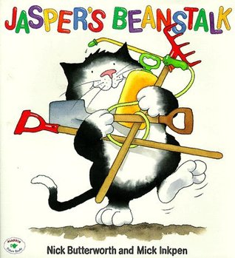
- What is Jasper looking for at the top of the beanstalk?
- Do you think he will climb to the top?

- Can you draw a picture of your Easter Weekend?

