Nursery home challenges W/B 15-06-2020
Hi everyone, I hope that you are all keeping safe, well and happy. Please find this week’s home learning below…
- Snails - (spirals)
This week we are going to look at snails. If you can introduce this with an actual snail (or even just a shell) this would be better.
We are going to pay close attention to the spiral shape on a snail’s shell. Talk about what a spiral looks like.
Adult to demonstrate by drawing some spirals of different sizes.
Children could trace around the spirals if they wish- (encourage correct pencil grip and control).
Once familiar with what spirals look like you can move onto the main activity.
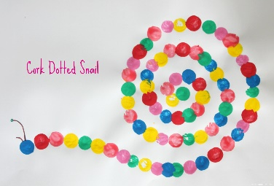
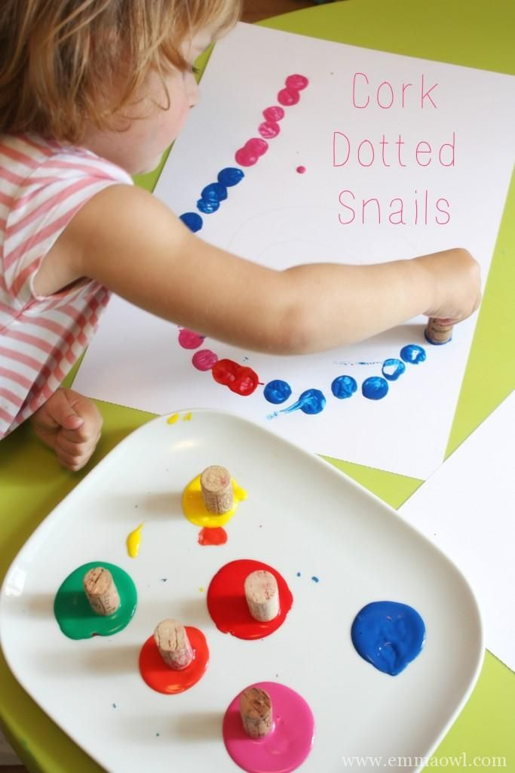
Ideas to extend further.

Main activity.
Adult to draw a large spiral in pencil.
Give child a selection of paints and a circle shape/stamper/cork/bottle top (anything circle that you can find)
Adult to model how we stamp around the line of the spiral in different colours.
Chat about the colours, count the circles and keep reinforcing the new vocabulary ‘spiral’.
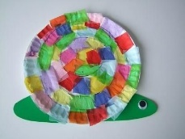

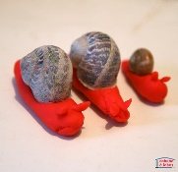
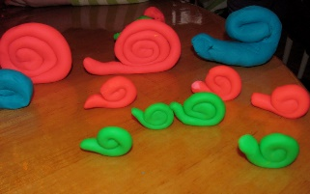
Main activity.
Books – Snail Trail, Snail and the whale, Sharing a Shell.
Use magnifying glasses to look closely at the spiral on a snail shell.
Look for other spirals.
Mark make spirals with fingers in sand, flour, soil, paint, chalk.
Cut out spirals. (if scissor control allows for this)
Make different sized snails and organise from the biggest to the smallest.

If you want to find out more information about snails, this would be fantastic!
- Revisiting shapes.
Feed the shape monsters with the correct shapes. https://www.topmarks.co.uk/early-years/shape-monsters

Talk about the properties of the shapes.
- Square – 4 sides, 4 corners, all sides are the same length.
- Rectangle- 4 sides, 4 corners, 2 longer sides, 2 shorter sides .
- Triangle- 3 corners, 3 sides.
- Circle- 1 side, 0 corners.
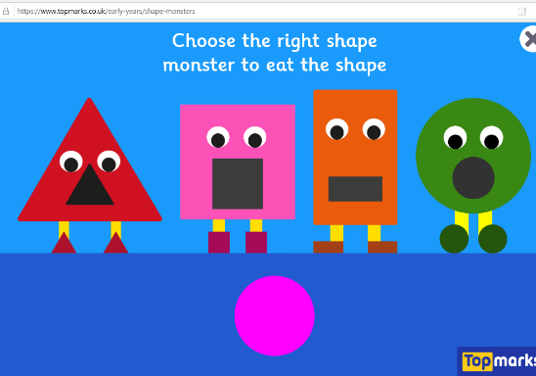

- The sound ‘s’.
Show your child an image of a snail (can use a real snail).
- Ask your child if they know what it is.
- Ask- ‘what sound can you hear at the beginning of ‘snail’?
- If they do not identify the initial sound, tell them- ‘we can hear the sound S’.
- Collect a selection of items in a bag that begin with the sound s, t, & a.
- Allow your child to choose items from the bag.
- Ask -What have you found? (encourage them to say the name of the item).
- Can they identify the initial sound of each item?
- The aim of this activity is to hear the initial sound ONLY. It does not matter at this point if your child cannot recognise what the letters look like. This activity is focussing on ‘tuning into initial sounds’.

Extension (optional).

