Nursery home challenges W/B 18-05-2020
Hi everyone, I hope that you are all keeping safe, well and happy. Please find this week’s home learning below…
- Listening- phase 1
A lot of children really enjoyed the listening activity from last week. Any activity that tunes into children’s listening skills is really good for the first stages of reading. Due to the Coronavirus outbreak there are a few websites that we would use in school that are free for parents at home.
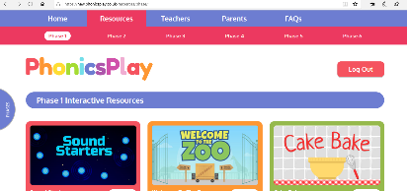
The one that I would like you to look at this week is ‘Phonics Play’. https://www.phonicsplay.co.uk/
- Click on the link above
- Choose new version
- It will give you the free username and password- type this in the box (top left)
- Click on ‘resources’ – you will find this on the toolbar at the top of the page.
- Click on phase 1
- Explore the activities on here.
Important information – please do not click on any other phase as we do not follow the rest of this scheme at school. Using the other phases will only confuse your child.
Please note that if your child has just started school it is probably best to enjoy the games stated below.
- Sound starters
- Welcome to the zoo
- Hickory Dickory Dock
The other activities require a lot of background work which we have been previously working on during our small group sessions (if appropriate).
If your child struggles with ‘Cake Bake’ and ‘Super Smoothie’ please do not worry, this will come in time. If this is the case, focus on the other three games. Have fun!

2) Embedding Numbers.
Over the next few weeks I want to ensure that children recognise numbers 1-10 and understand the true meaning behind them. This week I would like to focus on numbers 1-4.
Work with each number separately and begin with number 1.
Follow the process below… (I will use number 1 as an example)
- Show your child the number 1.
- Show you child 1 dot/spot.
- Show your child one finger- ask- ‘can you show me 1 finger?’
- Ask your child to look around the house to find 1 of something- 1 box, 1 pen, 1 car, 1 peg (anything at all)
- Can they write the number 1?
- Can they find a number one on packets, tins, instructions?
Repeat this activity with numbers 2, 3 & 4.
Please take photographs of your child completing this activity as I would like to make a number line display when we get back to school.

3-Ladybird crafts or baking (you can even use dough). It’s up to you!
This week I would like you to look back on your ladybird facts, look at images of ladybirds, talk about what they look like then represent this through any of the above suggestions.
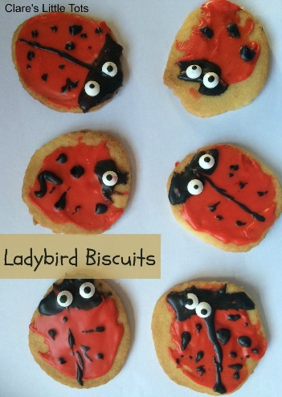
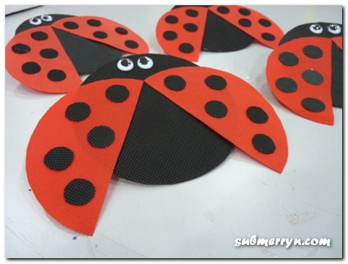
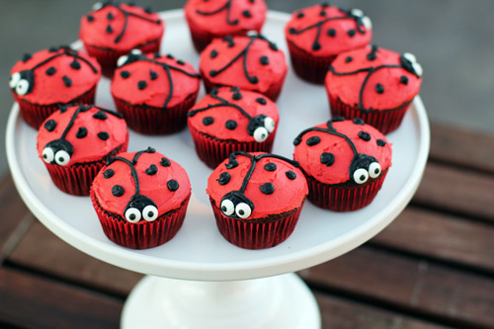

Please email me on emmapape@maryport.cumbria.sch.uk if you have any questions around any of the home learning challenges. Alternatively, you can send me a post on Tapestry.
Thank you
Miss Pape

