Nursery home challenges W/B 1-06-2020
Hi everyone, I hope that you are all keeping safe, well and happy. Please find this week’s home learning below…
- Listening- phase 1
A lot of children have really been enjoying the phase 1 activities. Please continue to use the phonics play website (if possible). Remember phase 1 ONLY. This week we will try and tune into different sounds with a simple listening activity on YouTube.

All you need to do is…
- Search for YouTube phase 1 listening games.
- Click on any of the above images (there are more to choose from).
- Play the video but pause it after each sound to give your child the opportunity to guess what they can hear.
- Resume the video and let your child see if they were correct.

- Colours.
Part 1- During your daily exercise please encourage your child to search their outdoor environment for items that are different colours. For example – Can you find something that is red? Can you find something that is blue? Can you find something that is brown? Adults are to make a note or take a photograph.

Part 2- Ask your children to draw the items of each colour- a red flower, a brown tree trunk, the blue sky…. Please post any finished pictures on Tapestry.

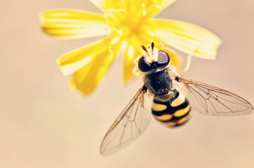

- Bee jobs

- Over the next week or so we will be talking about bees.

I would like you to search the internet with your child and find out some ‘bee facts’.

- I would also like you to look closely at the colour of bees and point out the repeating pattern- black, yellow, black, yellow, black yellow.
- Draw an oval shape (to represent the bee) and begin colouring (a yellow and black repeating pattern) be sure not to colour in the whole bee and allow your child the opportunity to complete the pattern.
- Try this activity again until you think that your child is understanding the concept of pattern.
- Once this is clear, you can be as creative as you like with bees of different colours- using two colours ONLY. (only use different colours is your child can see the patterns, if not keep repeating the activity).
Please post your patterns on Tapestry, I can’t wait to see them!

Please email me on emmapape@maryport.cumbria.sch.uk if you have any questions around any of the home learning challenges. Alternatively, you can send me a post on Tapestry.
Thank you
Miss Pape

