Nursery home challenges W/B 20-04-2020
- What is outside your window?
Draw the things that you can see from your window.
Tell me what you can see.
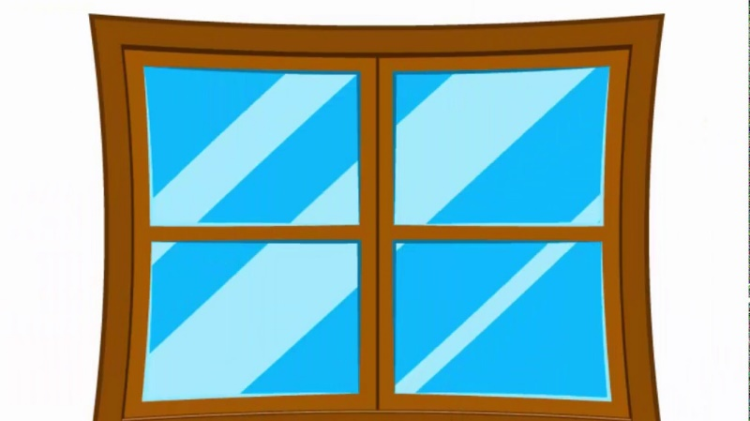

- We want to see your dance moves!
Allow your child to listen to two contrasting songs. One song must be slow, the other must be faster.
Encourage your child to listen carefully to the music and dance in response, adults can join in too!
We look forward to seeing your videos on Tapestry!

- Adding leaves to the beanstalk.
(Please do not attempt the yellow challenge unless this has been discussed.)
What you will need.
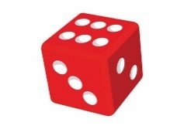
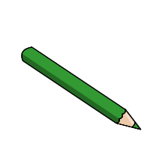
x1

Green pen/pencil
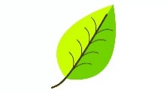
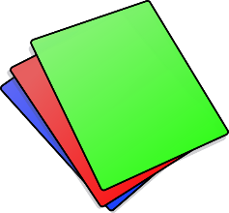
A selection of real leaves or paper leaves (adult to make)
Paper/card.

What you need to do…
- Adult needs to draw the base of the beanstalk on the paper (using the green pencil).
- Explain to your child that the beanstalk needs some leaves.
- Show your child the leaves.
- Ask your child to roll the dice and use their Peter Pointer finger to count the dots. (If they can say how many dots without counting, then this is even better).
- Ask your child to add that many leaves to the beanstalk. It may help to show your child the numeral that matches the number of spots. For example, if they roll a number two, show them what a number 2 looks like.
You can use glue to stick the leaves onto the beanstalk if you wish.

Yellow challenge.
- Adult needs to draw the base of the beanstalk on the paper twice. (using the green pencil).
- Child will roll the dice, count the spots, say the number and add the correct number of leaves to one beanstalk.
- Child will repeat this with the other beanstalk.
- Adult to encourage child to find out how many leaves we have ‘all together’ by counting the total number of leaves on both beanstalks. Please note- there is no need to write down the number problem (sum). At this point we are ONLY beginning to use vocabulary involved in ‘adding’ and finding the total number of items in two groups.

Please email me on emmapape@maryport.cumbria.sch.uk if you have any questions around any of the home learning challenges. Alternatively, you can send me a post on Tapestry.
Thank you
Miss Pape

